
RXOFFICE USER MANUAL

Contents
1 Installation 9
2 User interface layout 10
2.1 Toolbar 10
2.1.1 User interface language 10
2.2 Screen layout 11
2.2.1 Record status indicator 11
2.2.2 Column names 11
2.2.3 Grid 11
2.2.4 Master detail grid 13
2.2.4.1 Grid with details editor 13
2.3 Workflow 14
3 ORDERS MODULE 16
3.1 Generic 16
3.1.1 Delivery detail 16
3.1.2 Order history 17
3.2 Rx orders 20
3.2.1 Lens selection 20
3.2.2 Blank selection 22
3.2.3 Office prescription entry 22
3.2.3.1 Near vision prescription entry 22
3.2.3.2 Far vision prescription entry 23
3.2.4 User defined parameters 23
3.2.5 Measure front curve 24
3.2.6 Prism 25
3.3 Fitting parameters 25
3.3.1 Edging Options 25
3.3.1.1 Fitting parameter dictionary 26
3.3.1.2 User defined edging type 27
3.3.1.3 Predefined shapes and Lab own shape 27
2.2.3.1 Trace data Repository 28
3.3.1.4 Load Trace data from file 29
3.3.1.5 Save trace data 30
3.3.1.6 Tracer Connection 30
3.3.2 Additional Supplements 31
3.3.3 Add other products 31
3.3.4 Save order and calculation 32
3.3.5 JOB preview 32
3.3.6 Print Jobticket 33
3.3.7 Manufacturing parameters 35
3.4 Bulk order (stock anything) 36
3.5 Product order 37
3.5.1 Import 38
3.5.2 Bulk job ticket print 38
3.6 Finding a job 38
3.7 Credit Order 39
4 Products 41
4.1 Frame 41
4.2 Coating 43
4.3 Tint 44
4.4 Supplement 44
4.5 Miscellaneous products 44
4.6 Product groups 45
4.6.1 How to create combinations 45
4.6.2 How to use combinations 46
4.7 Inventory Management 46
5 Category 48
6 Production PARAMETERS 49
6.1 Lens Design 49
6.1.1 Corridor and SEGHT 49
6.1.2 Conventional RX 49
6.1.3 Rx lens design 50
6.2 Optical Decentration 50
6.2.1 Optical Decentration 50
6.2.1.1 Manual decentration 50
6.2.1.2 Auto decentration 51
6.3 Box Data and pupil data 52
6.4 Tracing process 52
6.5 base curve 53
6.5.1 base curve chart 53
6.5.2 base curve tolerance 53
6.5.3 Same base curve for order 54
6.5.4 Blank selection process 54
6.6 Block ring selection 54
6.7 Safety margin 56
6.8 Finished lens diameter 56
6.9 Thickness 57
6.10 Prism thinning/ Block prism 57
6.11 Compensation Rules 58
6.12 Engraving mark 60
6.13 Ink mark 61
6.14 Lenticular 62
6.15 Freeform bifocal 64
7 Device Host 65
8 Production basic data 66
8.1 Procedure adding new lenses 66
8.2 Materials 67
8.3 Lens designs 69
8.4 Rx Blanks 70
8.5 Stock lenses 73
8.5.1 Create stock lens by range 74
8.5.2 Create stock lenses from Excel 74
8.6 Lens styles 75
8.7 Block rings 76
8.8 Coating Rings 77
8.9 Frame types 78
8.10 Safety margin 79
8.11 Thickness setting based on edging type 79
8.12 Trace data 80
8.13 Engraving 81
8.14 Ink mark 82
9 Purchasing 83
9.1 Create purchase 83
9.2 Purchase suggestion 83
9.3 Receive goods 85
9.3.1 Restock 86
9.3.2 Re-sell 86
9.3.2.1 Partial shipment 86
9.3.2.2 Unit price 87
9.3.2.3 Export purchase 87
10 Stock transfer 88
11 Stock management 88
11.1 Safety stock 88
11.2 Lead-time demand 88
11.3 Forecasting demand 88
12 Inventory Control 89
12.1 Remove items from stock 89
12.2 Return items to stock 89
12.3 Stock Take 90
13 Stock Transfer 92
14 Stock Adjustment 94
15 LAB TRACK MODULE 95
15.1 Status tracking 95
15.2 Defect registration 97
15.3 Coating tracing 98
16 Order Tracking 100
16.1 Job history 100
16.2 Work in progress 100
17 Reports 102
17.1 Custom reports 102
17.2 Report Deginer 103
17.2.1 Advanced 103
17.3 Pivot reports 104
17.3.1 Example Pivot 107
17.4 Dashboard 108
17.5 Machine monitoring 109
18 Online 111
19 Contacts Module 112
19.1 Customers 112
19.1.1 Statement options 112
19.2 Employee 113
19.3 Sales Agent 113
20 Mailroom 114
20.1 Predefined Shipping price 114
20.2 Pending shipment 115
20.3 Serial barcode scanner 118
21 Price module (ERP version) 119
21.1 Lens 120
21.2 Supplement Charges 121
21.3 Product bundling (Packages). 122
21.4 Copy pricelist 123
22 Discounts and rewards 125
22.1 Buy X get Y 127
23 Rebate program 128
24 Import / Export 129
24.1 Generic 129
24.2 Frame data 130
24.3 Lens Description Standard (LDS) 130
24.4 Import sag data 136
25 QC 137
26 Accounting 138
26.1 Statement 138
26.2 Payments 138
27 Thickness configuration options 140
27.1 Low power lens thickness 141
27.2 Safety lenses 141
28 Configuration 142
29 Status 142
30 Production 142
31 Permissions 143
32 Redo 145
33 Appendix 148
33.1 Blending 148
33.2 Product mapping 148
33.3 Outsourcing 150
33.4 Blank selection 152
33.5 Alternate lenses 153
33.6 Define conditional rules 155
33.7 Power corrections 155
33.8 Email accounts 156
34 EDI import/Exporting 156
34.1 EDI Credentials 156
34.2 EDI Export/Import according each contact 157
34.3 Edi Mapping 158
35 Plugin 159
36 Job data adjustment 160
37 Shape Adjustment 160
38 Troubleshooting 164
38.1 Lens thickness 164
38.2 Off-power 164
38.3 Freeform calculations 165
38.4 Lens assignment and pricing 166
38.5 Machine interface 167
39 Bonus agreements 170
40 Backup 170

Installation
The installation procedure is straight forward; copy the executables and dll’s from the distribution folder to the workstation. You may use a script:
xcopy \\LMS\RxCalcData\Install\RX.Core\*.exe "%programfiles%\RX.Core" /S /Y
xcopy \\LMS\RxCalcData\Install\RX.Core\*.dll "%programfiles%\RX.Core" /S /Y
xcopy \\LMS\RxCalcData\Install\RX.Core\*.config "%programfiles%\RX.Core" /S /Y
xcopy \\LMS\RxCalcData\Install\RX.Core\*.bat "%programfiles%\RX.Core" /S /Y
xcopy \\LMS\RxCalcData\Install\RX.Core\*.png "%programfiles%\RX.Core" /S /Y
xcopy \\LMS\RxCalcData\Install\RX.Core\Shape\*.* "%programfiles%\RX.Core\Shape" /S /Y
On some older Windows 7 versions, the Microsoft.Net framework may be outdated and you get the message below when starting the program. In that case please install the latest version from
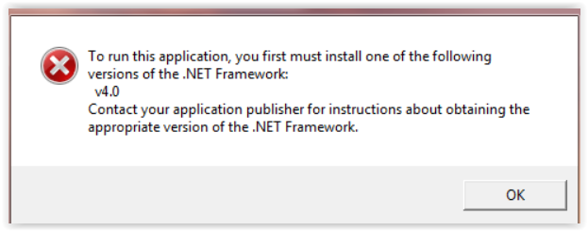
https://www.microsoft.com/net/download/dotnet-framework-runtime

User interface layout

Toolbar
Each screen contains the same toolbar with the following buttons.

- Create: add a new record (Ctrl + N)
- Delete: remove existing records (Ctrl + D)
- Edit: toggle read only mode
- Save: store the record in the database (Ctrl + S)
- Copy: duplicate the current record (Ctrl + O)
- Undo: revert changes for current record (Ctrl + U)
- Refresh: reload the records from the database (Ctrl + R)
- Print: print the current record (Ctrl + P)
- Export: export selected records to external file (csv, excel etc.) (Ctrl + E)
- Import: import records from external file (csv, excel etc.) (Ctrl + I)
- All: select all records (Ctrl + A)
- Clean: remove filters on the list
- Grid: hide/display list (Ctrl + G)
- Check: error-Check all selected records
- Support: run teamviewer for remote support (Ctrl + T)
- Filter: on top of each grid there is a filter row. This filter row allows you to search entries across multiple columns

User interface language
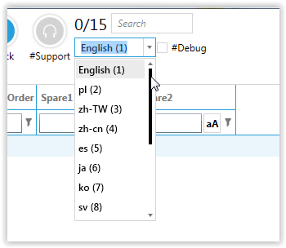
Select your language from the drop-down on the main toolbar. To change the default translations, select the “Resources” in the Configuration section.

Screen layout

Record status indicator
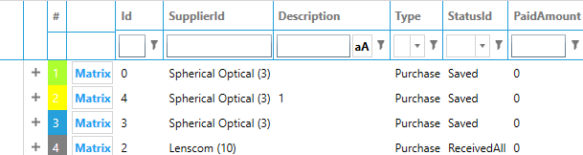
- Green: new item
- Yellow: modified
- Blue: unmodified
- Gray: read only

Column names
Usually the first column in the grid is the row's internal Id number. This number is computer generated and cannot be changed. All records are linked by their Id's, i.e. you can change a records name or code without causing a problem; the parent/child relationships is maintained through their internal Id. The Grid allows you to set the sorting direction to ascending or descending by double click the column header.

Grid
The system provides you with filtering functionality, which allows the user to easily filter the data by one or more columns, just by clicking on the filtering icon next to the header text. Filtering across multiple columns is supported.
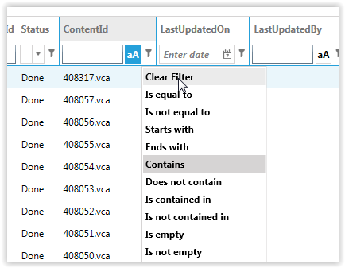

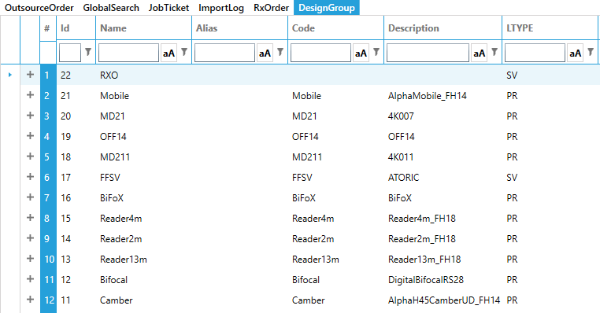
Master detail grid
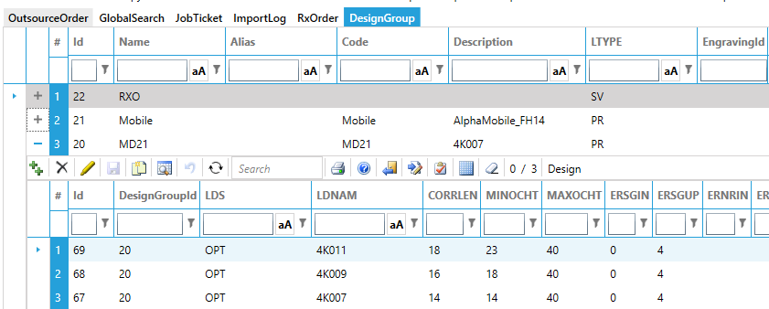

Grid with details editor
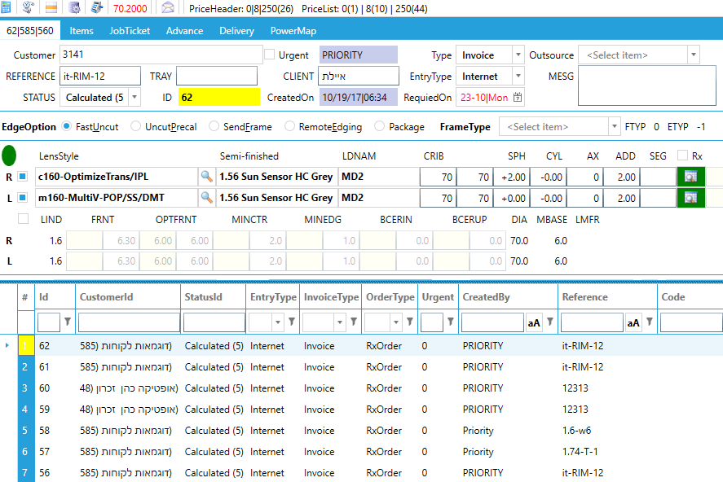

Workflow
Each job in the system has a status. The status will be updated automatically if a job is requested by a machine or by undergoing a known process (e.g. remove items from inventory, print delivery notes etc.). If the step does not link to a PC, you can manually update the status by scanning the job (see chapter LAB TRACK MODULE). Define the different steps in your production process in the Status screen. It is important the status number is in the order of the production processes. For example, it is not possible to have “In calculation” status with a status number of 10 and “Dispatched” status with a status number of 5.

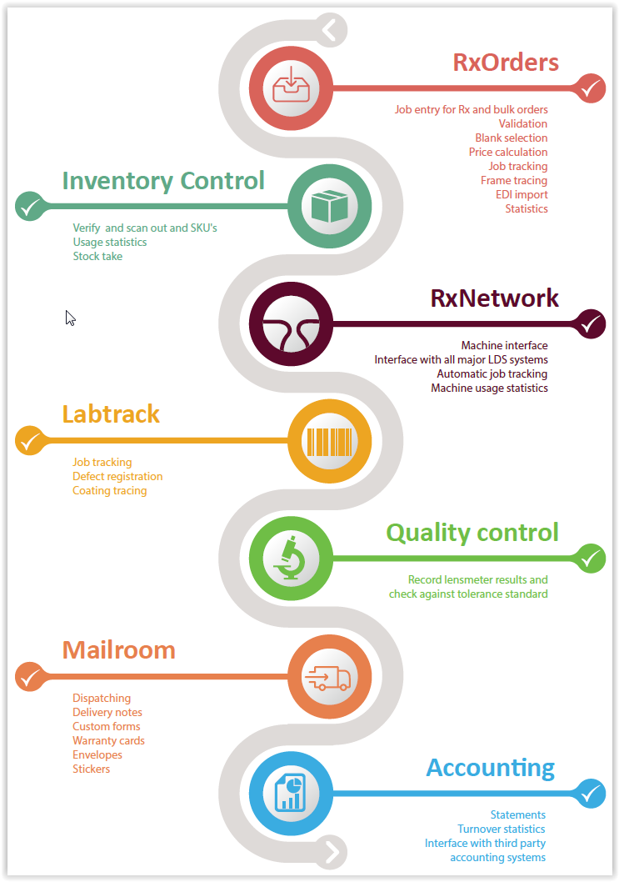

ORDERS MODULE

Generic
There are 2 different order types: RX order, bulk order. They share the same section to enter:
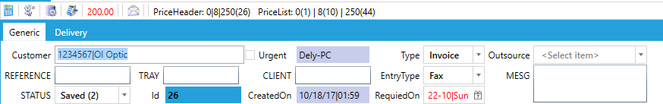

- Customer: The fastest way is to enter the customers code; if you don't know it, press F3 to get a complete filterable list. If the ship-to for this job is differs from the selected customer you can change it in the Delivery tab
- Order Type:
  - Invoice: a regular sale
  - Credit: Issue credit to the customer. The system will prevent any further inventory adjustments and workflow adjustments for the job.
  - Sample: same process as regular sale only at zero price
- Entry Type: fax, phone, internet, walk-in. This entry is for statistical purposes and you may apply discount based on the selection. i.e. online orders.
- Tray Number: track the job through your manufacturing process (Optional).
- Id: system generated internal job number. This number is used to uniquely identify the job throughout the entire process and cannot be changed.
- Reference: number provided by customer. This helps the Lab to keep track of the customers job.
- Client: the end customers name.
- Urgent: When selected, the system will print URGENT on the job ticket, make the job appear on top of the print queue and optionally add an “express charge”
- Outsource: to select a third-party factory. Leave empty to let the system decide (see section 22.2).
- Created date: order entry date
- Required date: calculated by the system based on the production time for the items. It can be overwritten by the user.
- LDS State:
  - LMS Done: the LMS prepared all data for calculation successfully
  - LMS Error: there is an error in preparing the data
  - PRECAL: estimated calculation (precalcs can't be produced on surfacing equipment. An outsourced job is likely to uses a precal and can be processed on edging equipment)
  - LDS done: calculation successful
  - LDS Error: error in calculation

Delivery detail
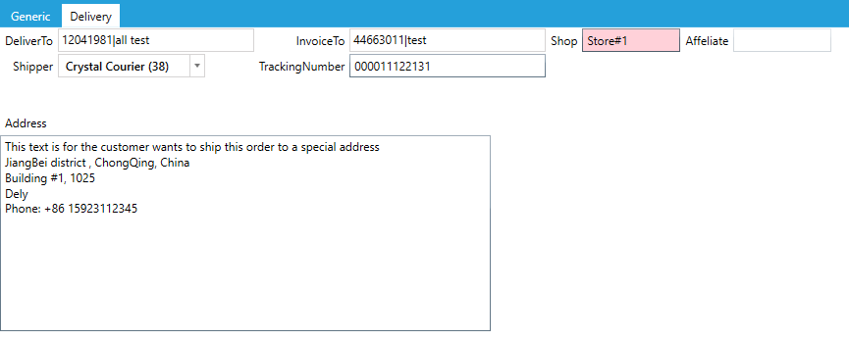
Here is the delivery information of the order. By default, Rxoffice will process the order’s delivery according to the data provided. The user can review and modify the delivery.
- Deliver to: where the order will be send to.
- Invoice to: customer who pays the order.
- Shipper: courier company
- Tracking Number: the couriers internal tracking number. This is provided by the courier.
- Shop: The retail store that the job was ordered from.

Order history
Order status tracking and production status tracking. Click “Show history” button to show all completed procedures of order.
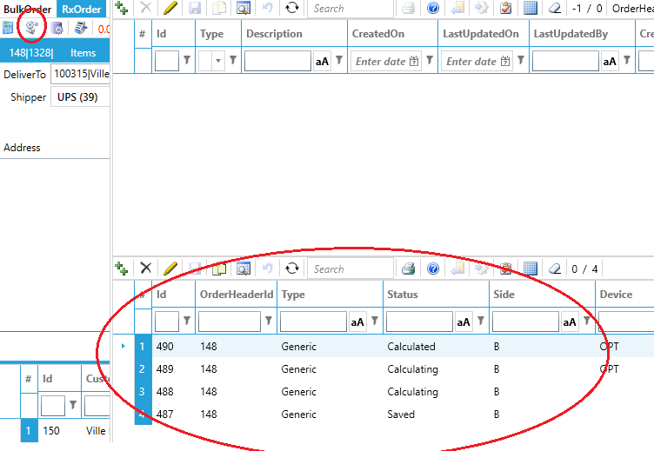
Order comments
Records the important events and information for the order as the job is processed.
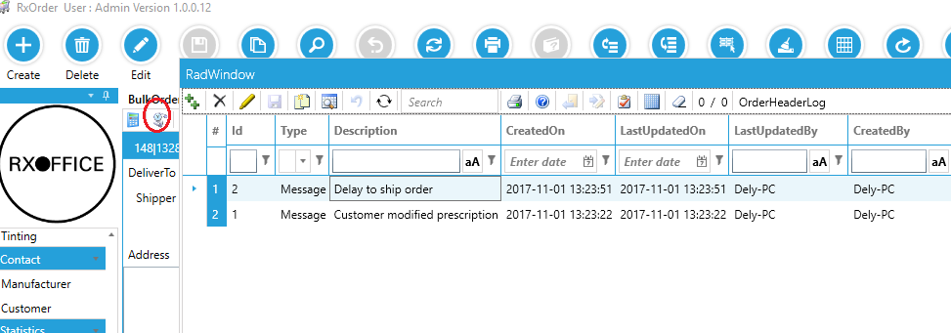

Price calculation
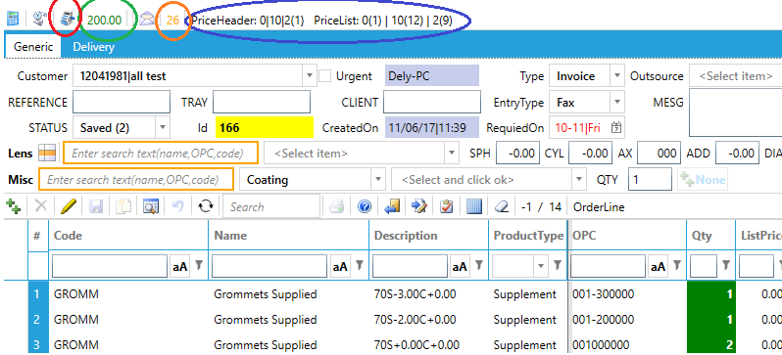
- Click “Calculate Price” button (red marked) to calculate the price of the items on the job. Please note: once the price is recalculated, the retail name is reset.
- Green marked number is total amount of the order.
- Blue marked text is the price setting of the customer
- Orange market text is the original id copied from

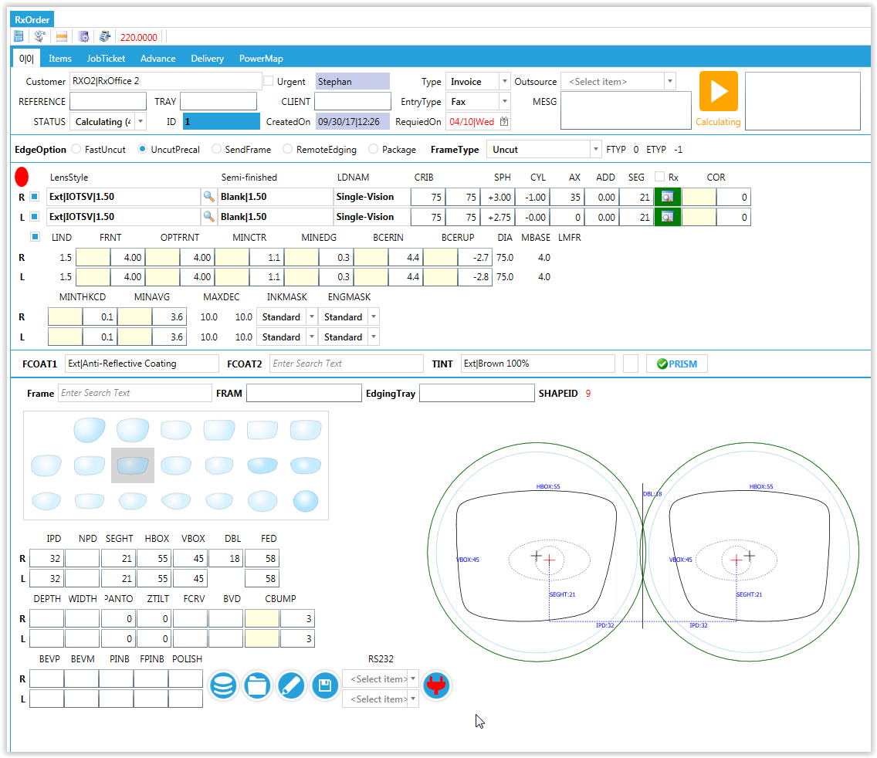
Rx orders

Lens selection
Option 1) enter the lens-code or select the lens from the drop-down list
Option 2) Give focus on the Lens Style box and press F3. The system pops up a list of all available lenses for this customer. Double click any item in this window to make your selection.
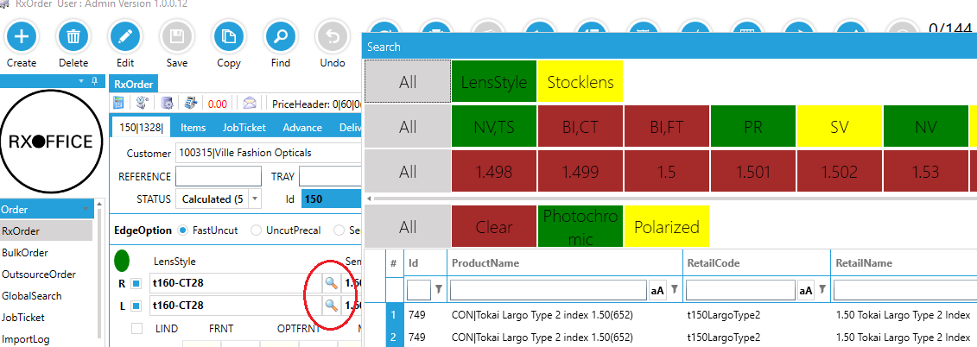
Option 3) Click on the search button. Use the options buttons to narrow down the available lenses. They are shown in the lower grid; double click any item to confirm selection.

Basic prescription parameters
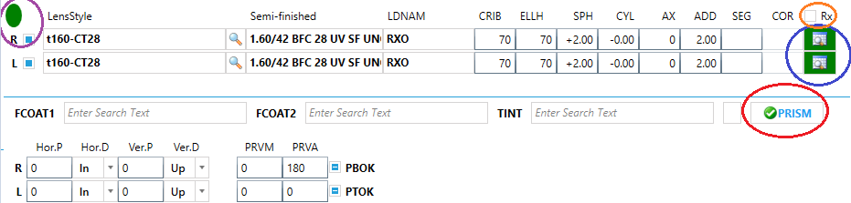

- Lens Style: freeform lens code
- Semi-finished: blank group for select freeform lens
- LDNAM: lens design group for selected freeform lens
- CRIB: finished lens diameter(mm)
- SPH: prescription sphere power(diopter)
- CYL: prescription cylinder power(diopter)
- AX: prescription cylinder axis(degree)
- ADD: prescription addition power(diopter)
- SEG: fitting height (mm)
- COR: corridor length for progressive lens
- Rx: force to current order as Rx order even if a stock lens is available for the customer’s prescription.
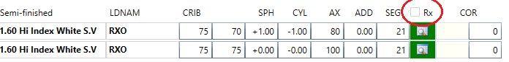
- Blank selection status
  - Green: selected
  - Red: program failed to select blank
- FCOAT1: primary coating
- FCOAT2: secondary coating
- TINT: factory applied tint. Note: to define a custom tint, click the small button next to the box

Blank selection
Blank selection is done automatically on saving the order. If you want to select a blank manually, click the “Search” button and double-click the blank you want to use. Press the button (Blue marked) to get all available blanks for current prescription, double click any item in the list to confirm selection.
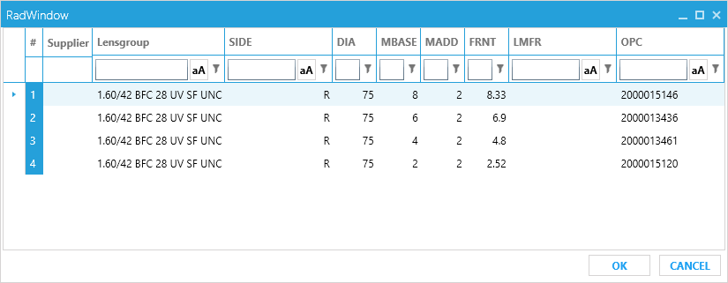
- MBASE: nominal base curve of the blank
- MADD: embedded addition power of the blank
- FRNT: real base curve of the blank
- LMFR: the manufacturer of the blank
- OPC: unique product code (SKU)

Office prescription entry
For office lens, the user can enter the prescription according to the near- or far vision prescription.

Near vision prescription entry
When the selected lens style or design is for office lens (Optimized reading lens), The “RxEntry” column will be the type of ‘Near’.
For near prescription format:
- NSPH: near vision sphere
- NCYL: near vision cylinder
- DEG: the degression power
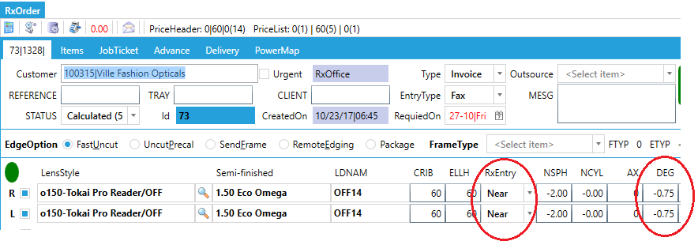

Far vision prescription entry
For far prescription entry, there is a FWD (far working distance), which means the working distance for a far object. Normally it is the distance for user to look at a computer monitor, tablet or white board.
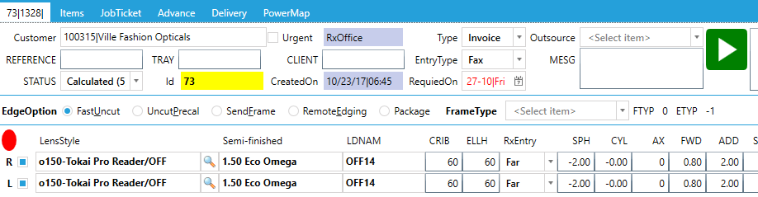

User defined parameters
Check the “Show advanced parameters” box (Circled in red below) to override the system default values. Enter the value you want to override in the yellow box. For example, the minimum edge thickness is determined by the system based on lens material, frame type and power. If you want to override the value, you enter the value in the yellow box. For the calculations, the system will use the user defined values; if not entered it defaults back to the systems values.
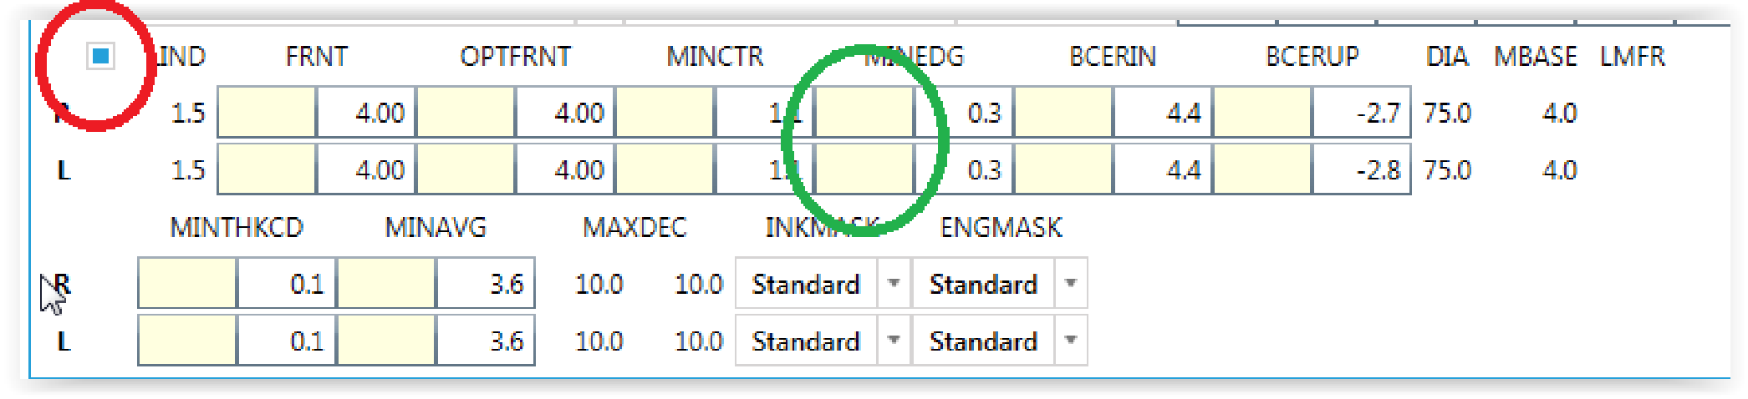
- LIND: refractive index of material
- FRNT: real base curve (diopter)
- OPTFRNT: optimum/suggested front curve (diopter)
- MINCTR: minimum center thickness (mm)
- MINEDG: minimum edge thickness (mm)
- BCERIN: horizontal optical decentration (mm)
- BCERUP: vertical optical decentration (mm)
- DIA: selected blank diameter (mm)
- MBASE: selected blank base curve (diopter)
- LMFR: blank manufacturer
- MINTHKCD: minimum edge thickness at crib shape(mm)
- MINAVG: minimum average thickness (mm). (CTHICK + THNP) / 2 must be greater than or equal to MINAVG.
- MAXDEC: maximum decentration limit (mm)
- INKMASK: ink mark identifier
- ENGMASK: laser mark identifier

Measure front curve
To convert sagittal height or radius of curvature to diopters, click the button next to the FRNT. Enter the measured value and click the Convert button next to it.
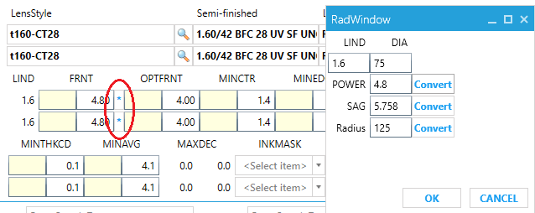
- LIND: refractive index of the order
- DIA: blank diameter (mm)
- SAG: sagittal height (mm)
- POWER: front curve (diopter)
- Radius: the radius of surface curvature (mm)
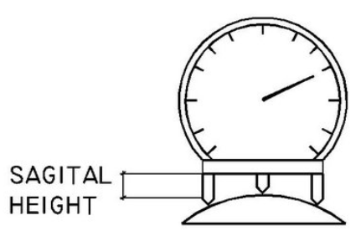

Prism
Click “Prism” button to enable prism entry. Either enter as compounding- (horizontal/vertical) or resultant prism. Horizontal/Vertical prism will convert to resultant prism as typing.
- PBOK enables blocking prism
- PTOK enables prism thinning
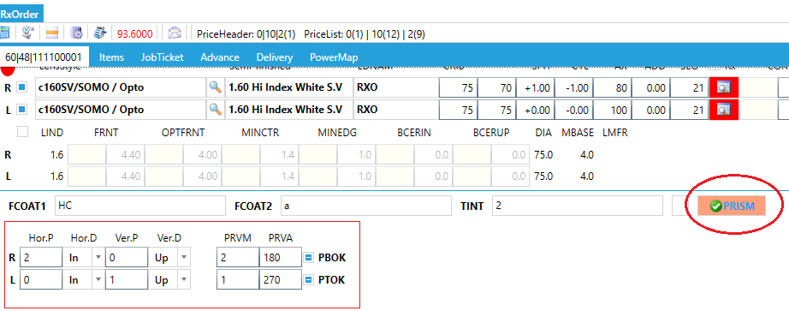

Fitting parameters
Note: when you provide a frame shape (any option other than “Fast uncut”), do not manually enter the CRIB/ELLH. The system will automatically calculate the best ellipse to optimize center thickness. Also, best horizontal and vertical offset in respect to the frame shape center is automatically calculated to minimize final ellipse size.

Edging Options
- Fast uncut: lens without applying any frame parameter information
- Fast Uncut: enter round and optionally elliptical dimension
- Uncut Precal: select one of the predefined shapes
- Send frame: customer will send in the frame for edging. Select a predefined shape and estimated box information. Now you can produce the lens and attach the trace when the frame actually arrives at the lab.
- Remote edging: the edging will be done at the lab. If the customer did not send the trace electronically, you can trace the frame now.
- Package: select the frame from your frame repository

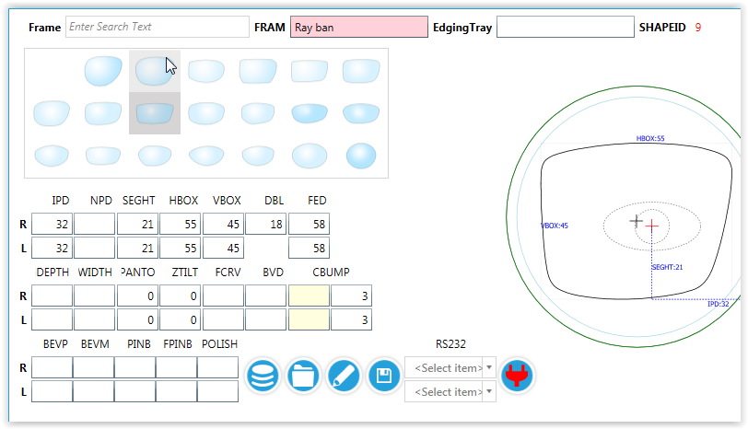
Fitting parameter dictionary
- Frame: frame for the order
- FRAM: frame name, comes from trace data FRAM
- Edging Tray: Identifier of edging tray box
- SHAPED ID: predefined shape Id
- IPD: Monocular decentration distance (mm)
- NPD: Monocular near decentration distance (mm).
- SEGHT: Layout Reference Point height measured from the LRP center to the lower horizontal element of a box circumscribing the shape.
- HBOX: Horizontal boxed lens size of frame (mm).
- VBOX: Vertical boxed lens size of frame (mm).
- DBL: Distance between lenses (mm).
- FED: Frame Effective Diameter (twice the longest radius from box center to edge of shape) (mm).
- GDEPTH: Groove depth in mm when ETYP = 3
- GWIDTH: Groove width in mm when ETYP = 3.
- PANTO: Pantoscopic angle (degrees).
- ZTILT: Side-to-side or horizontal tilt of frame as traced (degrees)..
- BVD: Back vertex distance, as worn (mm).
- CBUMP: Required minimum excess material for edging used in computing crib diameter in mm; may be conveyed to LDS (mm).
- BEVP: Bevel position
  - 0 – Manual
  - 1 – Follow front (BEVM = mm from front)
  - 2 – Percent back (BEVM = % from front)
  - 3 – Frame curve (BEVC = curve to follow, BEVM = mm from front)
  - 50/50
  - Follow back (BEVM = mm from back)
  - 6, 8, 9 - Unused
  - Automatic (Use edger settings) (If HICRV=1, use BEVH, BTILT, TILTBASE records)
  - 10 - Free float
- BEVM: Bevel modifier. Percentage or distance in mm based on value of BEVP. Percentage should be expressed as a number between 0 and 100
- PINB: Edger back pin bevel width in mm measured along cut surface of lens (0= no pin bevel).
- FPINB: Edger front pin bevel width in mm measured along cut part of lens.
- POLISH: Polishing mode.
    - 0 = no polish,
    - 1 = polish edge and pin bevels.
    - 2 = polish pin bevels only.
    - 3 = polish edge only.
    - +128 indicates high luster.

User defined edging type

You can define available combinations of frame-and edge type. It is not limited to the standard VCA types; custom types for e.g. the MEI are supported. Other settings based on user defined edging type are “Thickness setting”, “edging production control” and glazing price setting.

Predefined shapes and Lab own shape
Rxoffice offers some predefined shapes, in this case HBOX, VBOX, DBL are required to scale the shape for fitting. By default, Rxoffice will apply predefined shape to order when shape data is absent and the edging type is “Uncut Precal”.
The default Shape is defined by config(“RxOrder_DefaultShape”) when no predefined shape is selected. RxOffice allows the lab to define its own predefined shape for “Uncut Precal”:
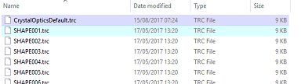
- Put the Lab shape’s VCA file to “%Rxoffice root folder%”/Shape folder, normally it is “C:/Program files/Rx.Mysql/Shape” folder, in this example, it is “CrystalOpticsDefault.trc”(extension .vca or .trc)

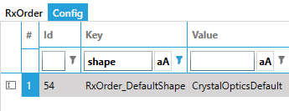
- Change “Config” -> “RxOrder_DefaultShape” to #1 shape file.
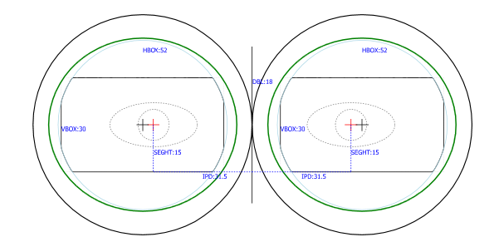
Note: if the order’s shape Id is 0 or file doesn’t exist, RxOffice will generate rectangle shape with HBOX, VBOX, FED

Trace data Repository
- Select Shape from RxOffice data storage, Click “Trace Repository” button
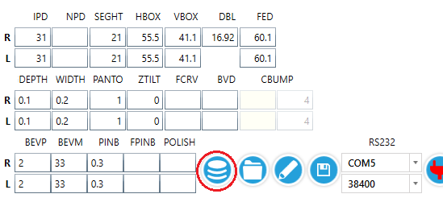
- Select the shape, then double click(click “ok” button) to apply

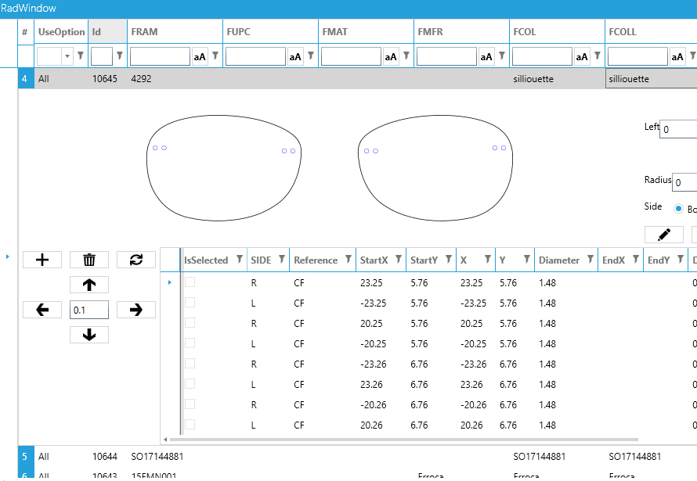
Load Trace data from file
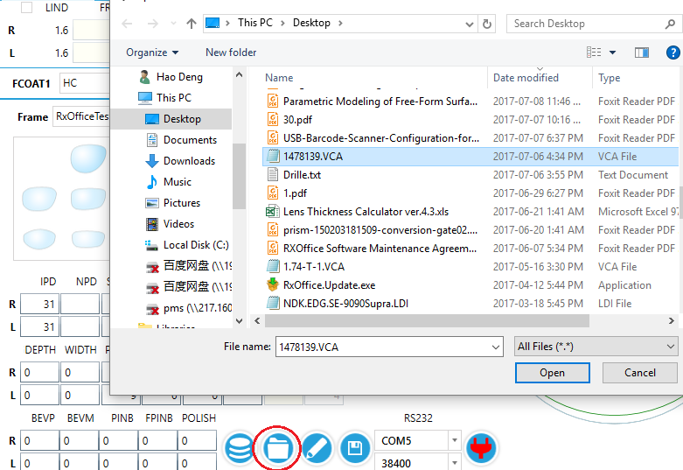

Save trace data
Save the current order’s shape to the database.
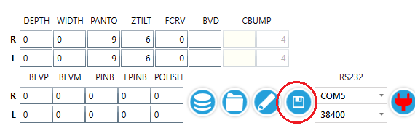

Tracer Connection
When a tracer is connected to computer, set the proper COM port and baud rate then click “Connect” button, RxOffice will try to set up connection with tracer. If the color of the “Connect” button changes from “Red” to “Green”, the connection is established successfully.
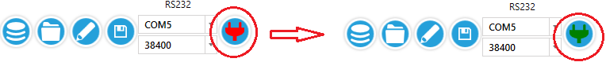
Predefined tracer setting:
Each PC might have different serial port setting. RxOffice supports to predefine that. In “Machine” screen, the user can add machine

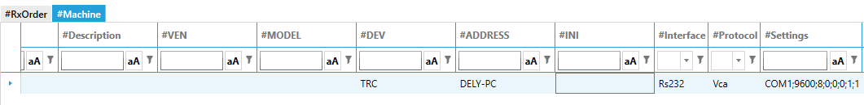
- DEV: device type, “TRC”
- ADDRESS: Operator’s computer name
- INTERFACE: communication option, “Rs232”
- Settings: serial port setting, sample data: COM1;9600;8;0;0;0;1;1

“Settings” stores the text for serial port settings, each setting can be parsed with “,” delimiter.
- First field: Port name
- Second field: Baud Rate
- Third field: Data bits, None = 0, One = 1, Two = 2, OnePointFive = 3
- Forth field: parity, None = 0, Odd = 1, Even = 2, Mark = 3, Space = 4
- Fifth field: handshake, None = 0, XOnXOff = 1, RequestToSend = 2, RequestToSendXOnXOff = 3
- Sixth field: DtrEnable, 0=false, 1=true
- Seven field: RtsEnable, 0=false, 1=true

Additional Supplements
The proper supplements (add-on charges) are appended to the order automatically, for example, High SPH/CYL charge, Decentration charge, Glazing charge, Prism charge etc. The supplement products have to be set up properly. Refer to Product section->Supplement.

Add other products
The user can add other products to order in “Items” table:
- select the product type
- select the product
- enter the order quantity
- press “add” button
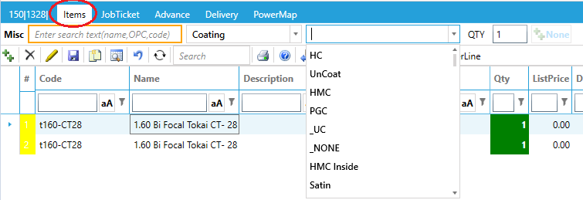

Save order and calculation
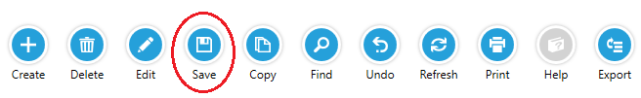
- Click 'SAVE' after all of the detail is entered.

Click the calculation button (red marked) to calculate the current job.
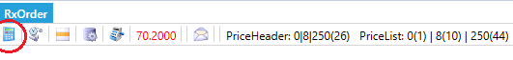
- During calculating, the arrow is orange. Once it becomes green, the calculation is done. Note: you don't have to wait for the calculation to be finished.
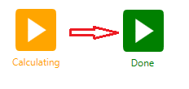
- the order is ready for production once the calculation is finished successfully.

JOB preview
The JOB preview on the jobticket provides intuitive presentation of semi-finished blank, frame, finished lens, human eye and relative position. Moreover, it is useful for quality checking when drawing size is 1:1 as physical size.
- Blank circle: the diameter of semi-finished blank.
- Green circle: the diameter of finished lens.
- Blank cross: the center of frame
- Red cross: Layout reference point of lens
- Upper orange arc: Far vision reference point of progressive lens
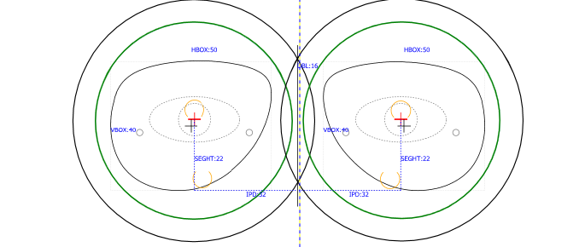
- Lower orange arc: Near vision reference point of progressive lens

Print Jobticket
Click 'PRINT' or double click ‘Jobticket screen’ for print out the Jobticket
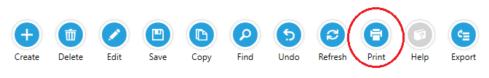
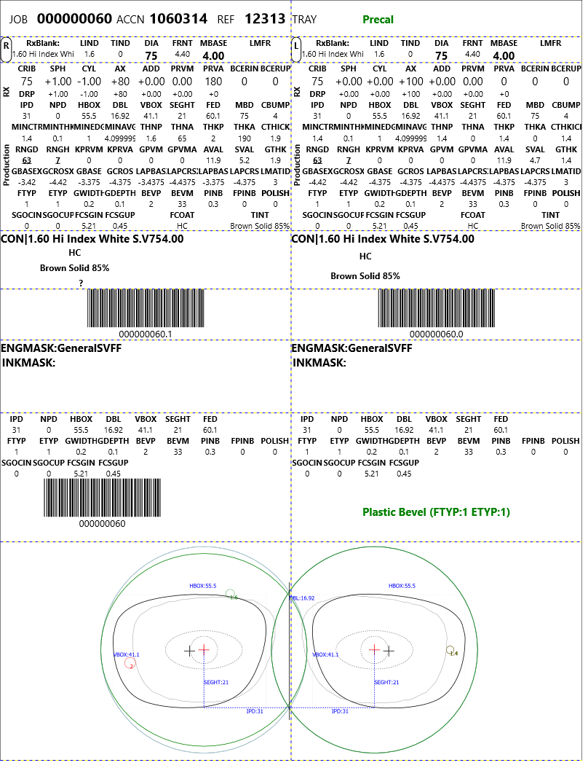
Standard Jobticket template
Order items and price calculation
On the Price tab you can see the pricing and optionally add additional charges. Click “PriceCalculation” button (), price of each order item will be re-calculated, normally customer service can answer the customer’s quotation request before order saving. There is order amount(red font) on the toolbar

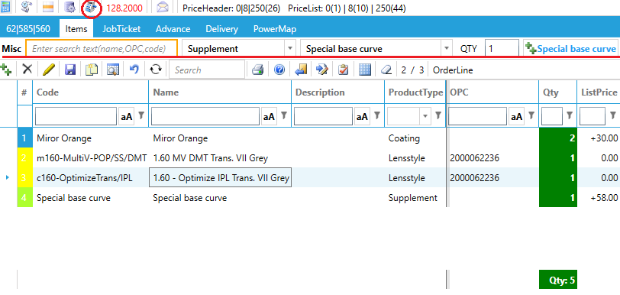
Manufacturing parameters
In the Configuration, there are several parameters to control your Rx manufacturing process
Name | Description | Default
RxOrder_SameBlankDiamter | Use the same blank diameter (larger) for both sides. If one side requires a 65mm blank and the other 70mm, the system will use the 70 mm on both sides. | false
RxOrder_Equalize_Crib | Make the CRIB same for right and left. If one side requires a minimum CRIB of 63mm and the other 64 mm, the system will make both 64mm | 0
RxOrder_SameBaseCurveForRxOrder | Use the same base curve for both sides. For plus lenses, use the steeper and for minus the flatter curve. | false
RxOrder_PTOK_Minus | Minus lenses use prism thinning | false
RxOrder_ToolPadThickness | Thickness of the polishing pad | 0.1mm
RxOrder_FrameBaseCurveMatching | Math the lens base curve to the frame curvature | false
RxOrder_BlockingTapeThk | Blocking tape thickness (mm). This compensation is applied to SVAL. | 0.2mm
RxOrder_BlockingSafetyMargin | Block ring safety margin (mm) | 1
RxOrder_BlockingSafetyHeight | Minimum alloy (mm) | 0
RxOrder_OvalSetting | Make plus lens oval:  0: never  1: always  2: conditionally | 2
RxOrder_OvalSetting_Polarized | Make polarized lenses always round. | false
RxOrder_OvalSetting_Tint | Make tinted lenses always round. | false

Bulk order (stock anything)
Orders which do not require any additional services like surfacing, coating or edging can be entered in the bulk order screen. Unlike the Rx order screen, the number of different lenses in this type of order is unlimited e.g. you can add as many (different) items as you want. To make the entry for stock and rx blanks more convenient, you can use a matrix. The client could add their own matrix for items such as: Chemistrie parts for inventory re-orders.

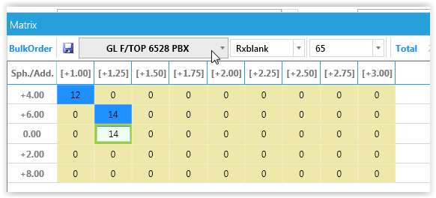
Select the lens, diameter and, optionally for multifocal, a side. Enter the quantity in the grid and click the Save button; the items are now added to the order.
If you only have one or two items, it may be faster simply adding line by line.
- enter the product
- enter the powers
- enter the quantity
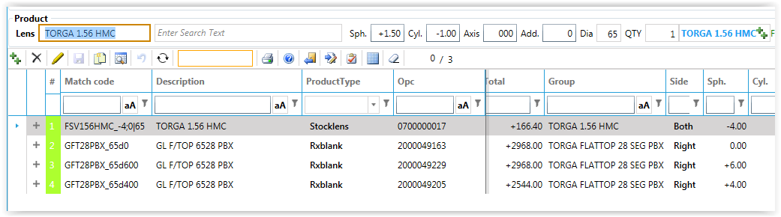
- click the + button to add the item to the order

Product order
Enter the name of the product or it's (barcode. If valid the system will show the product in the blue area. You can either enter the final quantity or press the + button multiple times. To remove an item from the list, click the Delete button on the toolbar. To add an item which does not exist in the database, click the + button on the toolbar.
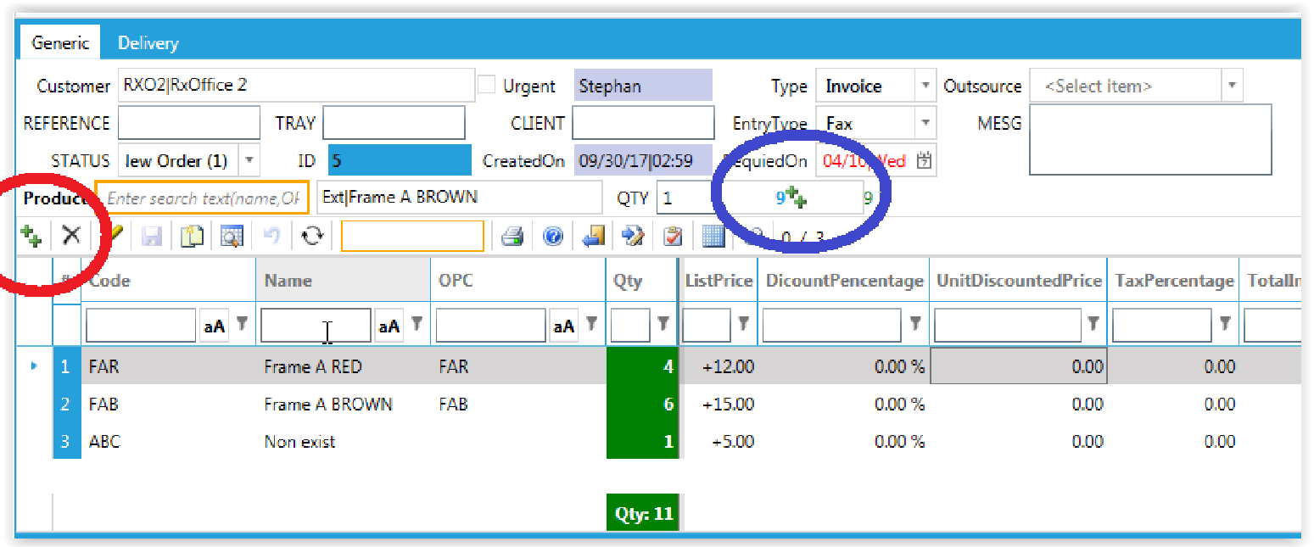

Import
For fast order creation you can import an excel file in the following format:
column A: SKU
column B: quantity

Bulk job ticket print
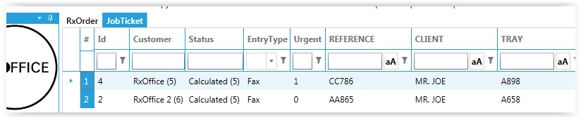
Open the “Jobticket” screen from the navigation panel. All jobs ready to be printed are listed, urgent ones on top. Select the items you want to print and click the Print button. The jobs are printed and removed from the list.

Finding a job
From the toolbar, click the “Search” icon to enter the search parameters and click ok. The search mechanism uses a case insensitive “contains” filter. So if you enter ABC in the Reference, the system will list all orders starting with Reference ABC.
A quick way to show all orders for the current active customer is the icon “Show last month orders” icon

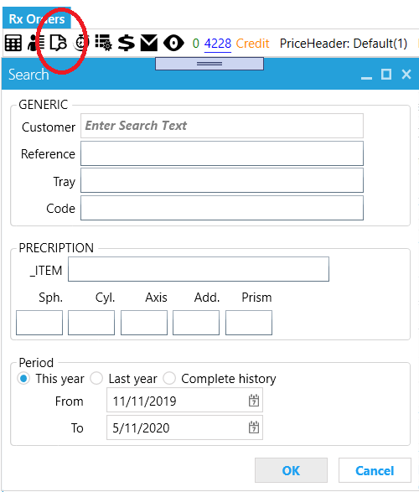
Credit Order
You may issue a credit invoice if a customer asks for a refund or if you decide to give a customer a credit for any reason (ERP version only). When you issue a credit invoice, the software uses the information from the credit invoice to update your clients’ account, alter your accounts receivables and adjust your sales tax records accordingly.
Click the + button to create an order as usual. When you select Type “Credit”, the credit window pops up. Enter the reference or order Id or tray number you want to credit. Choose the reason (you can define them in the return reasons screen) why the order is credited and choose how much you want to refund (percentage or absolute amount). Optionally you can add customer-and or staff comments.
There are several return options:
Return: return items to stock. This option creates a new order with invoice type equal to Credit
Replace: This option creates a new order with invoice type equal to Invoice and will be handled as a regular invoice. How the new price is calculated depends on the “Refund type” and “Approved parameter”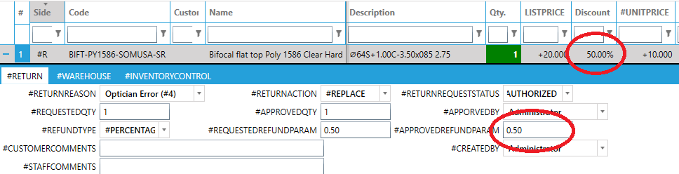
Repair: for statistic purpose only
Credit: this option creates a new order with invoice type equal to Credit. By default the items are not returned to stock
To view the return, you can click each lines detail.
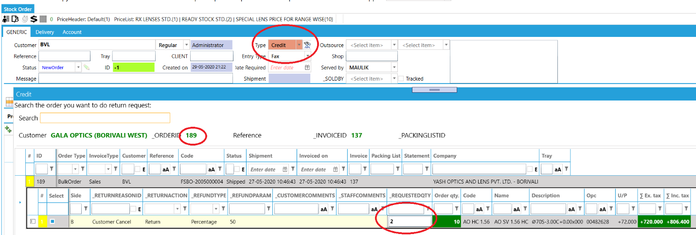
In case you have a line with a quantity for example 10 and you want to credit 2 items and return 3, you can create the “credit” like above and then copy the order line
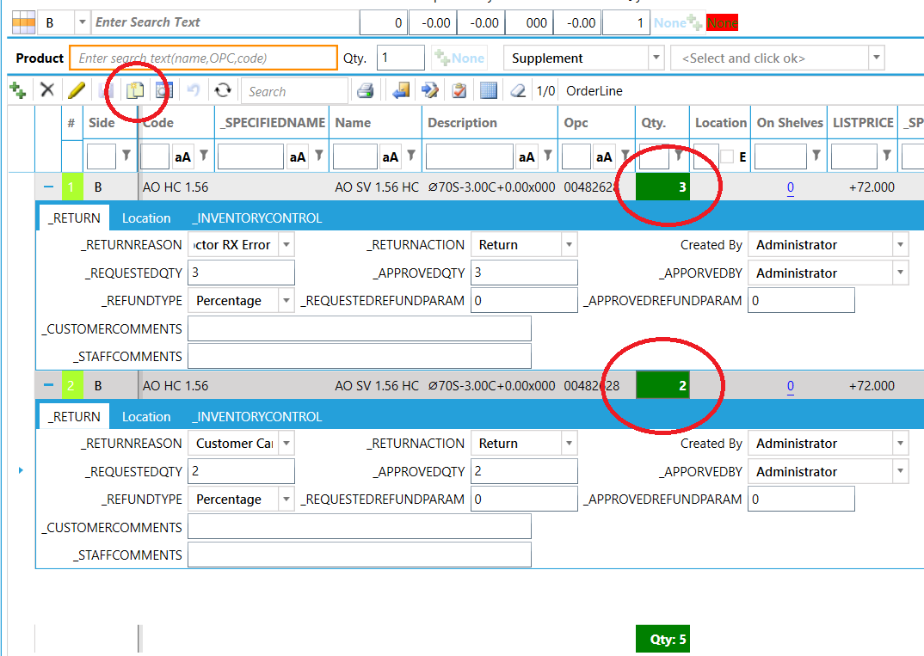

Products
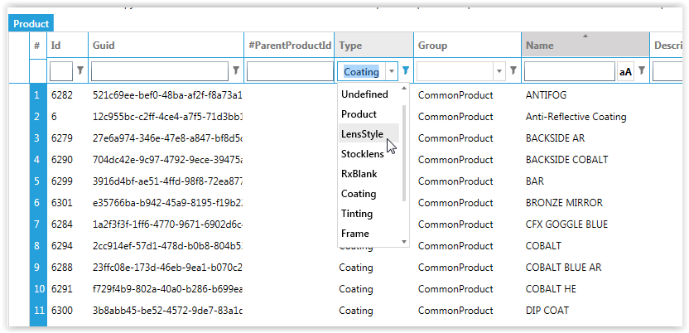
The system allows defining any type of product. Depending on the type of product you would either use the lens, frame or product screen.

Frame
You can build a repository of frames
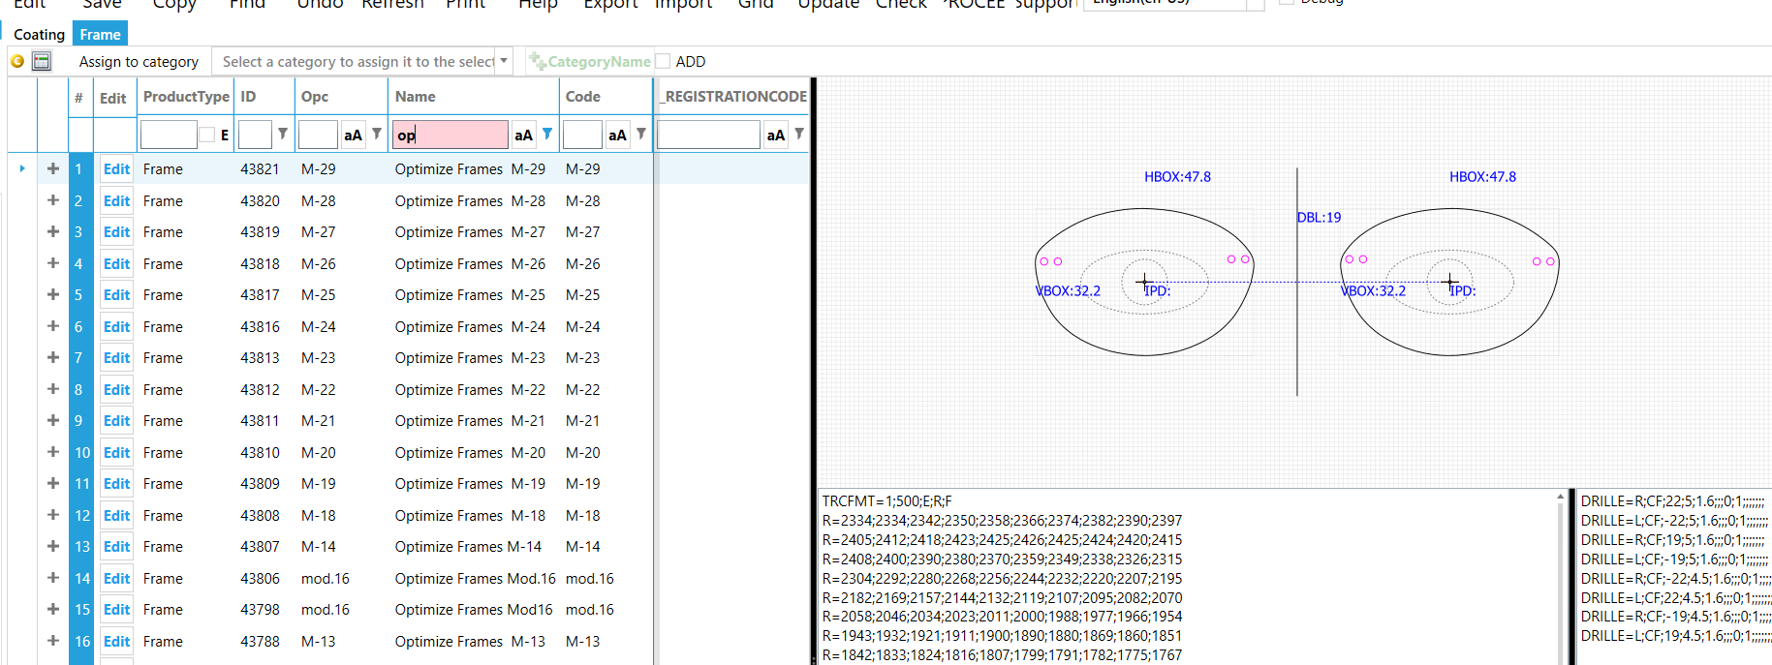
If you have a trace repository (for example you received the trace data from your supplier) and want to sell the physical frames for these traces, you must create a frame entry (i.e. a product) first. On the ROE, frames are shown by manufacturer and collection. To easily assign these properties (before converting them to frames), right click the traces and select “Set collection” or “Set Manufacturer” (note the manufacturer is something else then the supplier; anyone can supply a Ray ban, but the manufacturer still is Ray ban).
Right-click the traces to be converted to a frame product and select “Create frame”. The system will create the frame items. FUPC is assigned to the product’s OPC and FRAM to the products name.
Before the frame can actually be sold, the system requires a price entry. The system prompts if you want to create it (note: like any product you can create a price at any time by right click the item and select “Create price” at a later stage).
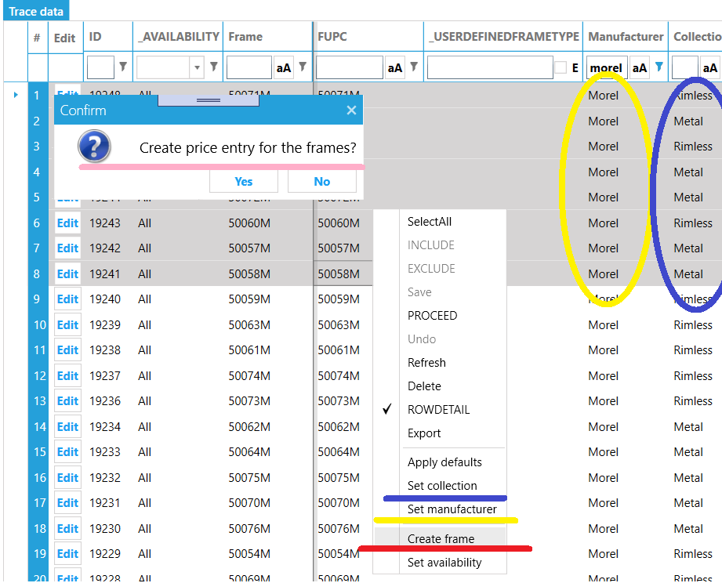

If have pictures for the frames, they MUST have format xxxxx.png, xxxxx.jpg or xxxxx.jpeg where xxxxx is the OPC. To show them in the ROE, upload them to yyyyyy\MyImages\Products where yyyyyyy is the folder on your internet server. After you uploaded type enter “htttp(s)://your_url/Orders/Maintenance/ConvertImages” in the browser address bar. This will convert the images to the correct size and extension.

Coating
The different types of coating are defined in the coatings screen. Optionally you can enter the processes the coating includes.
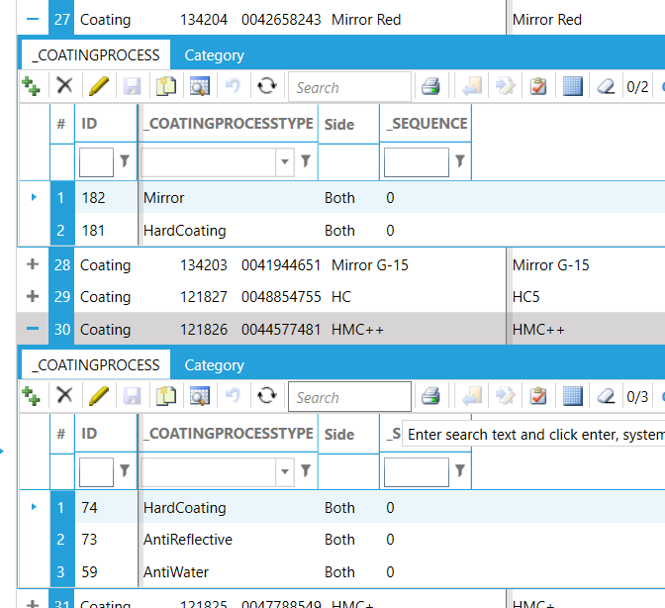
Some coatings restrict the tints that can be applied to the lens. To define this restriction, you must create a “group” of tints, and then assign this group to the coating’s tint group. In the example below, if the user selects a Mirror G-15 coating, the
- available tint options are restricted to tints defined in the “Color for mirror” group and
- the system will default the tint to “Grey solid”
- the secondary coating will default to “Back HMC” (which is another coating defined this screen)
To enable specific coatings only available for specific lenses, you have to create a group (right click the coatings you want in the group and select “Add to group”) and then assign that group to the “lens style”

Tint
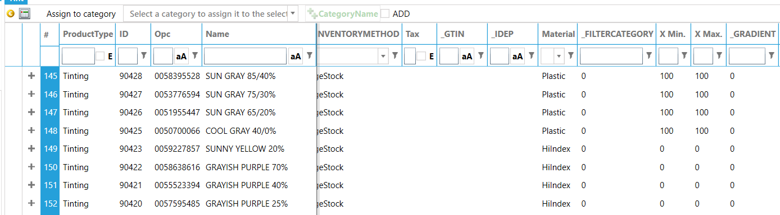

Supplement
Additional charges like “high prism”, “high cylinder” etc. can be defined in the supplements screen. The system will automatically add the charge to the order according to the criteria defined. For example, defining a high prism is very straight forward; enter the “from” and “to” values for the prism and system will check prescription if value is in this raange and if yes, add the supplements. Defining a glazing charge can be more complex. You can add more criteria in the details screen. For example you can set a frametype, lens type etc. to limit the scenario this supplement will be added. A common scenario is a separate glazing charge for rimless- and full frame. But you could split it more into single vision rimmless and multifocal rimmless (or even into mor detail)
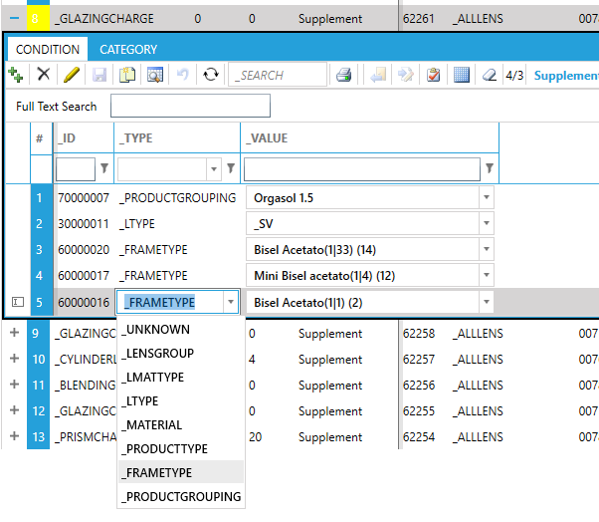

Miscellaneous products
Physical items like cleaning cloth, nose-pads, tracer etc. are entered in the products screen.

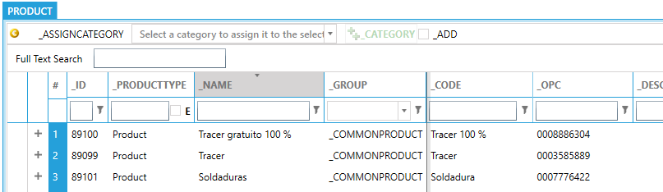

Product groups
The product groups allow you to create a subset of products. It is a very powerful feature to limit the possible combinations of lens and additional processes. For example, you defined 10 different coatings in the system, but for a specific lens you want to allow only 5. Create a “product group” for the 5 coatings and assign this product group to the lens (see section 14.1).

How to create combinations
There are two ways to create combinations:
- in the “Product groups” screen select the product you want to include in the group and

click the “Add” button;
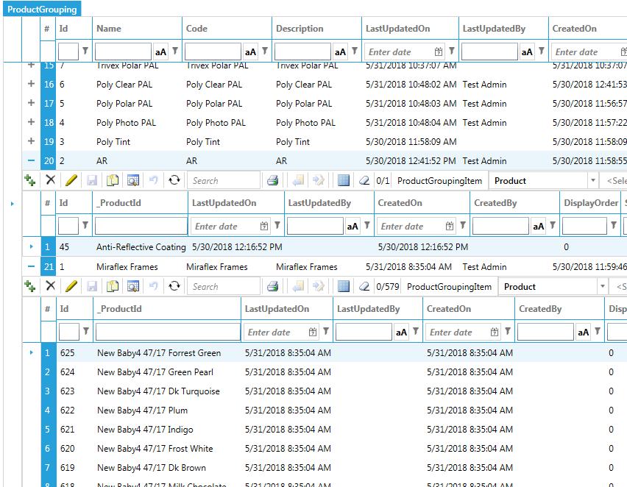
- Select the products you want to add to a group and right-click. Select the “Add to group” menu item. You will be prompted for the name of the combination to add them. If the name does not exist yet, the system will create the combination. If the combination exists, the selected items are appended (note: duplicates are automatically prevented)
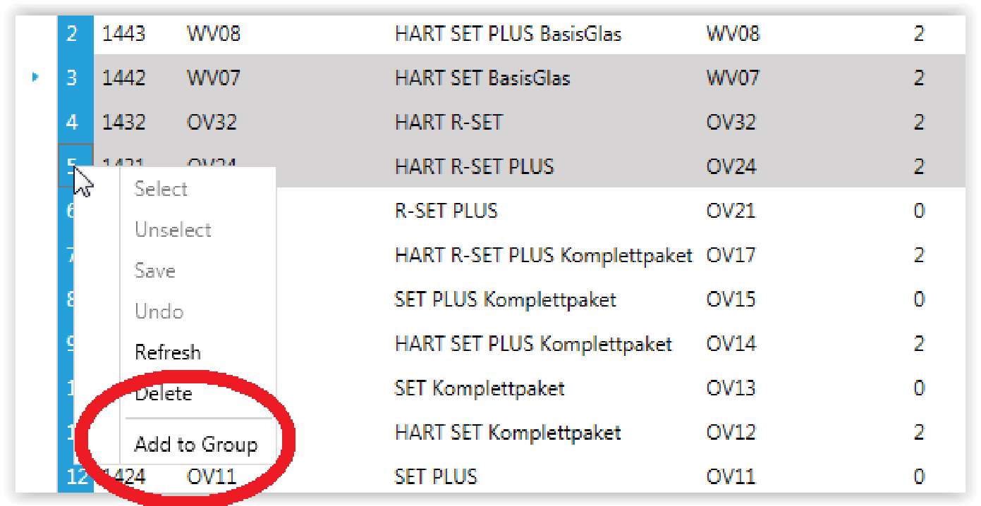

How to use combinations
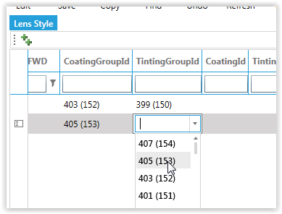
In the Lens Style screen, you can assign the combinations to the lens to limit the availability. Technically there you can define coatings and tints in the same group, but for easy data maintenance it is advised to separate it and give the group a meaningful name.
In the Lens pricing you can also assign a combination. In the lens pricing the processes in the combinations are free of charge (so usually the assigned combinations are a subset of the available processes. i.e. if you would assign the same group in the Lens styles as in lens pricing, all items would be free of charge.

Inventory Management
Inventory management is a system of stock level controlling. In the system it consists of setting up the Inventory and tracking low stocks.
Some products may not require inventory tracking. For example, services, coatings or tints. In this case, you can opt for no tracking, by choosing Do not manage stock option in the Inventory method field.
Each product (Stock keeping Unit SKU) can be set to:
- Stock Verify: use the inventory control module (chapter 12) to deduct items from stock
- Stock Instantly: deduct the items from stock at the moment you save the order
- Stock instantly and ignore stock level: same as previous only suppress low on stock warnings (so if customer orders 10, but system only has 6, the system will virtually increase the stock to 10 and then deduct 10 as if they were present)
- Outsource: send the order to another factory.
You can manage inventory per warehouse. Each location has its own quantity on hand
On hand is the total stock quantity on hand. It is reduced every time when an order is processed in the inventory control module.
Reserved quantity is product quantity that is ordered but not processed in the inventory control module yet.
On order quantity is product quantity that is ordered from the supplier but not arrived yet.
Safety stock is an additional quantity of an item held in the inventory to reduce the risk that the item will be out of stock. It acts as a buffer stock in case sales are greater than planned and/or the supplier is unable to deliver the additional units at the expected time.
Your safety stock and reorder point help you determine how low your stock can get before you need to order more. If you don’t reorder when you reach your reorder point, you’re likely to run out of stock. Safety stock contributes to your reorder point by accounting for things like: delays in shipping, sudden increases in demand, and inventory loss due to damage or theft (also called “shrink”).

Lead time is the delay between the time the reorder point (inventory level which initiates an order) is reached and renewed availability.
Lead-time demand is the amount of demand (in units sold) that builds up before your next purchase order comes in to replenish your stock. We’re calculating lead-time demand based on delivery lead time * average daily unit sales.

The delivery lead time is the average time in days that it takes for new stock to arrive after submitting an order. As a more concrete example, if you order a lens on Monday and the shipment arrives on Friday, then the lead time is four days.

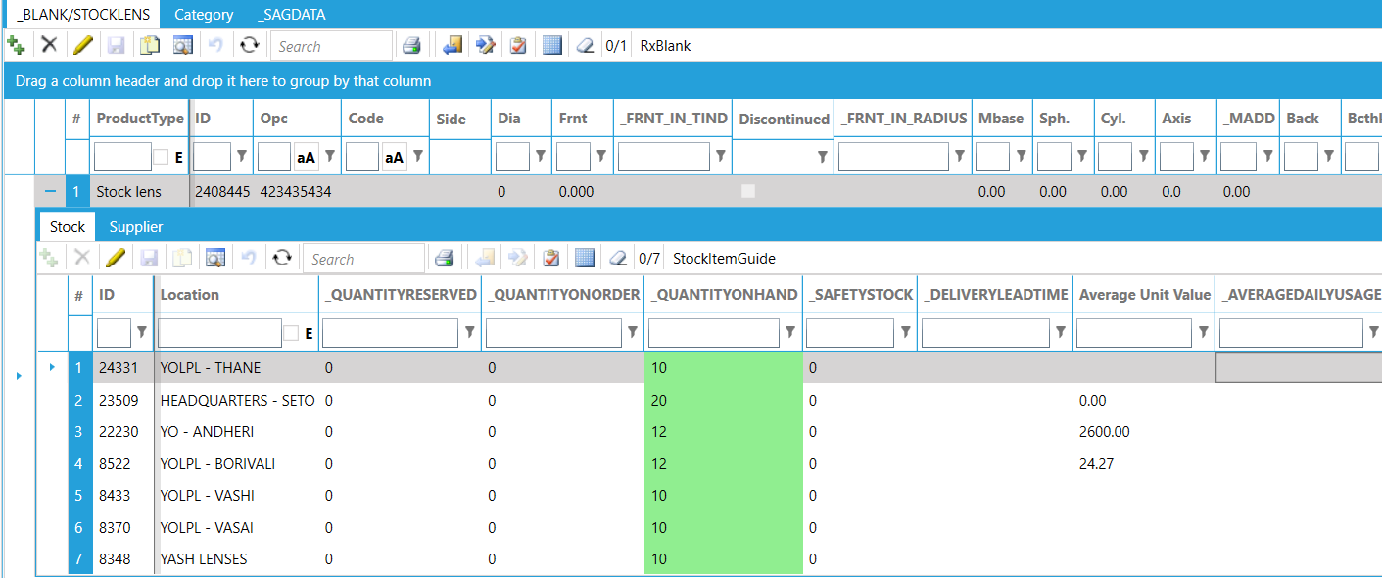
Lot and serial numbers
A lot number is an identification number assigned to a particular quantity or lot of material from a single manufacturer. Lot numbers can typically be found on the outside of packaging.

How to set inventory properties
Fastest way to set the delivery time or set the product to discontinued or the Delivery time, is to right click the item and do it from the context menu.
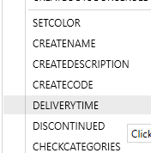
For lenses, it is easier to set individual properties in a matrix format instead of line by line. On the toolbar for stock- and semi finished lenses, click the matrix icon (or the line icon if you prefer line by line). In the pop-up window, select the lens you wan to edit. If the powers don’t overlap in diameter you can click “Load”; otherwise select the diameter first. This loads the current values into the gid. You can edit them in the grid directly, or Export/Import into Excel. When done, click the “Save” button to commit your changes to the database.
Note; if you choose “Stock quantity” in the dropdown, the system will not set the stock quantity directly but create a stock take entry.
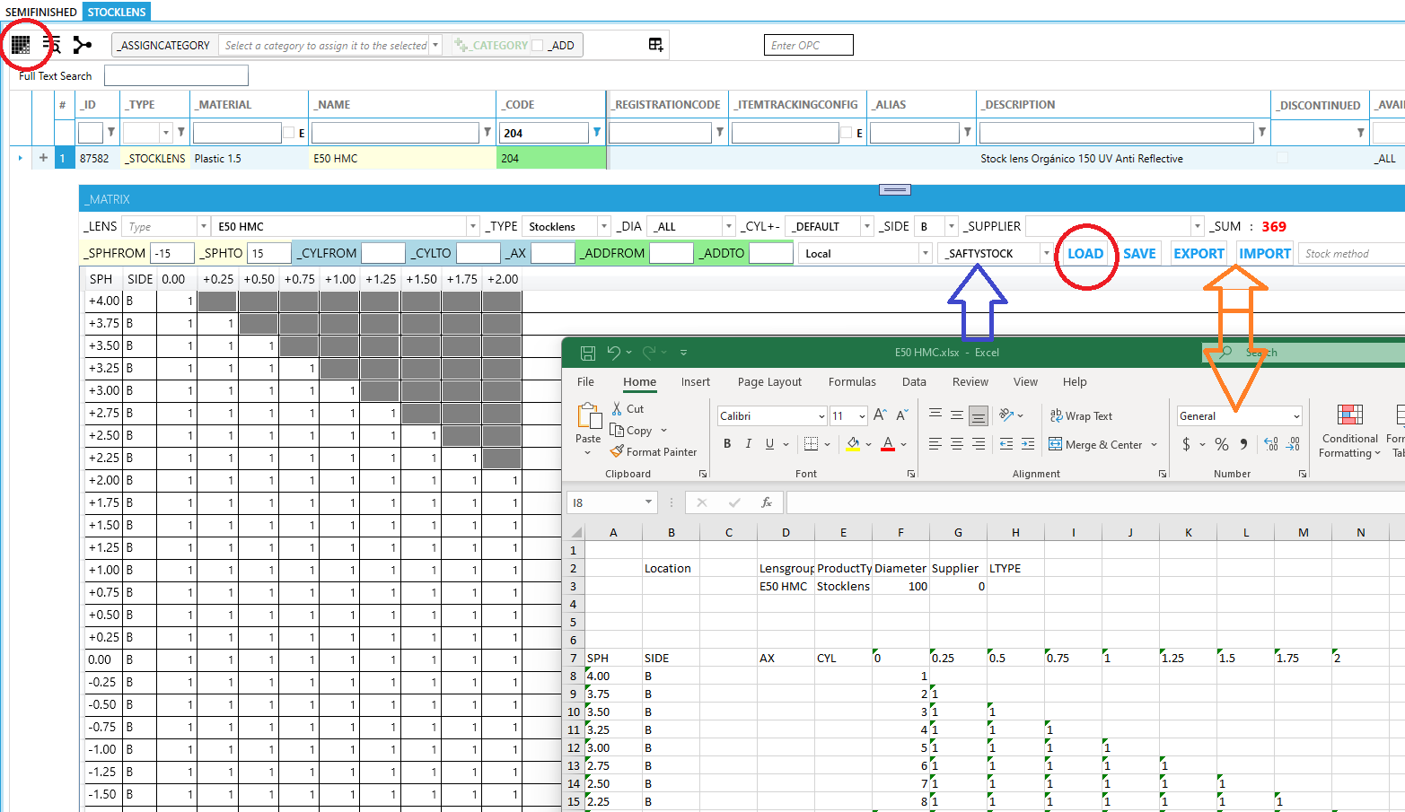

FORECASTING DEMAND
We’re simplifying this to average daily unit sales during a user defined period, to provide a general average demand for that product. The period is user defined so you can match overall sales seasons to better suit your product’s demand.

Calculating average daily unit sales is the total unit sales of a product in a period, divided by the number of days in that timeframe. So if lens XXXX sold 180 pieces over the past 90 days, then that’s an average of 2 XXXX units sold per day.

Our recommendation is to initially set safety stock at 50 percent of the lead-time demand; if you’re still running out of stock or reordering too often, you can increase that to 60 or 70 percent. If you’re regularly overstocked, you can lower safety stock to 30 or 40 percent of lead-time demand.
Given lead-time demand of 8 units, the safety stock for lens XXXXX would be 4 units (50% of 8 units).
Finally, since our reorder point formula is lead-time demand (8 units) + safety stock (4 units), this leaves us with a reorder point of 12 units for the XXXX lens. That safety stock of 4 units helps to safeguard against completely running out of stock in the event of the glasses arriving broken, or a shipment running a little late. This isn’t a catch-all formula for ensuring you’ll never run out of stock, but it should help to keep from running out of stock the majority of the time.

Category
To organize the products to easy search and statistical purposes, you can define categories and assign them to the products.
For the remote order entry, the categories will display in a hierarchal tree. As a rule, the “root” category may not have a parent category. In the example below, Cat 1 and Cat 2 don’t have a parent category. Cat 1 is the parent for Cat1-1 and Cat1-2
Cat1
Cat1-1
Cat1A
Product X
Product …
Cat1B
Product Z
Product …
Cat1-2
Product Q
Product …
Cat2
Product B
Product …
Following is not supported; a category may not have sub categories and products
Cat3
Cat2-2
Product Y
Product …

For easy assigning the product to a category, select a category from the dropdown and all products you want to assign to it. Click the ++ button; modified items will have the yellow indicator and items which already have the category assign will remain un-affected.
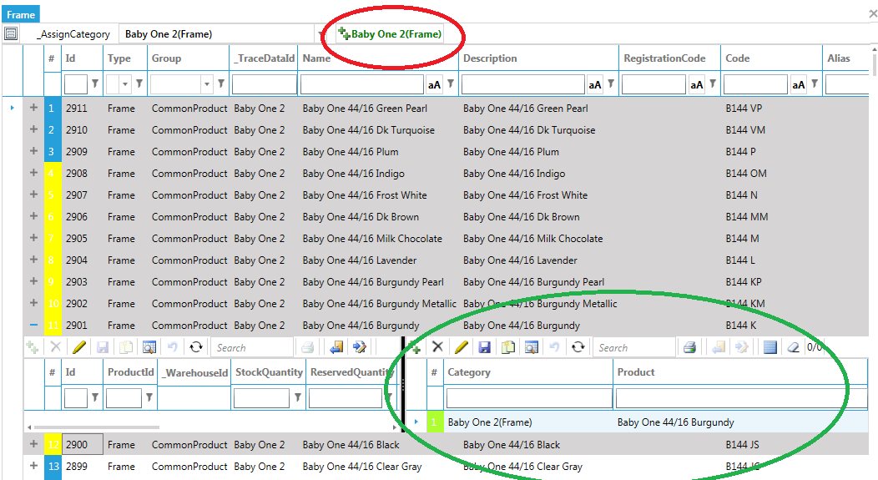

Production PARAMETERS

Lens Design

Corridor and SEGHT
The final lens design is determined by fitting height(SEGHT) or corridor(CORRILEN) of the prescription. In global configuration, the “Rx Order” UI will be rendered according to the value of “RxOrder_DesignSelectionMode”:
- 0 Select Design by fitting height
- 1 Select Design by corridor

Conventional RX
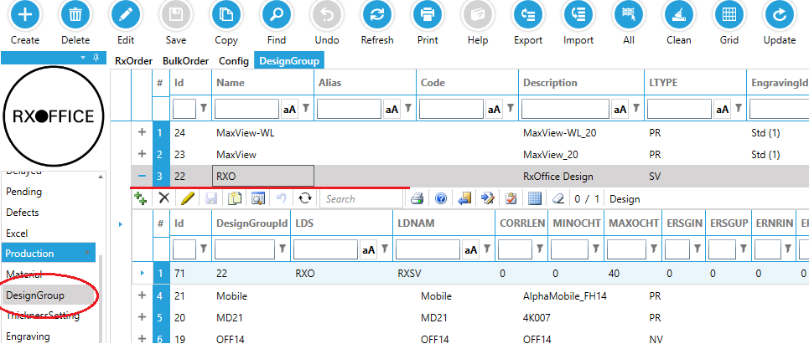
RxOffice provides a built-in conventional lens design, named after “RXO”. All this design applies to rx orders of stocklens all the time.

Rx lens design
The system searches a lens design by multiple conditions. If the conditions are too strict to return a result, the search engine will remove the “No mandatory” conditions one by one until a suitable design is found. If none of designs meets the conditions, searching engine will try to find the design with the most common corridor length: 9mm. If 9mm design doesn’t exist the system falls back to the first in the list.
- MINSPH~MAXSPH: Sphere range (Not mandatory)
- MINZITLT~MAXZITLT: ZITLT range (Not mandatory)
- MINOCHT~MAXOCHT: Fitting Height(SEGHT) range (Not mandatory)
- CORRLEN: Corridor length (Mandatory)
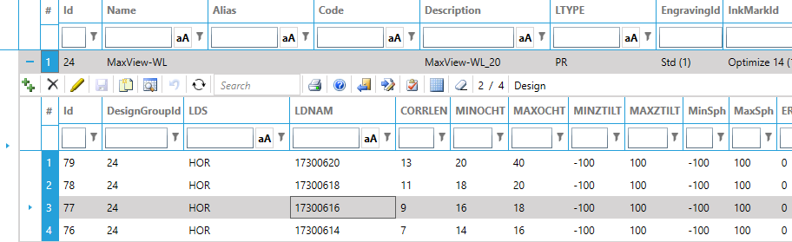

Optical Decentration

Optical Decentration
The system has multiple options to determine the optical decentration.
- BCERIN: Horizontal optical decentration (mm), positive towards nose, negative towards temple
- BCERUP: Vertical optical decentration (mm), positive up, negative down

Manual decentration
Enter the user specified decentration in BCERIN, BCERUP yellow background boxes.
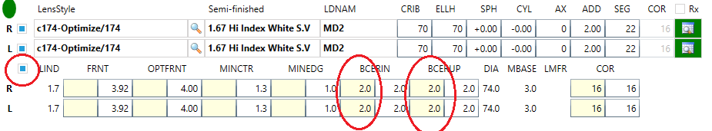

Auto decentration
In “Config”->” RxOrder_DecentrationMode” for setting "auto decentration mechanism.
Decentration mode
- 0: Default decentration by user defined
- 1: Optimum decentration
- 2: Conditional optimum decentration and minimum decentration, it is based on Delimiter of Power(Default)
- 3: Minimum decentration. Uses optimum decentration only if the resulting CRIB/ELLH for no decentration is bigger than DIA.
If the “RxOrder_DecentrationMode” is 2, config RxOrder_DecentrationSPHDelimiter” decides the delimiter of sphere for decentration.
- If the sphere of order is less than this value, the minimum optical decentration applies to the order.
- If the sphere of order is greater or equal than this value, the optimum optical decentration applies to the order.
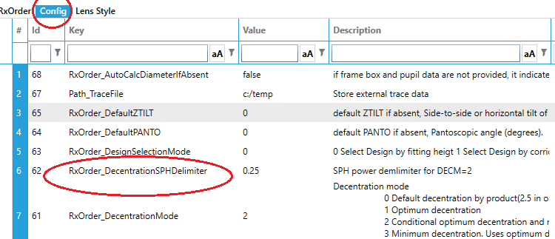

Box Data and pupil data
If box data (HBOX, VBOX, DBL) and pupil data (IPD, SEGHT) are provided, The Rxoffice can calculate the relative position for eye and frame for further production procedures, for example finished lens diameter calculation, edging blocking data etc.
Note: if the lens is bifocal, the near PD and segment height calculate the relative position. If only one of NPD and IPD is provided, the other can be calculated.
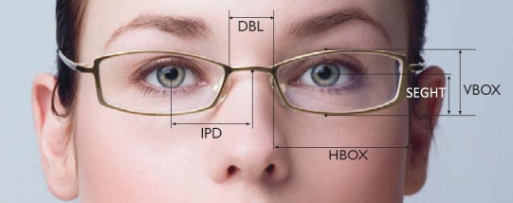

Tracing process
The trace data(frame shape) is crucial for finished-lens diameter calculation. The customers can provide it several ways:
- Send trace data file to the lab
- Send frame to the lab and operator trace the frame
- Select frame from the storage of lab
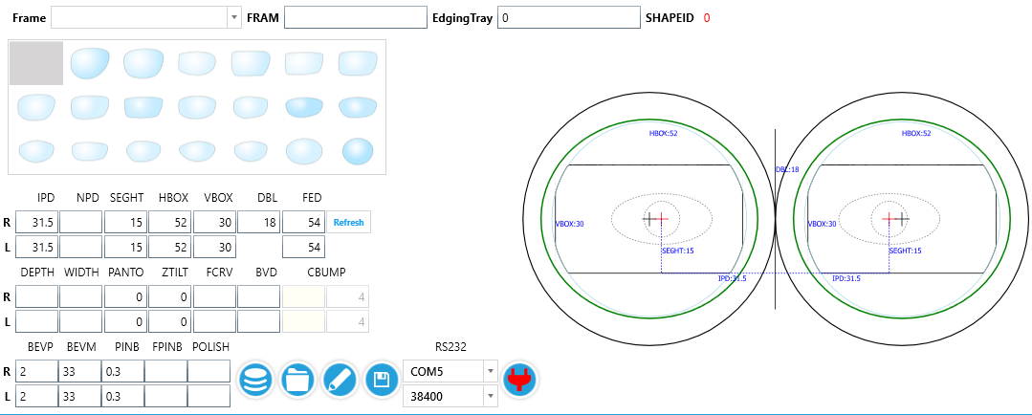
- Some customers only send the frame box data (HBOX, VBOX, DBL, FED) for “uncut precal” with generating a simulated shape.
Refer to the different section how the scenarios are handled in the system.

base curve

base curve chart
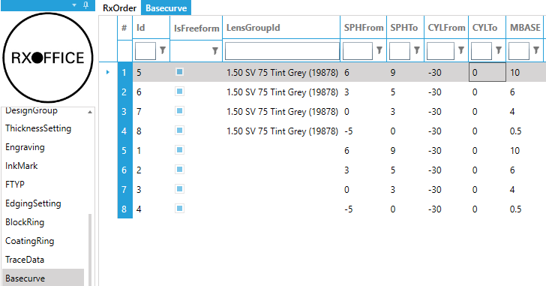
The system has a build in algorithm to find the optimum base curve from the prescription. To override the logic, you can define base curve charts to specify a base curve for a specified power range. Note: if the base curve can’t be found in the chart, the system will fall back to its internal algorithm.
- SPHFrom~SPHTo: sphere range
- CYLFrom~CYLTo: cylinder range
- IsFreeform: the base curve rule is only for freeform lens
- MBASE: optimum base curve
- LensGroup: if it is empty, the rule will apply for all lens groups, otherwise only apply this lens group.

base curve tolerance
Often the suggested base curve is not a 100% match with the available semi-finished blanks. For example, suggested base curve is 5, but only base curves 1,3,4,6,7,10 are available. To control the final selection, the system has two settings:
- RxOrder_base curve Tolerance When Specify: base curve selection tolerance when the customer specified the base curve, like optium base curve 5, available range from 3 to 7
- RxOrder_base curve Tolerance: base curve selection tolerance, like optium base curve 5, available range from 3 to 7
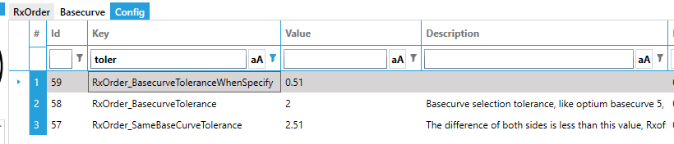

Same base curve for order
- RxOrder_Samebase curveForRxOrder: apply same base curve for right and left side if the base curve difference is less than RxOrder_Samebase curveTolerance
- RxOrder_Samebase curveTolerance: The difference of both sides is less than this value, Rxoffice will apply OPTFRNT for Right and left. Only can be positive
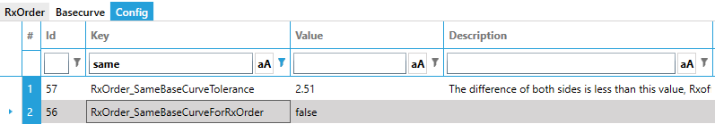

Blank selection process
After suggested base curve and tolerance are confirmed, Rxoffice takes the semi-finished blank with the smallest diameter and real base curve closest to the suggested.

Block ring selection
When calculating the order, the system loads available blocking rings for the order according to blocking ring settings. Which rings are available for a lens, can be defined in the block rings window (see paragraph 8.7). If no blocking rings are available, an error message appears.

Choosing the block ring there are several settings taking into consideration:
RxOrder_BlockingSafetyMargin: how many mm safety margin to apply when choosing the ring diameter. If for example the crib is 60 and safety 1 then the maximum block is 60 – 2* 1 = 58
RxOrder_BlockingSafetyHeight: this constraint determines the minimum alloy between the lens front surface and the bottom of the ring. To give the lens maximum stability during surfacing, it is best to have a large as possible block ring diameter. But if the block diameter is too big, the front curve too steep or the block ring height to small, the minimum alloy thickness constraint may not be fulfilled. In this case the system will first choose a ring with a larger height and if still not fulfilled a smaller ring. Note: block rings have a “hole” in the middle. A negative value for “Blocking safety height” allows the front of the lens to go “inside” this hole.

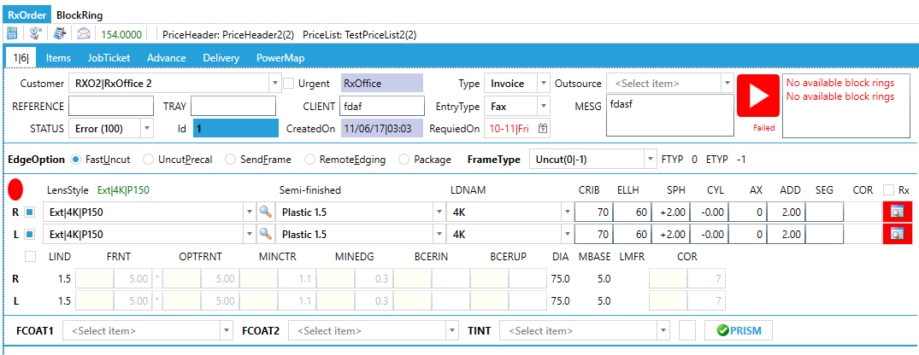
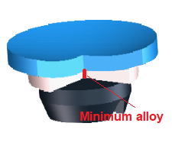

Safety margin
Safety margin compensates the finished-lens diameter for edging safely. RxOffice supports the lab customize it according to own production standard. if no valid safety margin meets the condition, Rxoffice calculates it with experienced algorithm.
- Red diameter is minimum diameter for fitting
- Green diameter is minimum diameter for fitting + safety margin
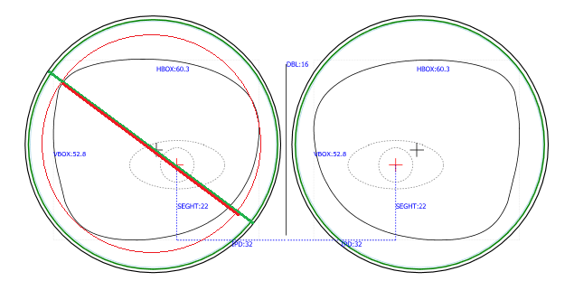

Finished lens diameter
If the frame box data (HBOX, VBOX, DBL) and pupil data (IPD, SEGHT) are provided, Rxoffice can calculate the finished lens diameter automatically. If customer specified a crib diameter smaller than the minimum required diameter, the diameter will be corrected automatically. sometimes, customers don’t specify the diameter for “uncut” order, by default Rxoffice shows error “Diameter is not specified” to the user. But if this case happens very often, the efficient way is to find a property solution for calculating diameter automatically. By setting “Config”->”RxOrder_AutoCalcDiameterIfAbsent” as “true”:
- If the order is plus lens, set lens diameter with the minimum diameter of available blanks
- If the order is minus lens or plano lens, set lens diameter with the maximum diameter of available blanks
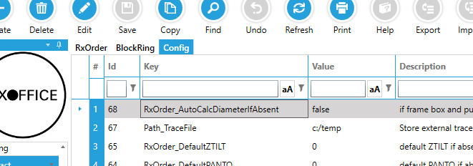

Thickness
Rxoffice uses MINCTR, MINEDG, MINTHKCD, MINAVG to control the finished lens thickness.
Lens material, Semi-blanks, Edging type. You can find these parameters on below data setting screen. Below factors will have impact on thickness setting of the order. Rxoffice chooses greatest value of each parameter as final setting. For example, if
- Lens material MINCTR is 0.8 mm
- Semi-blanks MINCTR is 1.0 mm
- Edging type MINCTR is 1.6 mm
RxOffice takes 1.6 mm as final setting for the order.
Note: If the order is uncut lens, MINEDG and MINTHKCD has same impact on thickness for crib diameter. Otherwise MINTHKCD is the setting for crib diameter, MINEDG is the setting for crib diameter cut to frame shape.

Prism thinning/ Block prism
“Prism thinning” is applied by default, note: “Prism thinning” will be disabled if prescribed prism exists.
PTOK: enable prism thinning.
PBOK: enable block prism, it also counts for blocker support blocking prism
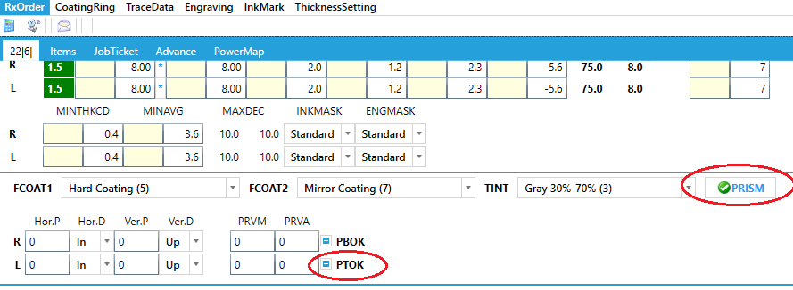

Compensation Rules
RxOffice offers the powerful and flexible compensations in order to overcome the tolerance in the production. The user is able to config the compensation according to different real conditions, for example, power range, LDS system, material, Lens type etc. If all built-in conditions are not satisfied, it supports “conditional rules” as well. Go to “Inventory module”->”Compensation”:
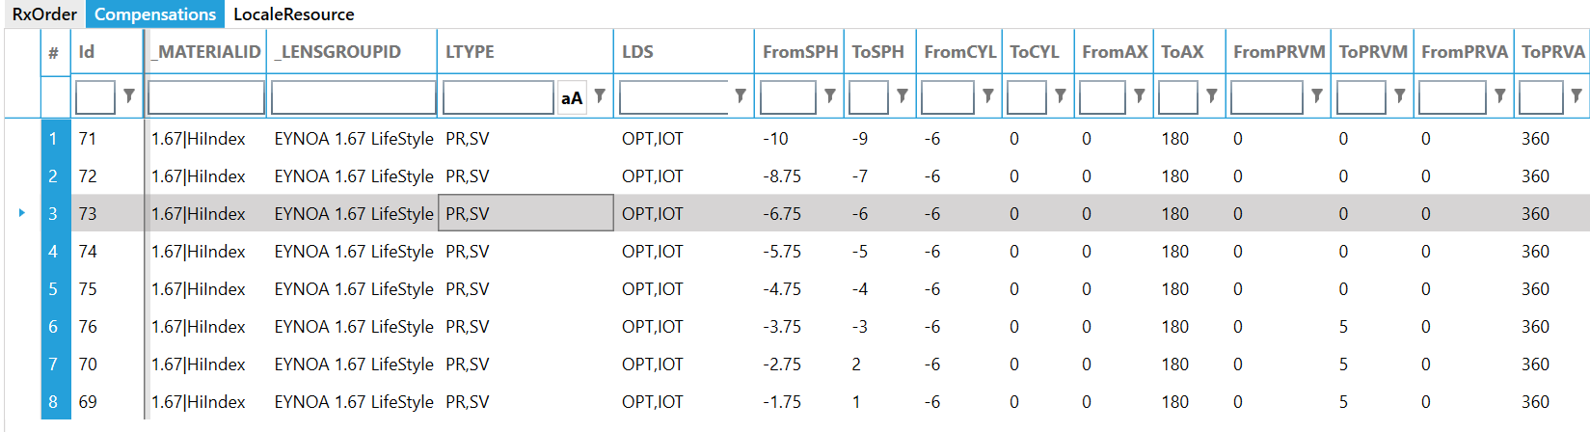
Column explanation:
*MaterialId: The Material for compensation rule
*LensGroupId: LensStyle or BlankLensGroup for compensation rule
*LTYPE: lens type, this column can specify multiple lens types, for example: PR,SV means this compensation rule applies to progressive lens and single vision lens.
*LDS: LDS system, this column can specify multiple LDS systems, for example: OPT,IOT means this compensation rule applies to OPTOTECH and IOT LDS.
FromXX: minimum value for specific parameter
ToXX: maximum value for specific parameter
ADJXX: compensation value for specified parameter
*Condition: this column complies with “Conditional rules” feature, for example, JOB.SPH = -3 means this rule is only available prescription has -3.00 D SPH.

“*” columns mean no constrain on this column if it is absent

Engraving mark
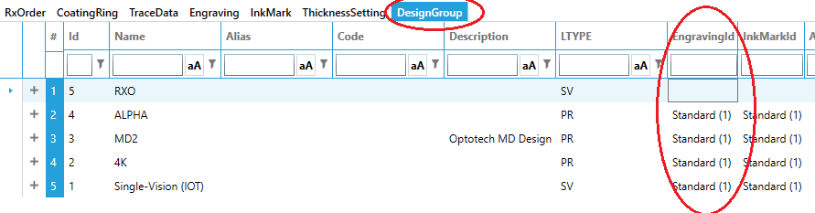
The system applies “DesignGroup”’s Engraving mark to the order. Optionally you can define a different engraving on the “lens style” or the “lens price” (ERP version only). As always, the priority is: lens price -> if empty, use lens style -> if empty, use design group.
A common requirement is to engrave a commercial description instead of the real corridor length. To accomplish this, you can define “Extension rules”. In the example below, corridor 7 will be send as S, 9 as M and 11 as L in the TEXT1 label (so the engraving template has a placeholder for TEXT1 defined) to the engraver. The CORRLEN is an example; it works same for any VCA label. Optionally you can add condition types. For example, you can make one rule for customer Id(!) 123 “7=S|9=M|11=L” and another for customer 456 “7=A|9=B|11=C”. Taking it even further, you can set a condition on the rule; “{SPH} > 2” will only apply the rule if the sphere is larger than 2.
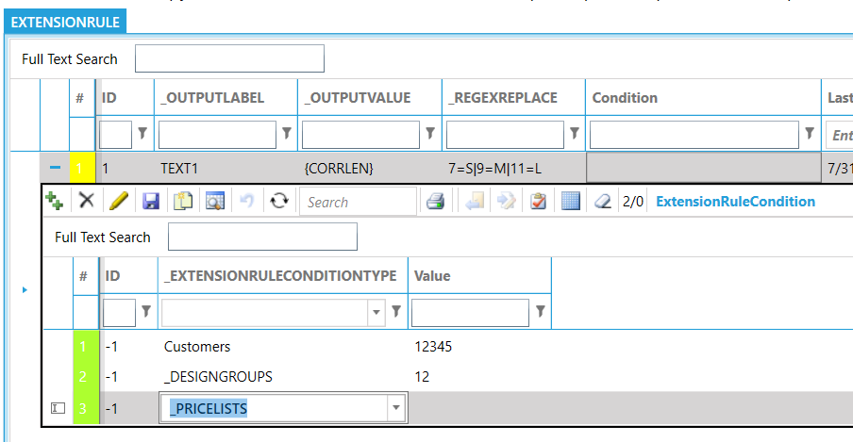

Ink mark
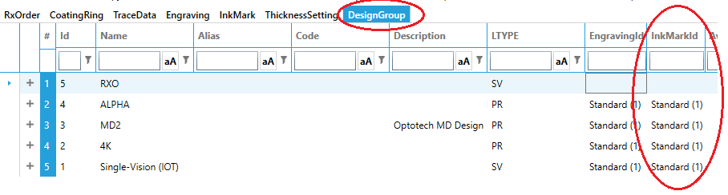
The system applies “DesignGroup”’s Ink mark to the order. In the ERP version, you can optionally set the InkMark on the lensstyle to have different stamping depending on the style (so same design can have different stamping)
Some machine vendors use templates. In this case the marking layout is defined on the machine and the LMS only sends the name of the template.
Other vendors, for example TECO and A&R, expect the layout (ENGMARK lines) to be send by the LMS. In this case you must define the layout in the “Extend” column. The ENGMARK lines are defined according to the VCA standard and the dynamic variables are populated based on the job values. All items in “curly brackets” are replace at runtime with the corresponding value. For example {SIDE} will be replaced with “R” or “L”, {ERNRUP} with the near reference (=addition) position.
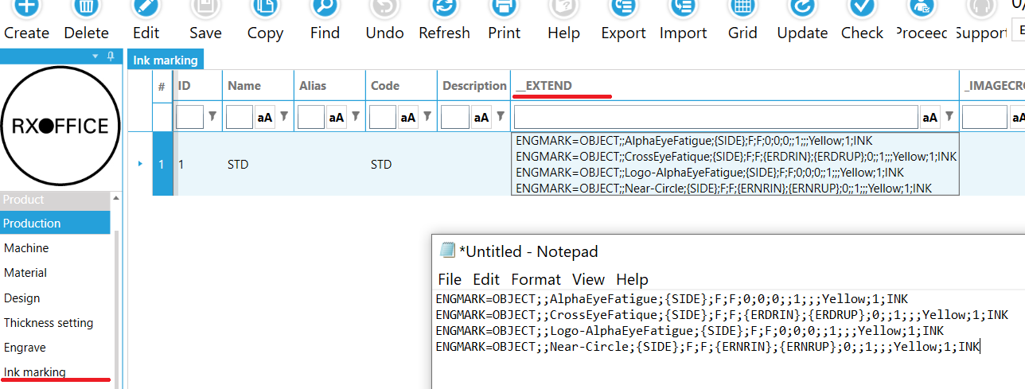

Lenticular
Blending will make the lens thinner and therefor lighter. Downside is the diameter of optical zone will be smaller. The final result is a compromise on thickness/weight and optical performance. In theory you can make a plus 5 prescription with a center thickness of 2mm; the lens will look very nice cosmetically, but the wearer will have an extremely small field of view.
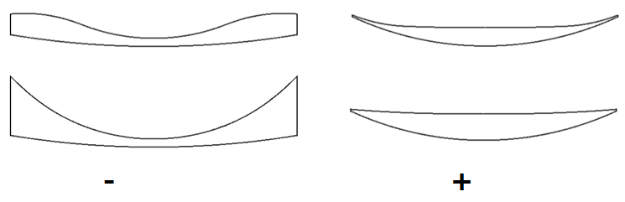
You can configure blending to be applied automatically to a prescription. To define a “blending option” enter
- a name for the option
- condition(s) when to apply the blending (CRIB from and to, SPH from and to)
- parameters to apply (Bending type, Optical zone diameter, edge angle)
The parameters are optional; if leave blank the system will calculate them automatically.
You can also omit the conditions. Then the system will apply blending on higher (plus or minus) powers only. If for example, you only want to apply blending on big frames with high minus power, you would enter CRIB from 60, CRIB to 80, SPH from -15, SPH to -5.
The blending option, you can assign to the Lens Style or the Lens Price (ERP version only). As everywhere in the system, the price is the highest priority and the lens style the fallback option.
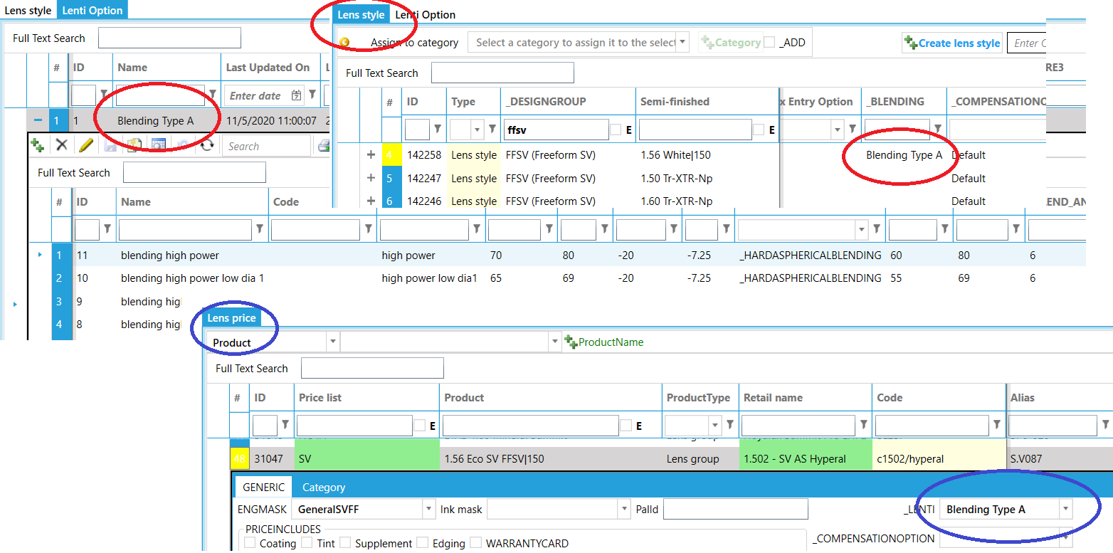
You can also define the blending on a “pair job” basis manually. Choose the blending type and optionally the inner diameter (optical zone, typical value = 40-50), outside blending diameter (typical value = CRIB) and blended surface slope angle at outside diameter (typical value for high minus lens = 0°-20°). If you don’t enter the optional parameters, the system will calculate them for you.
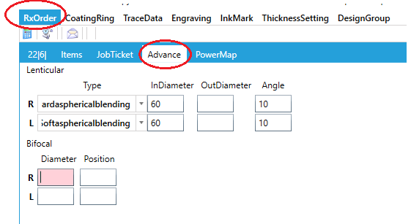

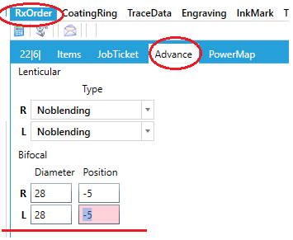
Freeform bifocal

Device Host
Efficient and easily maintainable management of devices is vital part in the lab. RxOffice Host module provides a powerful strategy for device management.
- Multiple communication protocol support: TCP, RS232, UDP
- Multiple data protocol support: VCA, SatisLoh, Coburn, RAW VCA
- Compatible a wide range of devices: SatisLoh, Optotech, Schneider, Coburn, A&R, MEI, Weco, Topcon, Nidek, Essilor.
- Data protocol Auto-detector, no more manual configurations for data protocol, Program detects the protocol automatically.
- Machine simulator, Decrease complexity for machine data testing.
- Multiple job channels, one platform for multiple data sources.
- Auto initialization and preset for VCA compatible device
- Detailed Log systems helps you shoot trouble quickly.
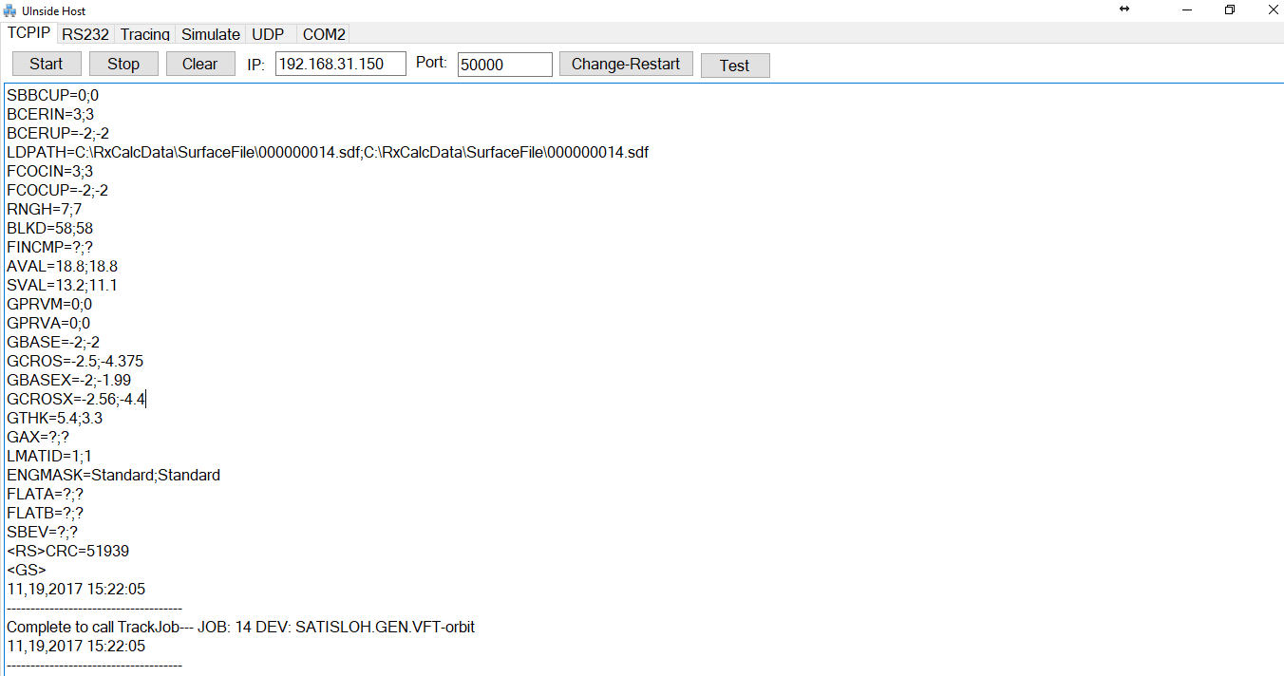
- Remote tracing service

Production basic data

Procedure adding new lenses
The starting point for adding lenses is the lens repository. Take a lens from your stock and scan it’s OPC (or hit the enter key). The system will search the online database for all other lenses belonging to this SKU. Initially they are marked as “new”; click the save button to store in your local repository.
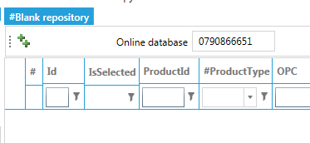
Select the items you want to import (use standard CTRL and SHIFT commands to select multiple items) and click the ++ to insert them to the database
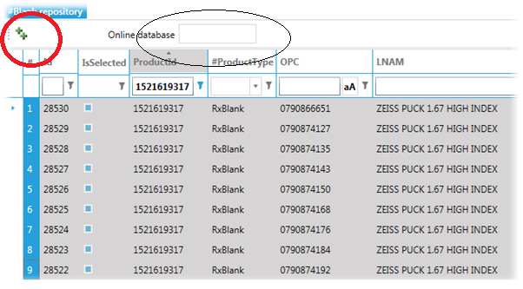
Now the blanks are available in the semi-finished - or stock section in the system. The import has created the conventional lens style and any missing material automatically.
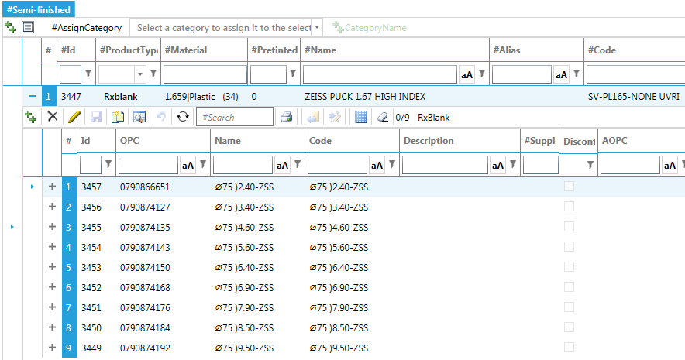

If the lens is also used for digital production, you can create additional lens->design combinations quickly with the “Create lens style” button
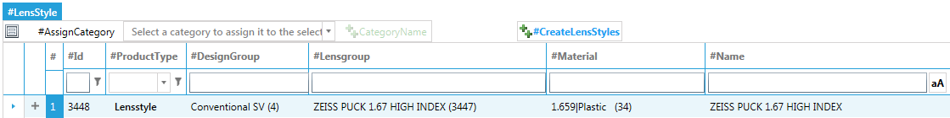
Before you can sell the lens, you must price it. Select the lens style and click the ++ button.
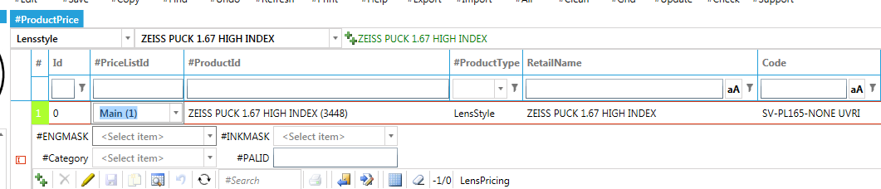

Materials
Define the materials you have. The Name is just a name for you to easily identify the material. Important are:
- LMATTYPE: Lens material type
- LIND: Refractive index of the lens
- LMATID: macro number on the machines to be used for this material
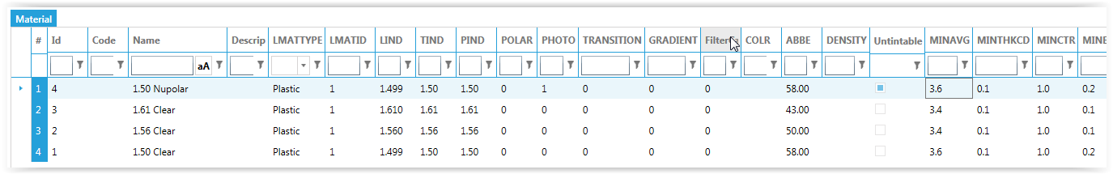

Lens designs
In the lens design screen, you define a “master/detail” relationship between the name of your design and the actual design used for this. Note that you can mix designs from different vendors as long as the corridor length is unique.
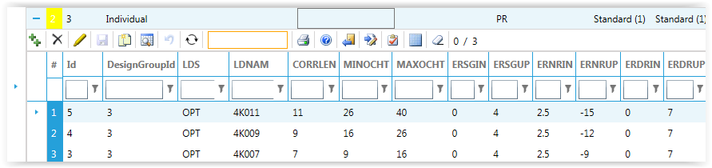
Mandatory data:
- LDS (calculation program): code for calculation vendor
- LDNAM: Design code, the calculation code as defined by the LDS vendor
- Corridor: The corridor for this design
- MINOCHT: Minimum fitting height
- MAXOCHT: Maximum fitting height
Note: the automatic corridor selection depends on the range between minimum and maximum fitting height i.e. if the users fitting height is in the range, the system will select the matching corridor length. 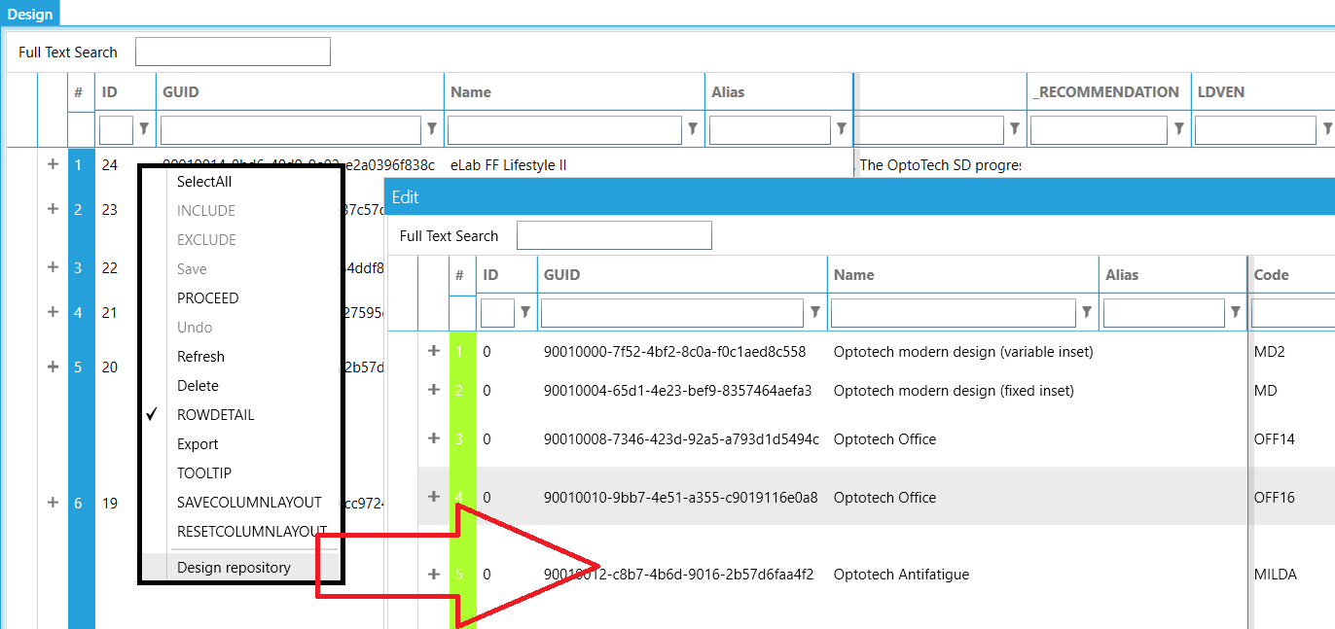
The system has a repository with the most common used designs. Right-click, the design grid and select “Design repository”. Select which designs you want to add to your database and click Ok.

Rx Blanks
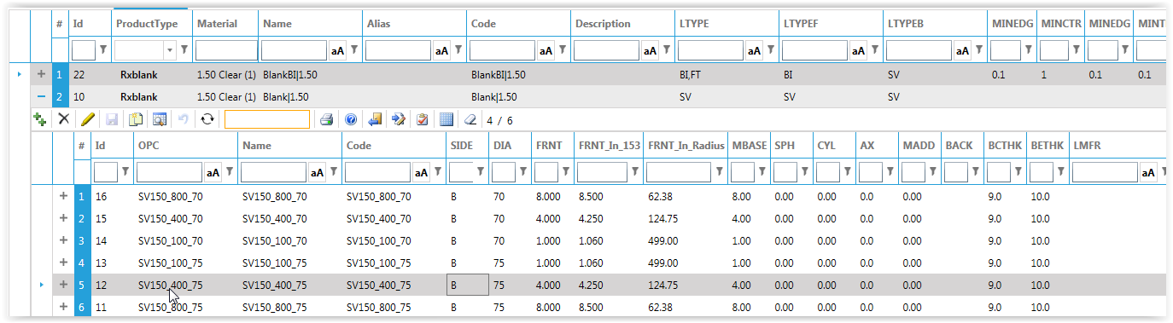
The lenses are defined in the Rx- or stock lens screen. Here you define the physical items. Most lens suppliers provide the lens information in a file. See section Lens Description Standard (LDS) how to import them from our worldwide lens database.
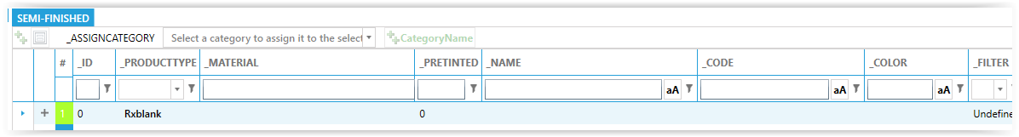
If you don’t have the LDS file, you can also manually enter the blanks. Choose “Semi finished” from the Navigator and click the “Create” button. A new row will appear. Choose the “Material” from the dropdown (create it if not exist) and then enter unique Name and code for the lens.
To enter the “physical lens”, click the ++ on the detail toolbar. Enter diameter, front curve etc. If you don’t have an OPC (barcode) on the lens, you can leave it empty; the system will create a dummy for you. The Code is also “auto-generated”
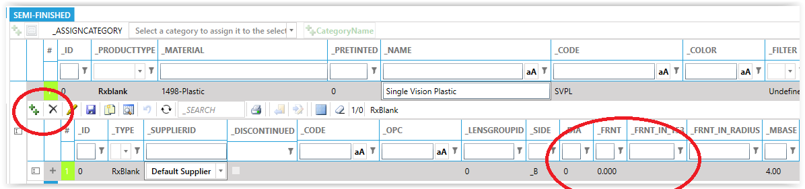

Conventional Bifocal
- BCSGIN: horizontal distance from blank center to center of segment (usually 5 mm)
- BCSGUP: vertical distance from blank center to center of segment (usually -5 mm; minus because below center)
- ERSGIN: horizontal optical decentration (also known as inset; usually 1.5 – 2.5 mm)
- ERSGUP: vertical optical decentration. If ERSGUP is same as BCSGUP, the optical center is on the datum line.
Optionally
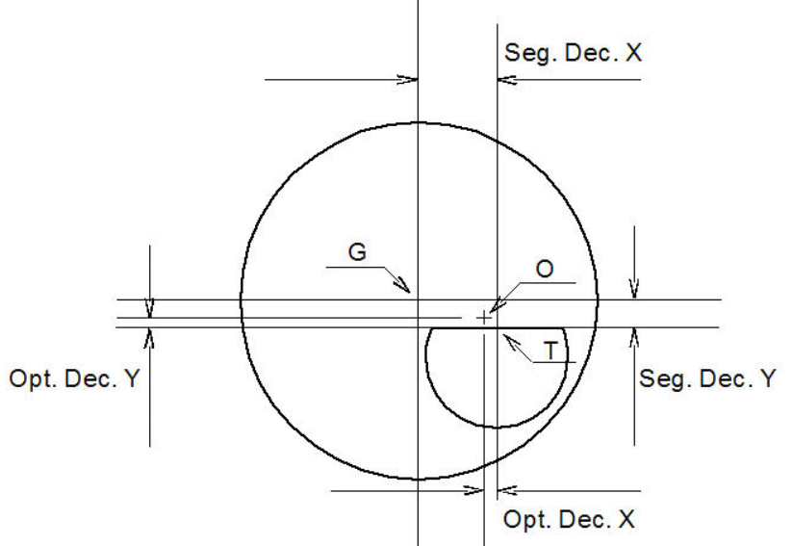
- SWIDTH: segment width in millimeter. This value is required by some surface blockers and edgers. 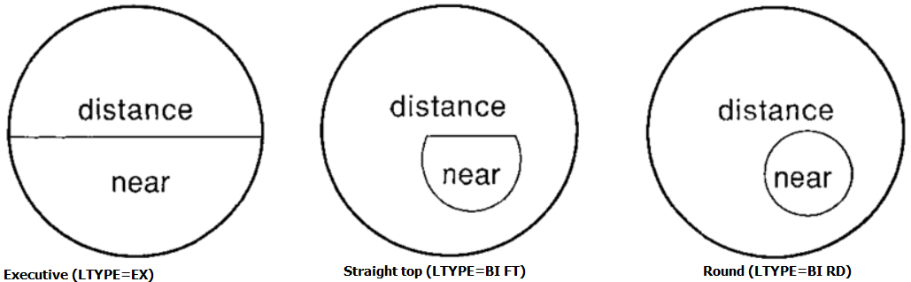
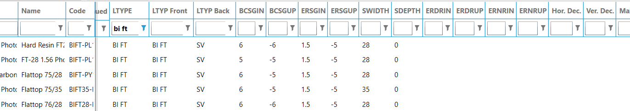
Conventional Executive Bifocal
- BCSGIN: 0
- BCSGUP: vertical distance from blank center to center of segment (usually -5 mm; minus because below center)
- ERSGIN: 0
- ERSGUP: vertical optical decentration. If ERSGUP is same as BCSGUP, the optical center is on the datum line.
- Max horizontal decentration: limit the horizontal decentration (usually 2.5 mm)
- Max vertical decentration: 0

Conventional progressive
- BCSGIN: blank geometrical center to Layout Reference Point (horizontal)
- BCSGUP: blank geometrical center to Layout Reference Point (vertical)
- ERSGIN: horizontal optical decentration (also known as inset; usually 2.5 mm)
- ERSGUP: vertical optical decentration.
Optionally you can define:
- ERDRIN/UP: horizontal/vertical position of the distance power (distance reference point)
- ERNRIN/UP: horizontal/vertical position of the reading power (near reference point)
- PTPRVM: prism thinning. Leave empty to have a default of 60% of the addition power.
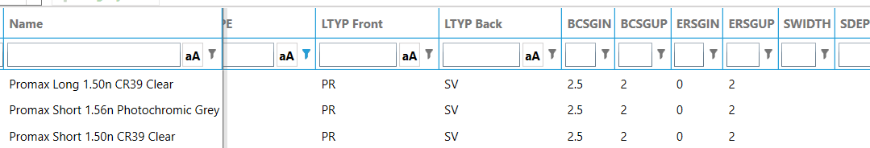
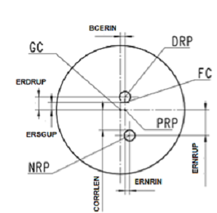
Single Vision Rx
If the lens can be decentered, BCSGIN and BCSGUP must be always "empty”. If you give it a value (even 0), it means BC(Geometrical center) and SG(Pupil position) have a fixed relative offset (decentration). You can give the lens a predefined fixed decentration value, but it is an unlikely scenario.
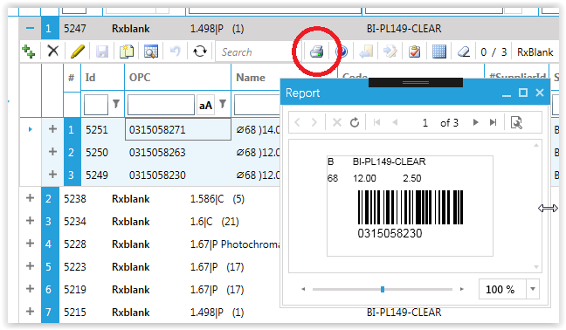
To print barcoded stickers for the blanks, select the blanks and click the Print button

Stock lenses
Ideally the stock lenses are imported from the LDS; that ensures all technical data and OPC are correct. But sometimes the LDS is not available from the supplier. There are two alternative ways to create stock lenses quickly

Create stock lens by range
On the stock lens toolbar, click the “Create by parameter” button. Enter all parameters to define the ranges. Note that -4 is less than 0, so to define a range, you must enter from -4 and to 0. Then click the OK button and the system will create you the entire range. Note: the system can not know the real OPC codes, so it will create dummy’s. Back curve, blank center thickness are optional. If not enterd the system will enter “best practice” values.
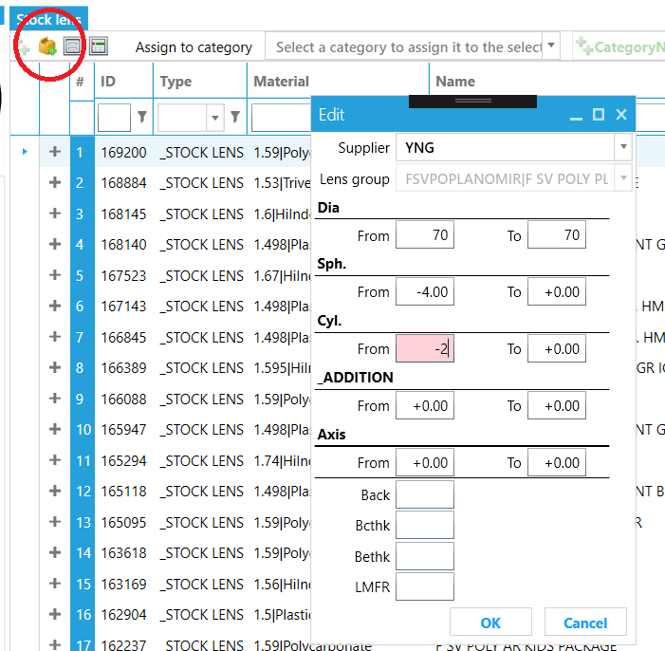

Create stock lenses from Excel
Open the Lens Matrix
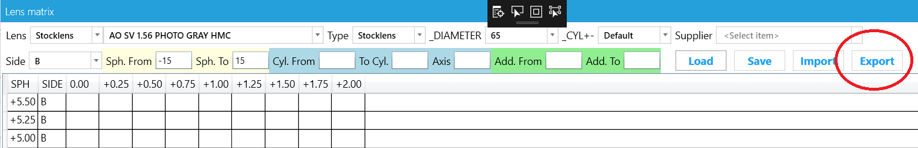
In the Excel give the “lenses to add” a quantity
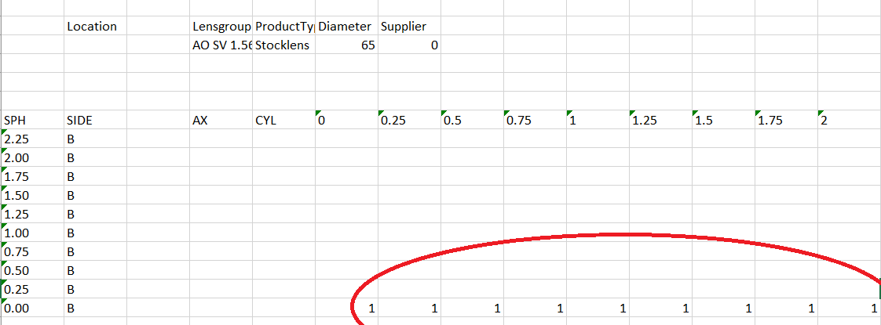
Create a new stock take, and click the Import to browse for the Excel file. This will add the missing lenses to the database. Note: no need to Save the stocktake
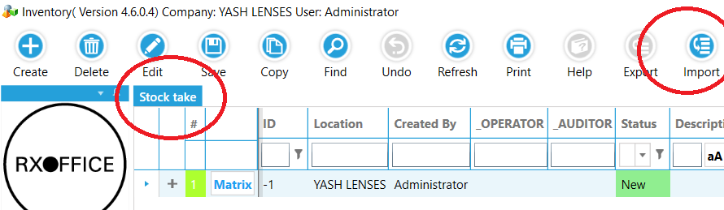

Lens styles
The lens styles define the combination of physical item (i.e. lens group) and the design applied to it. With freeform technology, one physical item can be used with any design you may have.
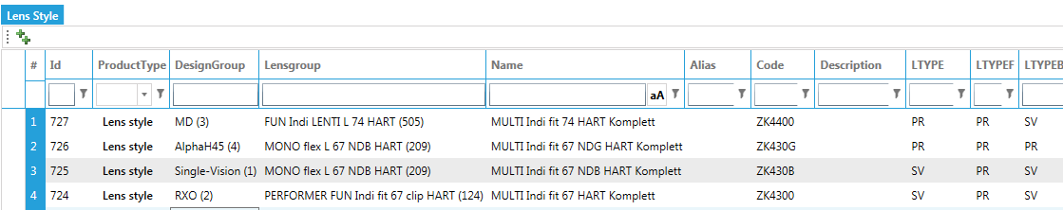
Creating all the different combinations can be a time-consuming task. You can click the ++ button and add all the designs on the left-hand side and the lens groups on the right. Click the OK button and the system creates all combinations automatically (any duplicates will be skipped)

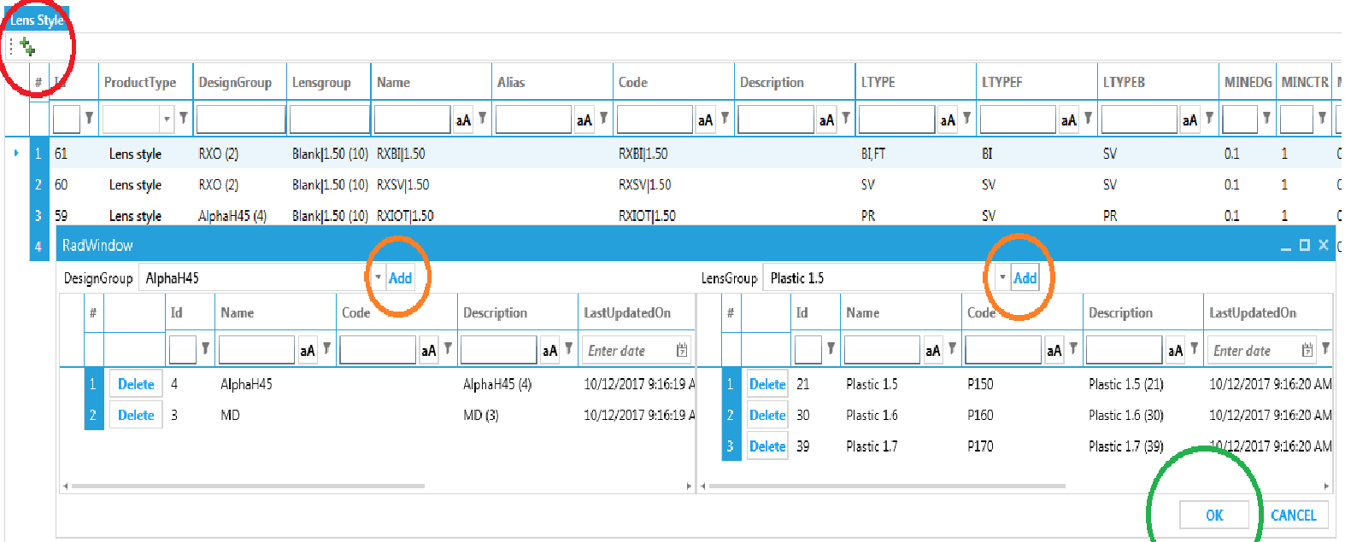

Block rings
Define the block rings you have. The lab often has more blocker machine for manufacturing. Each blocker is responsible for different purpose, for example, blocking freeform or conventional lens, production line associated (if you don't want to use the 50x10 ring for a specific lens, you create a group without this block ring and assign this group to the lens), the block ring is incompatible. Due to the quality of blocking procedure is significantly important in whole manufacturing. RxOffice offers a flexible way for blocking ring management. On “BlockRing” screen:
- Group: the lab can create multiple ring groups for different purpose
- AvailableLensType: limits what kind of lens can use this ring
- BlockingLensType: what type of lens can use this ring
As below example, there are 3 defined groups, “Freeform”, “Corbum” and “Default (Empty in group column)”, For #5 line, it indicates this ring belongs to Group “freeform” and only freeform “PR(progressive)” lens can use it.
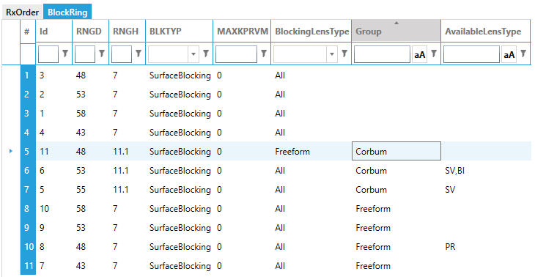
In the “lensStyle” or “Semi-finished” screen, the blocking ring group can be assigned. Leave empty if the lens uses default blocking ring group.
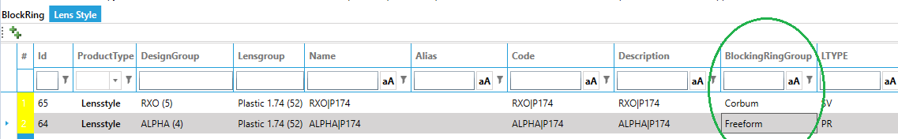

Coating Rings
Define the coating ring size for lens production. It exerts an impact on lens diameter only if order has coating.
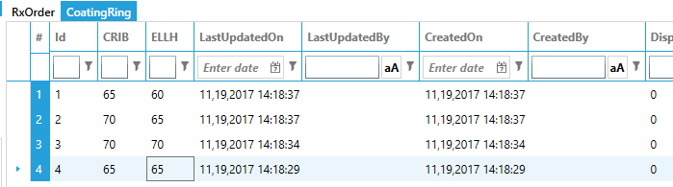
- CRIB: Coating ring A diameter
- ELLH: Coating ring B diameter

Frame types
Define the different frame -and edge type combinations available in your lab.
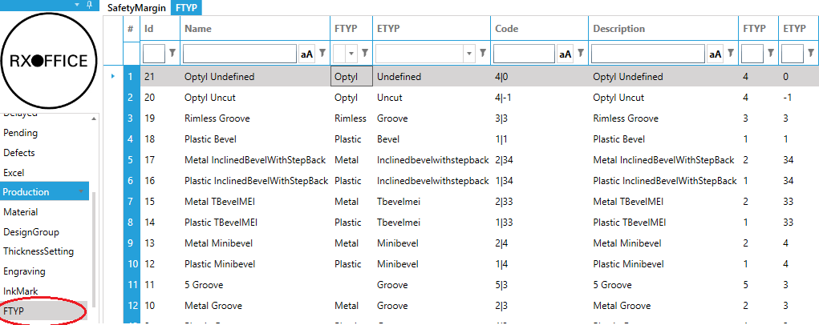
- FTYP: Integer frame type.
0– Undefined
1 – Plastic
2 – Metal
3 – Rimless
4 – Optyl
5..127 – reserved
- ETYP:
Type of edge to cut on lens:
-1 - Uncut1 – Bevel (“V” shown in Figure A.7)
2 – Rimless (“Flat” shown in Figure A.7)
3 – Groove
4 – Mini-bevel (a smaller-than-traditional “V”)
5 – “T” bevel (see Figure A.7)
6 – “U” bevel (see Figure A.7)
7…32 reserved
33…127 defined between host and device

Edging options
Once you defined the frame types you can assign defaults for processing the different types. Optionally you can set different options for specific customers.
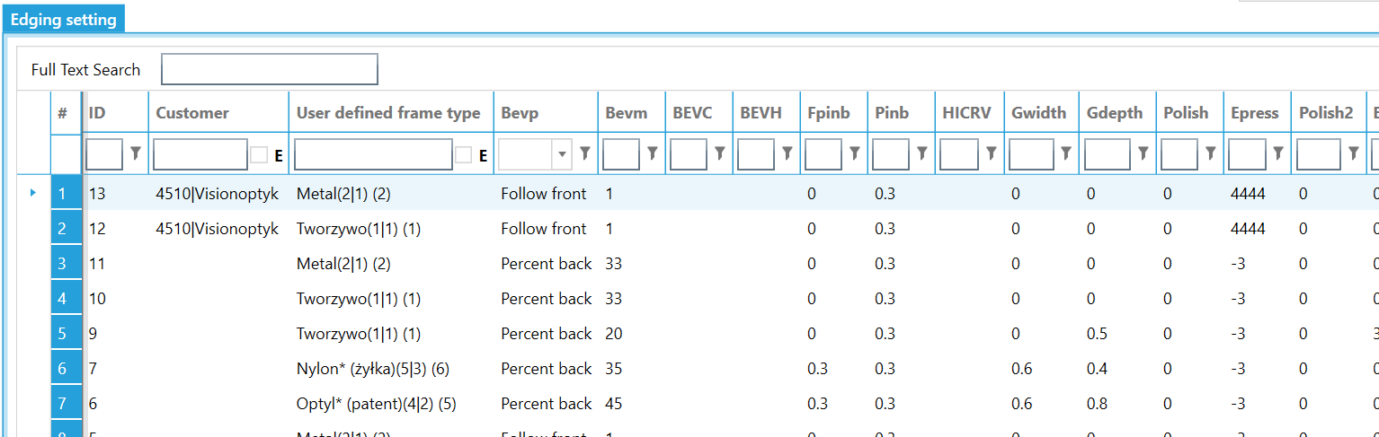
Optionally you can have different parameters for same frame type based on polarized, transition, basecurve or even specify a condition in the “Extend”
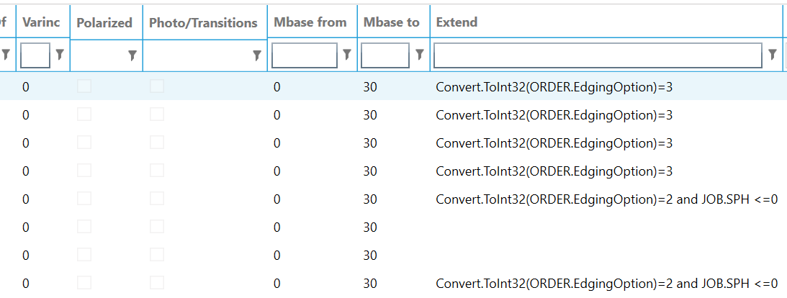

Safety margin
Define customized safety margin rules by sphere range and stock lens order.
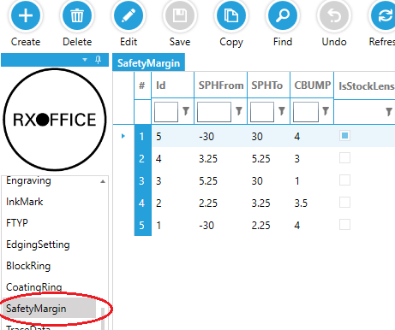
- SPHFrom~SPHTo: Sphere range
- IsStockLens: apply to stock lens order

Thickness setting based on edging type
The lab defined the lens thickness rule according to several factors, “ThicknessSetting” helps the lab place the rules in file.
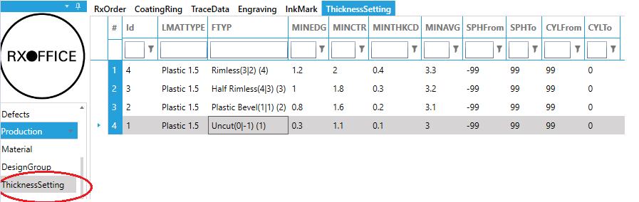
- LMATTYPE: lens material
- FTYP: user defined edge type
- MINCTR: minimum center thickness (mm)
- MINEDG: minimum edge thickness (mm). If a shape is provided, this value refers to the thickness on the shape.
- MINTHKCD: Minimum edge thickness at crib shape(mm). This setting is to prevent the lens from breaking on the edges and make sure they are not too much “knife edge” (sharp lenses destroy the polishing pads)
- MINAVG: Minimum average thickness (mm). To ensure the lens will not bend and break, (CTHICK + THNP) / 2 must be greater than or equal to MINAVG(mm). Because higher powers have a higher THNP or CTHICK, they are not affected by this constraint. Lenses with power close to plano, will be.
- SPHFrom-SPHTo: Sphere range(Diopter)
- CYLFrom-CYLTo: Cylinder range(Diopter)

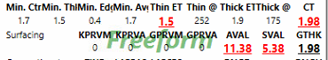

Trace data
To prevent re-tracing frequently used frames for orders you can store the data in the trace data repository. The can be saved from a local trace or imported files provided by the frame manufacturer (see section Frame data). Once in the database, you can add drill holes and alter the shape dimensions by clicking the “Edit” button.
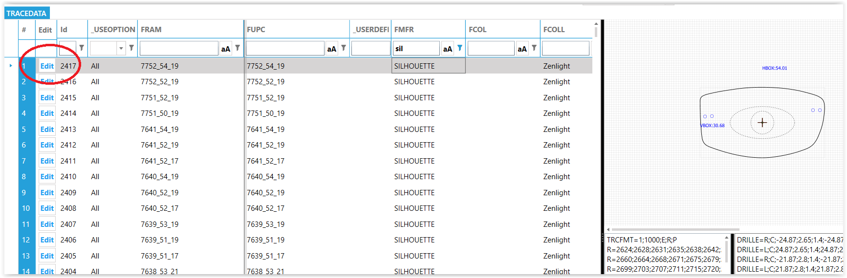
Not all trace data imported from the manufacturer is conform to your standard edging parameters. To adjust the data quickly to your standards, you can select multiple records and right-click. In the pop-up, select “Apply defaults”.
- If the user defined frame type is not set, the system will find the user define frame type from the FTYP and ETYP. If multiple user defined frame types found with the same ETYP and FTYP, the system will take the one with the lowest “Display Order”.
- If the user defined frame type is set, the system will apply the bevel, groove etc. settings from the user defined frame type to the trace data.
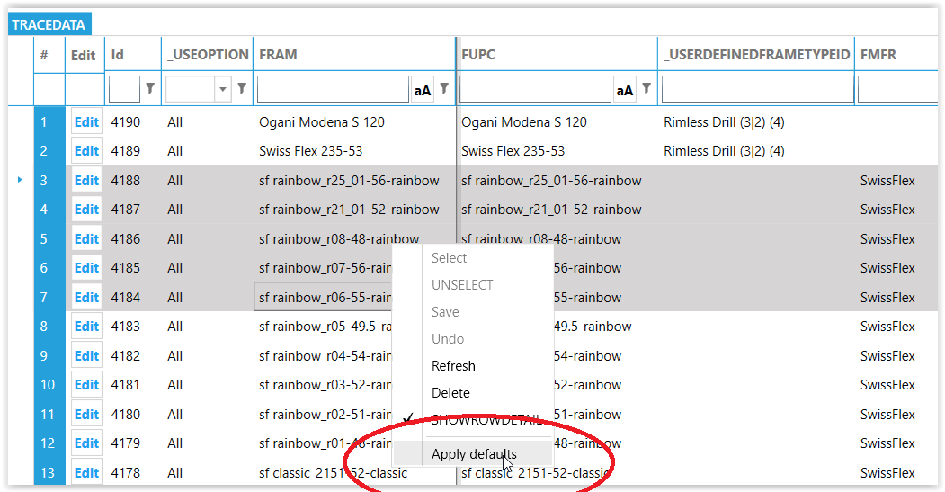

Engraving
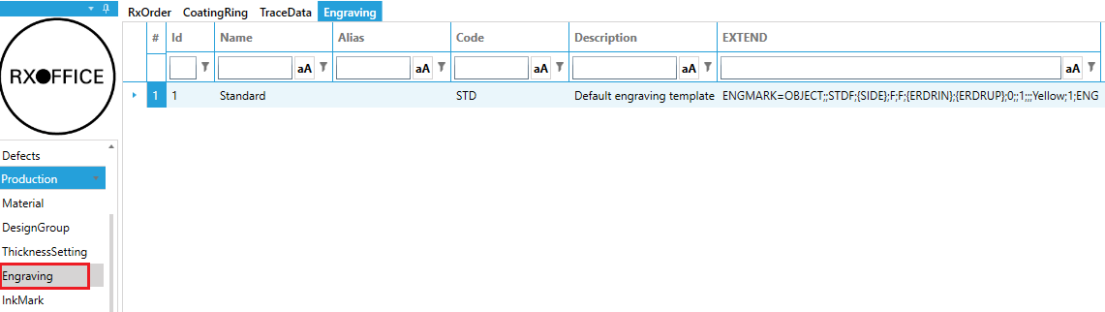
Laser engraving template data

Ink mark
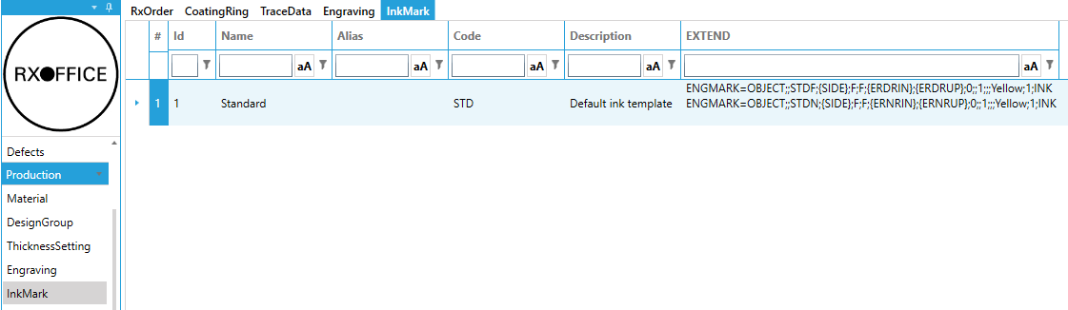
Progressive lens ink mark template data

Purchasing

Create purchase
Click the + on the toolbar to create a new purchase. The system prompts how you want to create the order.
Which method we use depends on our own preference, Import is the quickest one.
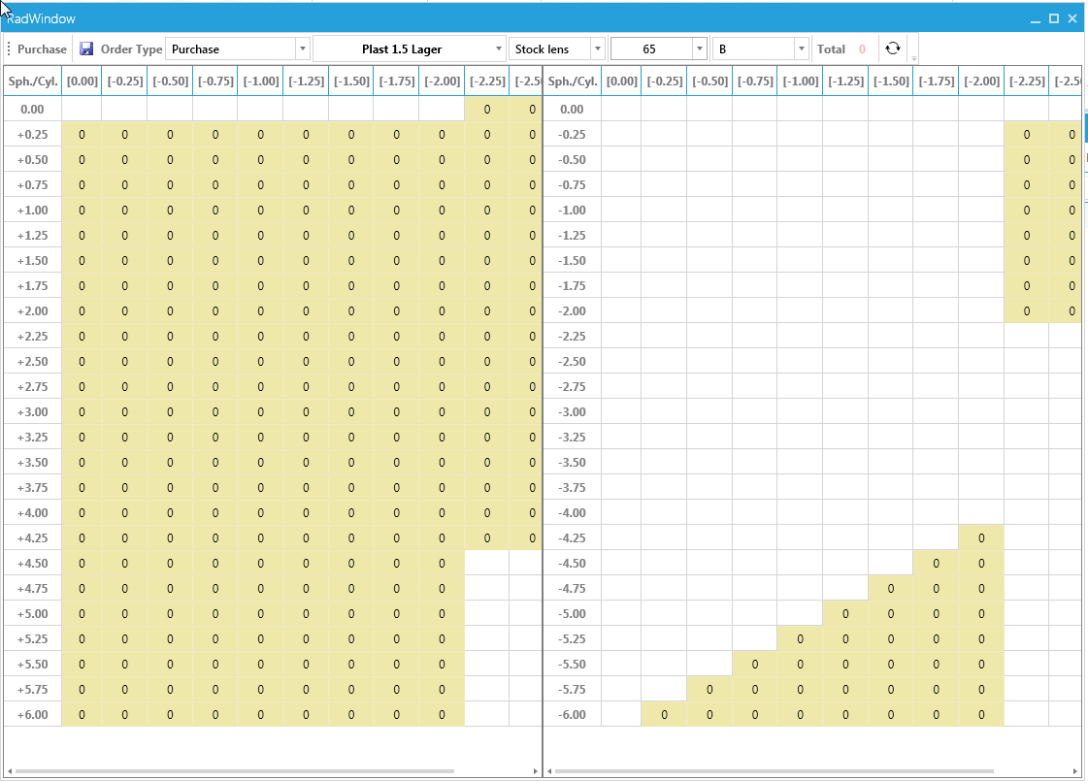
When you click the Save button, the items are added to PO.
To add more items in this PO, repeat the procedure above
After you saved the purchase you can Print or Export (see section 7.4)the purchase and send the order to the supplier.

Purchase suggestion
Open the Excel statistics window. The purchase suggestion is based on the usage in the selected date range. After you click the Export button, you can review the suggestion and import the created file as the source for a new purchase. The first column is how many you want to order.

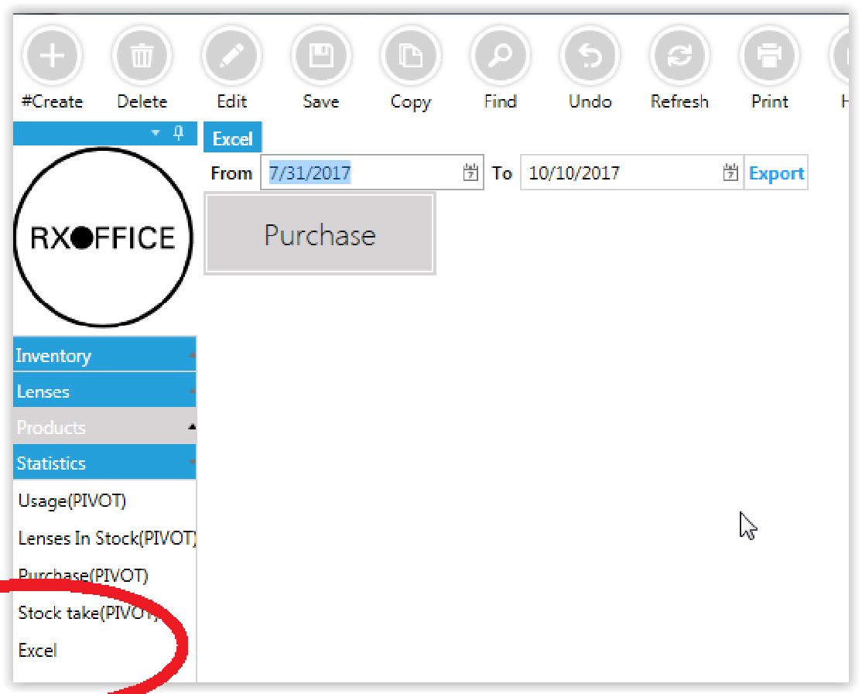
In the created excel file, enter the quantity you want to purchase. Column A must be quantity and B the OPC. All other columns are discarded on import.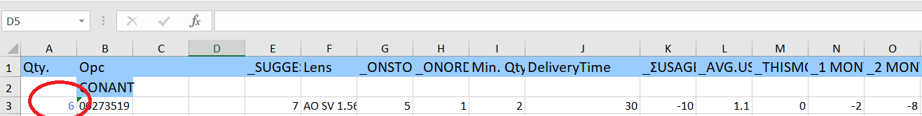

To import the data to a purchase, create a purchase and click the Import button on the child grid
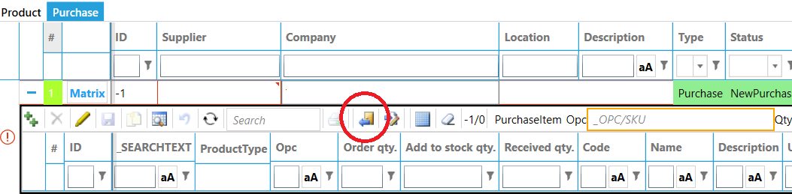

Receive goods
Select the items you received. To select all rows, click the “Select all” button on the toolbar. Now right-click the grid and select the “Received all”. This will enter the “order quantity” - “previous received” in the “add to stock quantity”. Click the main(!) “Save” button to commit the items to the stock; this resets the “add to stock quantity” to zero and updates the “received quantity”. Click the “+” on the row to see the stock history.

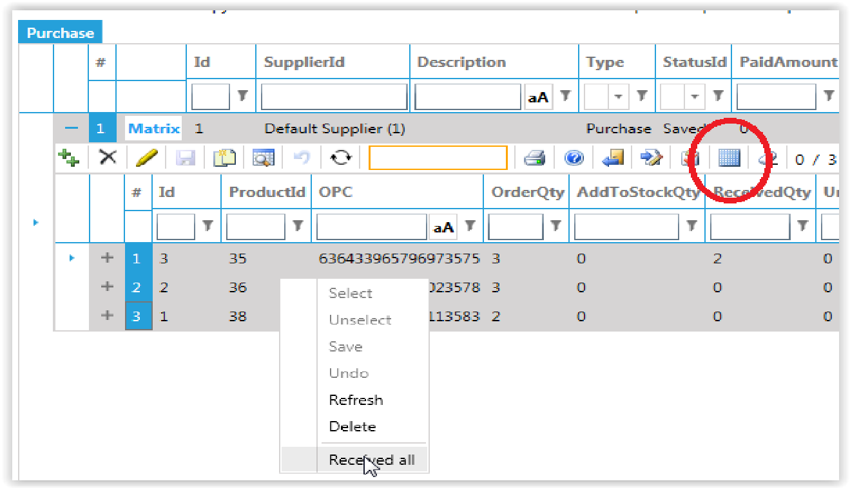
Restock
To re-order the lenses you used today, you can create a new purchase and click “Create purchase for today’s stock orders”.

Re-sell
To quickly convert the purchase to a bulk order, right-click the purchase to convert and select “Create bulk order for purchase”
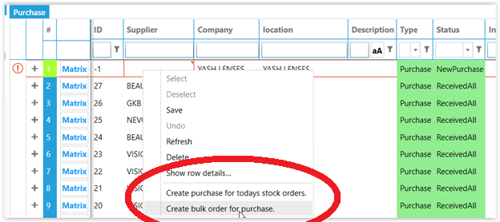

Partial shipment
If you have not received the entire ordered quantity, you can enter how many you did receive in the “Add to stock” quantity. When done, click the “Save” button in the main screen.

Unit price
By default the system will use the unit price as defined in the product. In case you order from a different supplier at a different price, you can select multiple items in the purchase →right click → enter unit price → ok, to change the price quickly

Import purchase
Create a file in the following format
QTY,OPC
And click the import button to create a purchase.

Export purchase
Select the purchase you want to export and click the Export button. When prompted for a file name, you can leave it to the default. The program will create 2 files in the \\YourServerName\RxCalcData\Reports\Purchases folder.
- the file with .csv extension is a list in the industry standard format and contains an OPC and quantity field.
- the file with .xls extension is in a “matrix” format. Each lens style is listed in a separate tab.
- Send file to supplier
- Locate the file you want to send to your supplier.
- Right-click the file and select “Mail recipient”. This will open your mail program with the selected file as attachment

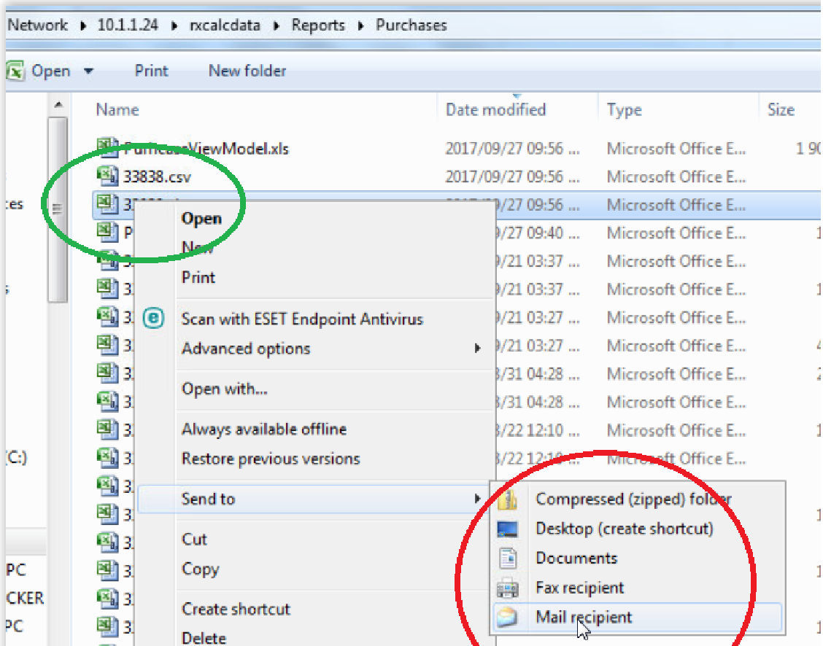

Stock transfer
Large companies having many plants in different geographical locations commonly require stock movement from one plant to another. For this purpose, the system has a special process that enables to move stock from one plant to another or between different storage locations of plants.

Inventory Control

Remove items from stock
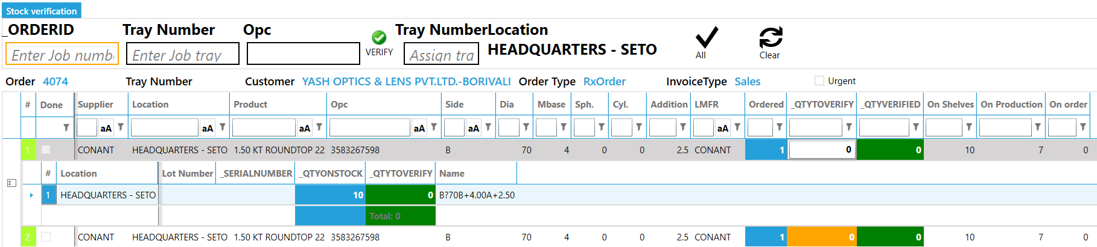
- In the stock department, the operator scans the barcode on the job ticket to load the products needing to be verified. The system provides some basic information about this order and lists the products (including their stock levels)
- the operator takes the physical product from the shelves and then scan products’ barcode (OPC) to verify the lens picked.
- Optionally when there are many items, you can select the row and click the Verify all button; this will remove all items from stock
- If not already assigned, optionally you can assign a tray number to the order

Return items to stock
In case you need to return verified products to stock you must cancel the order, then create a new order (note: copy the original and change parameters is most convenient).
- Click “Delete” button, then click “Yes” on popup window.
- If the order is verified, the system prompts to return products to stock. Click “Yes”, and the products are returned to inventory.
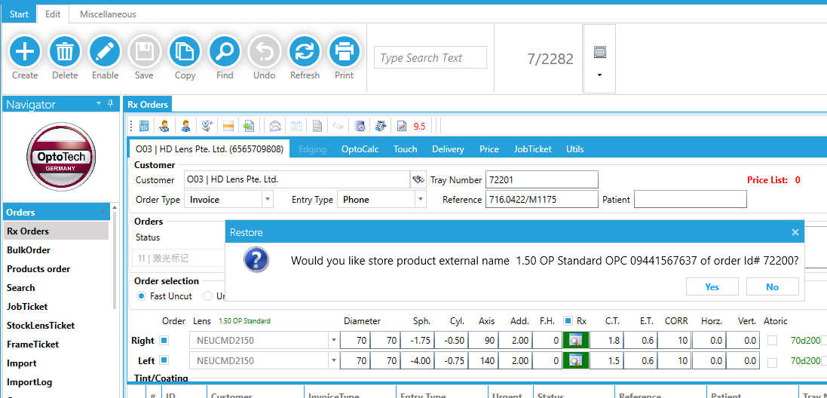

Stock Take
With the Stock take feature, you can adjust difference between the inventory status in Rxoffice and physical stock count for multiple warehouses. Variance reports are available for management statistics.
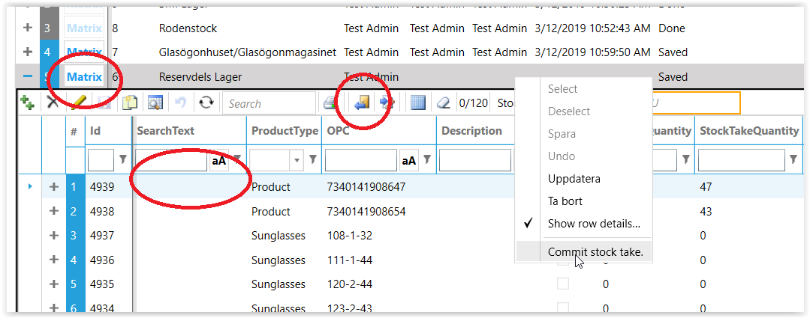

Click the “Add” button on the main toolbar and select the warehouse you want to perform the stock adjustment.
To enter
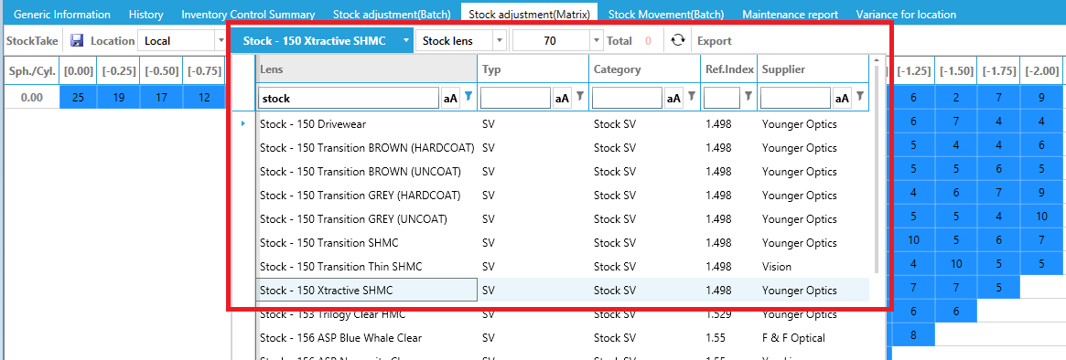
- click the “Matrix” button and the current quantity in matrix format. The X coordinate is CYL, Y coordinate is SPH. Each small cell is the current stock quantity for corresponding combination of SPH and CYL
- import a CSV file in the format: ID, ProductId, OPC, Quantity by click the “import button” in the line detail section (not the big import button on the main toolbar)
  - 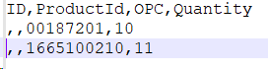
- add line by line (scan barcode of product in Search text box)
Once done, right click the row and click “Commit stock take”

Stock Transfer
In the stock transfer, you can move goods from one warehouse to the another.
- Click the “Create” button to create a new stock transfer
- To add the items you can:
  - manually add them by click the ++ in the child grid
  - scan a barcode to add the item
  - click the “Matrix” to add multiple items
Once done, you save it. Optionally you can print a stock transfer document
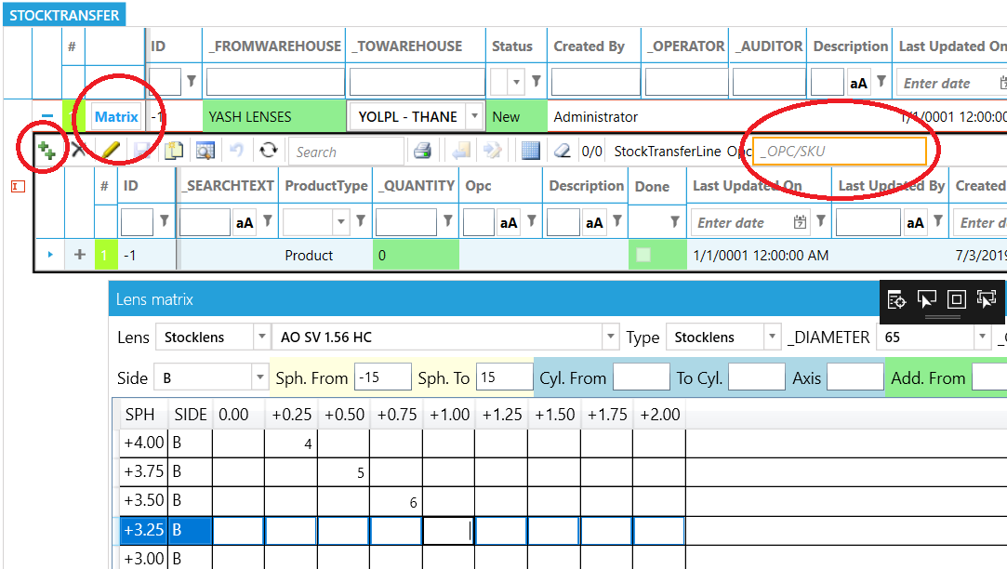
To actually submit the movement, click the “Check” button. This decreases the quantity in the From and increases in the To warehouse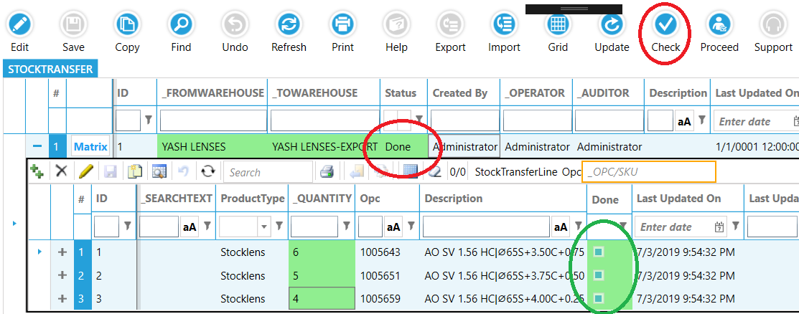
To create a transfer “manual” e.g. click the Create button and add some product you want to transfer. Status is new
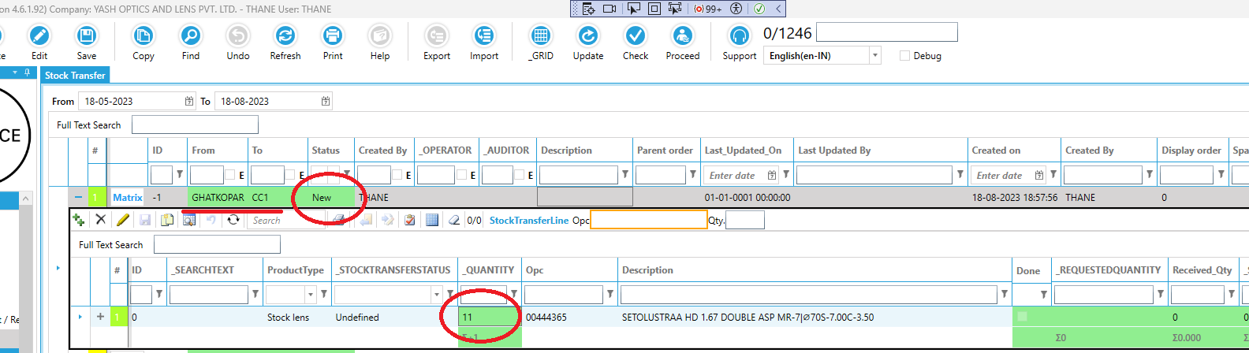
Click Save and status changes to “Saved”
Click Proceed; this changes the status to “Request”
Click proceed again to remove the items from the “From location”. In the example below, there was only 1 item on stock, so system removed only 1 and the status for the line is partial sent. Once there is enough stock, do proceed again and the status is “Sent”. Now you can log is as the “To location” and receive the items to the “To warehouse”.
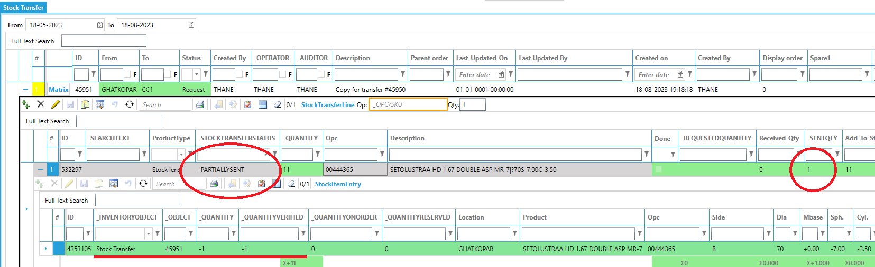

Stock Adjustment
In the stock adjustment, you can move adjust the quantities.
- Click the “Create” button to create a new stock adjustment
- To add the items you can:
  - manually add them by click the ++ in the child grid
  - scan a barcode to add the item
click the “Matrix” to add multiple items
Note: a positive number means increase quantity, a negative quantity will deduct. For example if the current quantity is 20 and you enter -5, then after proceeding this stock adjustment, the quantity will be 15.
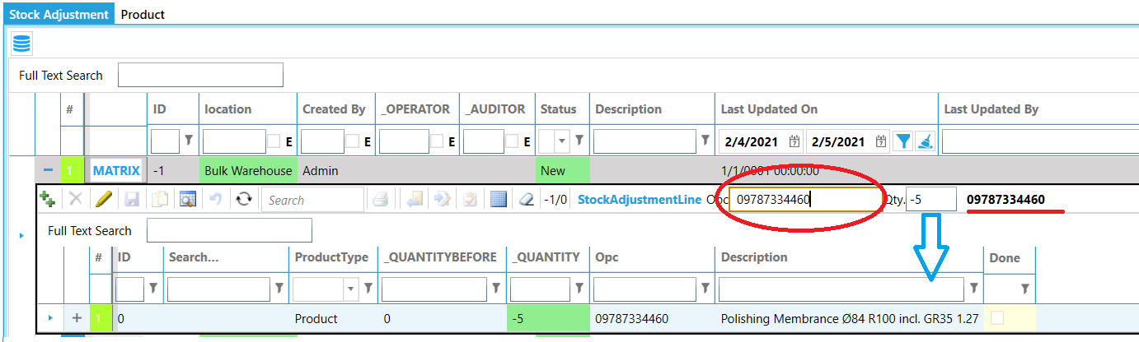

To actually submit the movement, click the “Proceed” button. This adjusts the quantity in the warehouse.

LAB TRACK MODULE

Status tracking
Preparation: open the RxOrders module with Admin account. In the Navigator panel select the Status item; the items you check the “Show in Labtrack” will appear in the Labtrack module. On scanning an order, the status will be set.
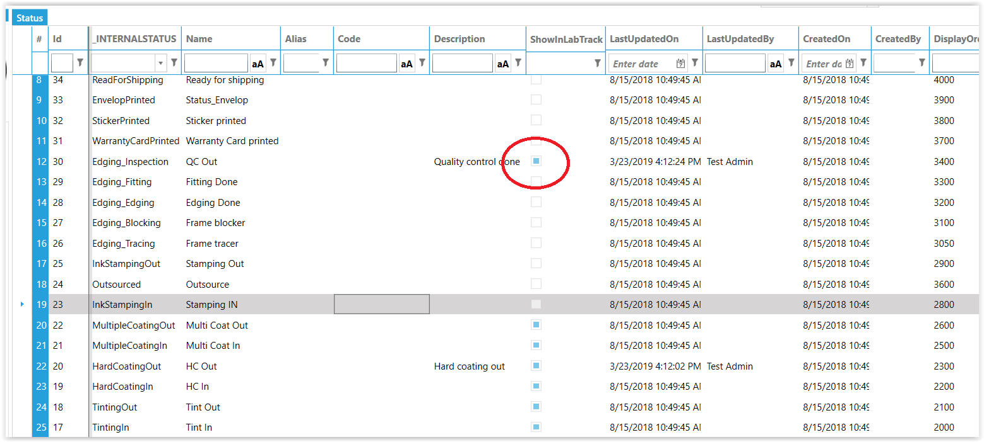
If you want to restrict an employee to certain status update, you can set the “Department” in the employee. If the department is set to undefined, there is no restriction. If the department is set to for example “Coating”, only status related to coating can be set.
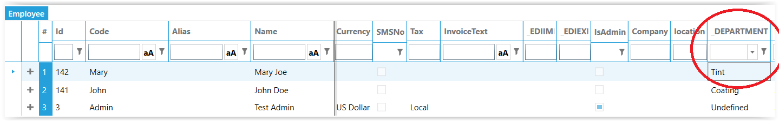
- in the Status column, set the status the job should have after scanning
- in the DEV column enter the text you want to appear in the statistics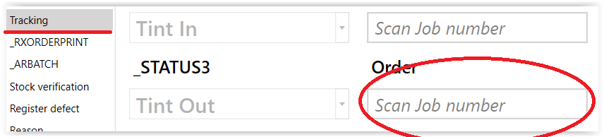
Workflow：
- Put the cursor in the status line you want to update the status to
- Scan order; status will be updated accordingly

Defect registration
Before you can register defects, any possible defect reasons must be defined in the system. The Status column defines the job status after you registered the defect. The Stock action defines if a new lens is required:
- Nothing; register defect for statistics only
- Redraw; new blank required. The defect requires to re-start the process from the beginning
- Return and redraw; return the current used lens to stock (e.g. undo previous inventory control action) and redraw a new lens from stock. i.e. wrong base curve detected before the lens is actually grinded.
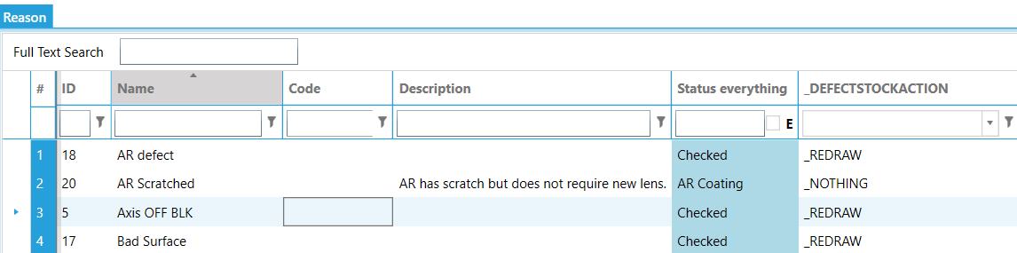
To register a defect:
- Scan Job Id
- choose either right or left side (for defect lens)
- select the specific reason
- enter all the selection column
- enter the specific reason given/approve by production Manager
- enter the Qty into the cost column
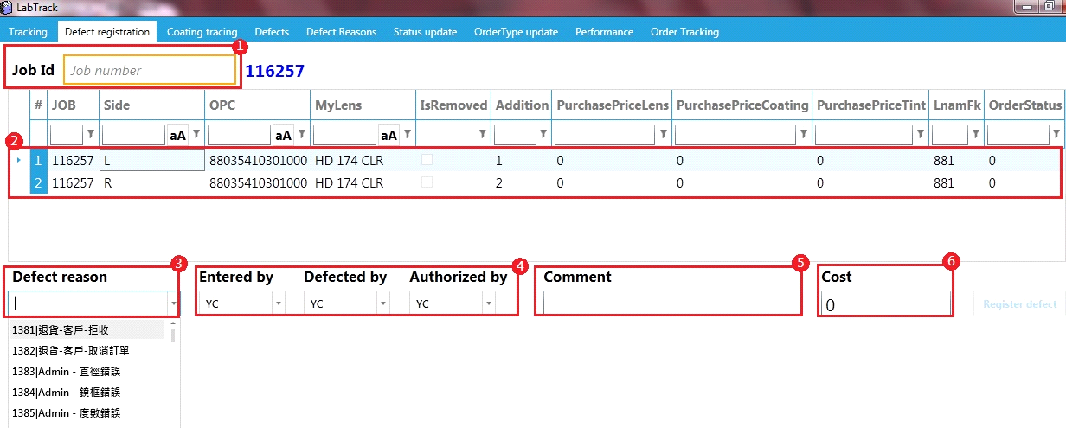

Coating tracing
The coating tracing allows you to log the jobs that where in the same coating batch. This is very useful for tracking defects. If a coating defect on a job occurs, it is easy to trace back which other jobs where in the same batch and therefor may have similar issues.
Add a new record to the “AR Batch” and select the Machine and type of coating to be applied in this batch. Optional you can add the Recipe. Scan the job ticket number into the “Order Id” box; this will add the order to the list. When all orders are in the list, click the Save button. Note: this will also insert a status entry into the order history.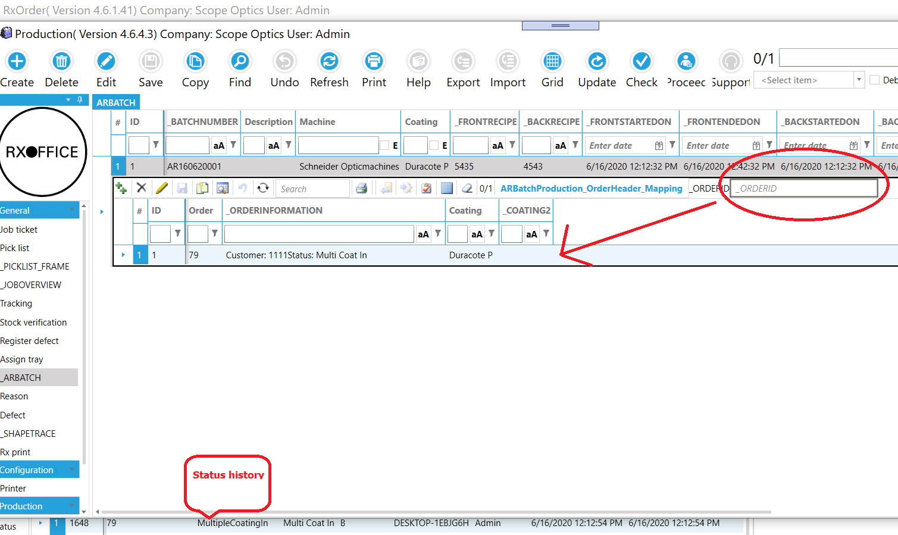

Order Tracking
There are multiple ways to see the order status.

Job history
You can check the steps performed on each job in it's job history

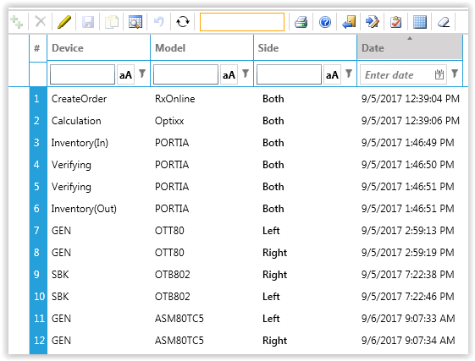
Work in progress
Jobs in the production have a different background color depending on which station- and how long the period of inactivity since last update. If the inactivity is less than x hours, the background is white; if it past x, the background increases red with a higher inactivity.
Station | x
Calculated | 2
Job ticket printed | 2
Inventory control | 3
Surfacing | 2
Outsourced | 72
Hard coating | 6
AR Coating | 8
Tint | 6
Edging | 4
Warranty card printed | 4
Envelope printed | 4

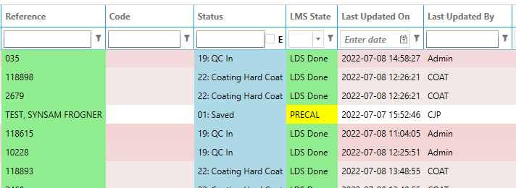

Reports
RxOffice offers powerful and flexible mechanism to manage the reports. the user has the rights to add/adjust/re-design all reports in a stand-alone report designer software. Each report has a template file (RxOffice provide a default template for each report). It is named with combination of “Report Identifier_LabId.trdx” (LabId is the internal identifier of each factory). All template files can be found in “%rootfolder%/report” folder. The user can open it with report designer to modify default template.
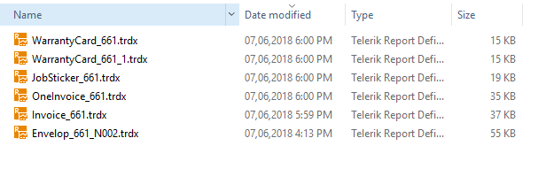

Custom reports
It is quite common that the customers ask a specified report layout to achieve their own purposes, like invoice, warranty card, envelope etc. RxOffice offers a full solution based on report engine. Here is the instruction:
- Register report to system:
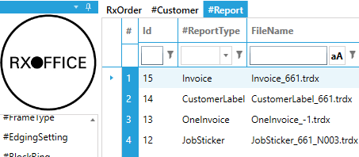
ReportType: the report type
FileName: template file name in “%rootfolder%/report” folder
- Assign to customer
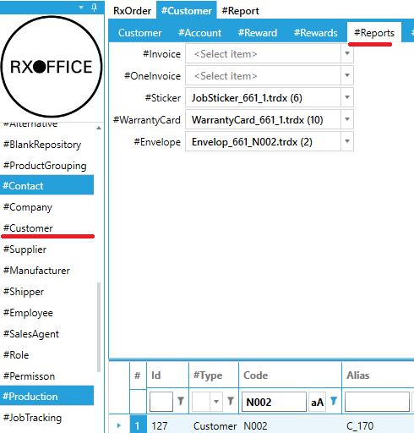
Navigate to “Customer” screen to specify the report template. Default templates are assigned.
- Once the changes are commit, the customer associated report will change

Report Deginer
RxOffice uses “Telerik report engine” as basic infrastructure. It provides a brilliant, concise solution for the user to create/edit report templates.
By default, You can find the report designer exe file on \\ServerName\RxCalcData \ReportDesigner\Telerik.ReportDesigner.exe
Report designer tutorial: https://docs.telerik.com/reporting/standalone-report-designer#starting-the-standalone-report-designer

Advanced
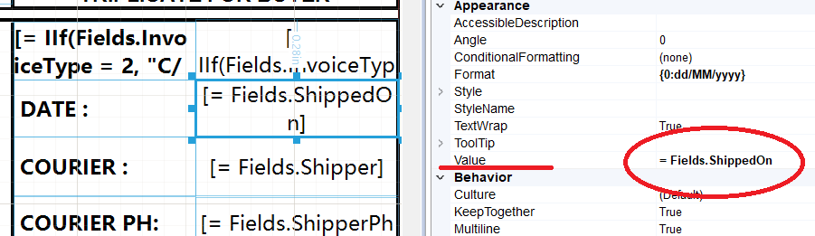
The fields on the reports are linked to the database through the corresponding =Fields.XXX property, where XXX is the name as in the LMS.

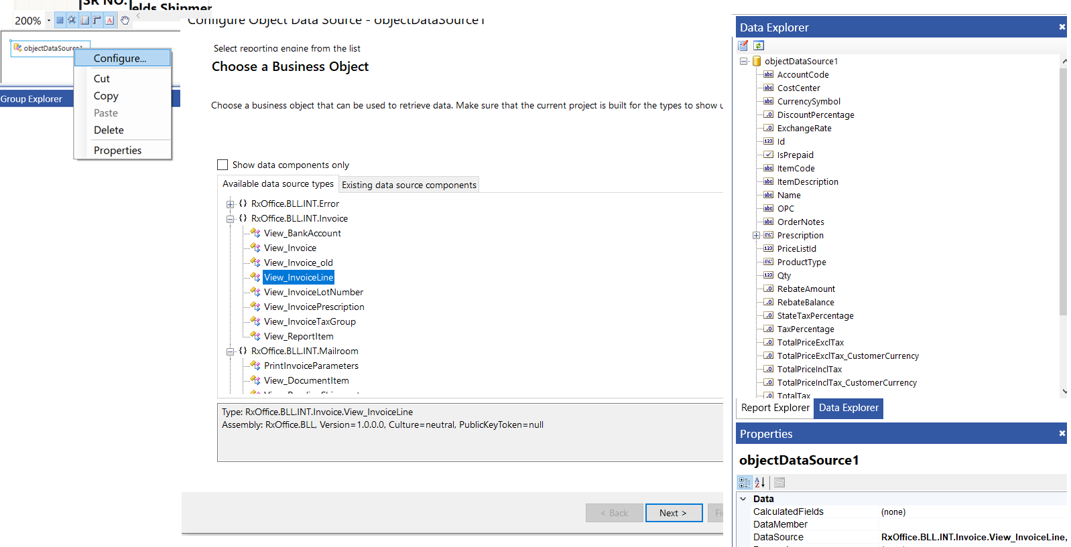
If you need a field which is not on the default report template, you the available fields are shown in the “Data explorer”. In case the list is empty, you can configure it like below.
Report | Data source
Packinglist | RxOffice.BLL.INT.Invoice.View_InvoiceLine
Statement | RxOffice.BLL.INT.Invoice.View_InvoiceLine
Warranty card | RxOffice.BLL.INT.Order.View_WarrantyCard
Job sticker | RxOffice.BLL.INT.Order.View_JobSticker
Envelope | RxOffice.BLL.INT.Order.View_Envelope
Pick list | RxOffice.BLL.INT.Order.View_OrderLine

Pivot reports
All data is available in so called pivot grids (2). The Pivot Field List is a control which provides functionality similar to the PivotTable Field List panel in MS Excel. Data can be drilled down by clicking the + or – sign. The pivots are available under the statistics section in each module. The inventory module has pivots related to usage, the order module related to jobs etc.
To load the data, select a date range of interest and click the “Load” button (1). To add more fields to the pivot, you can tick it in the field list (3). Modify the way of representing aggregated data by adding/sorting the column/row group descriptions (5), the aggregate descriptions (7) or the report filters (4). You can do this by dragging fields across the four list boxes in the field list or by reordering the items in a single list. Once you organized the data in a way you want to use frequently, you can give the layout a name and save it (9). Optionally you can export the data to excel (8); either expanded (meaning all the + clicked while exporting) or collapsed.
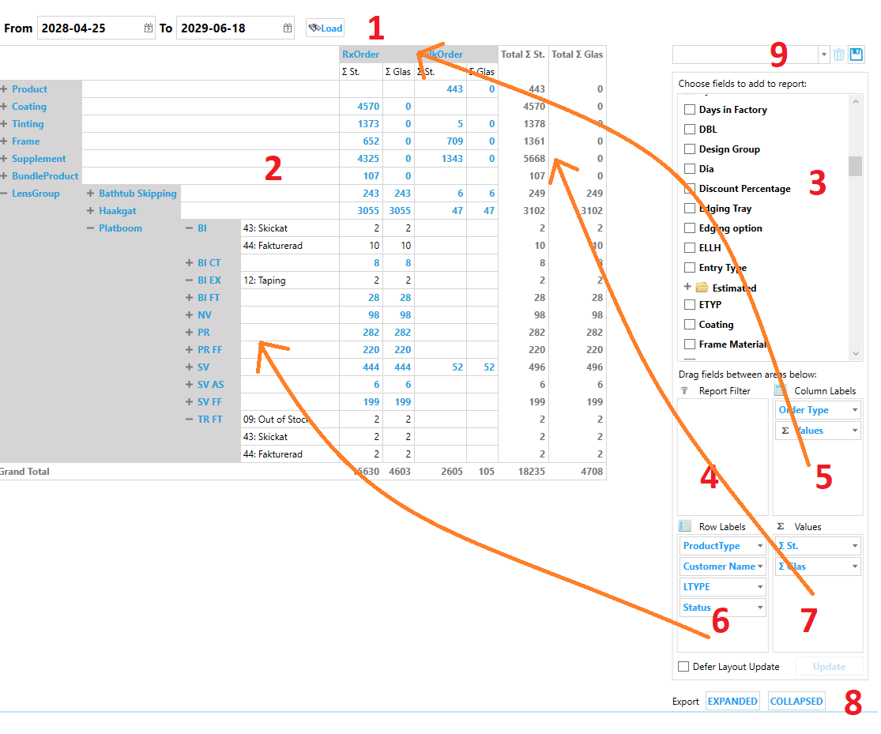

Value Options
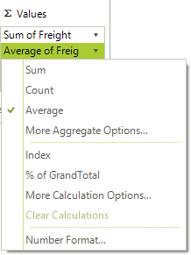
By using the drop-down menu of the items in the Values list, you can modify settings related to the aggregate descriptors. For example, you can choose between the available aggregate functions (Sum, Count, Average, etc.) or you can modify the way that the values are calculated and displayed (% of total, % of another field, index, rank, etc…). Additionally, you can change the number format of the calculated values.

Label Options
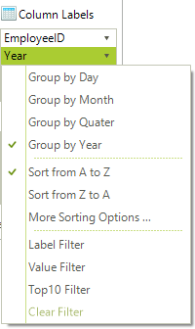
By using the drop-down menu of the items in the Row/Column Labels lists, you can modify settings related to the group descriptors. For example, you can edit the sorting options and apply a label filter, a value filter, or the so called Top10 filter. Additionally, you can manage settings that are specific to the type of the field. You can change the date interval used for grouping by a Date Time field or change the step used for grouping a numeric field.

Example Pivot
The order pivot has several options (all names can be changed in the “Resources” screen as usual) for the orders displayed in the selected period. Ordered (creation date), Shipped (dispatched date), Pending (work in progress), Delayed (current date passed due date), Backorder, Returns, Credits and Cancelled.

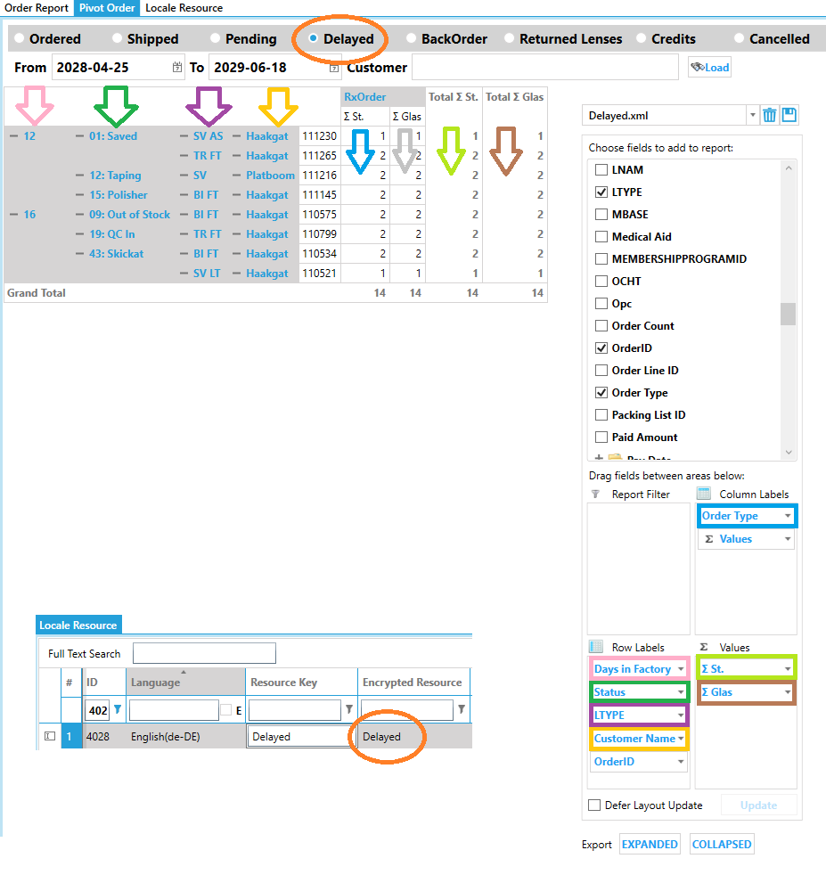

Dashboard
The dashboard visualizes the distribution of revenue, lens type, status, machine usage and monitoring etc. in an easy to understand way.
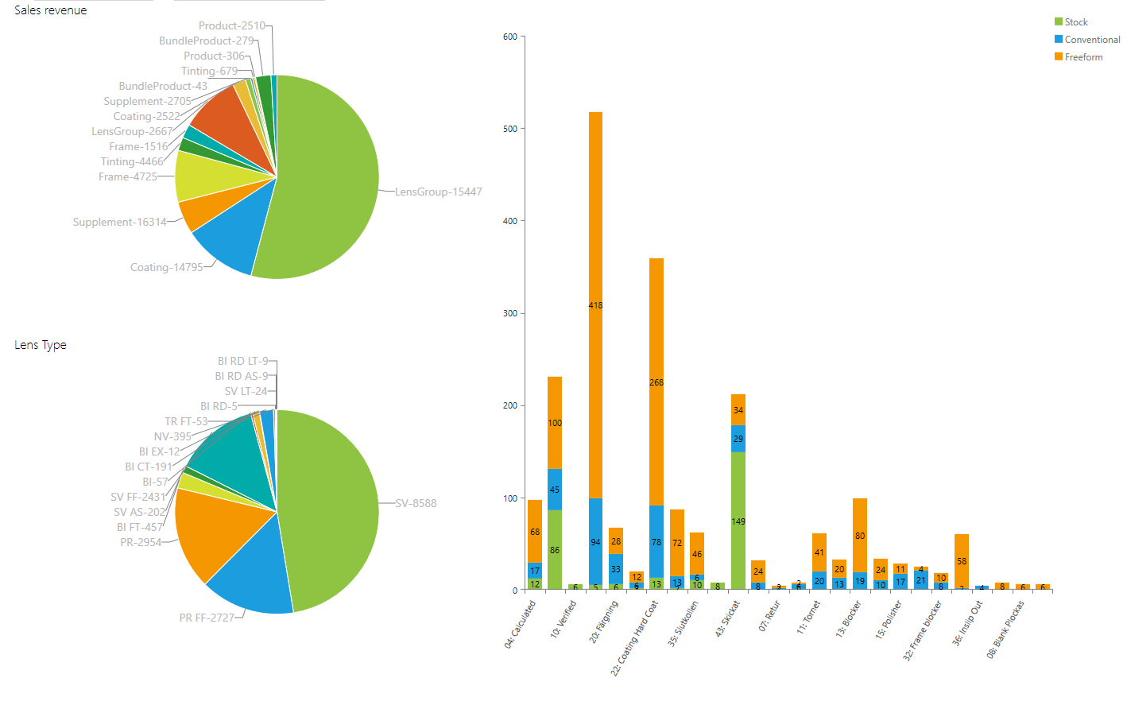

Machine monitoring
As with any other pivot, you can select the data to be displayed in a time span. Example below shows which type of lenses are produced on each machine.
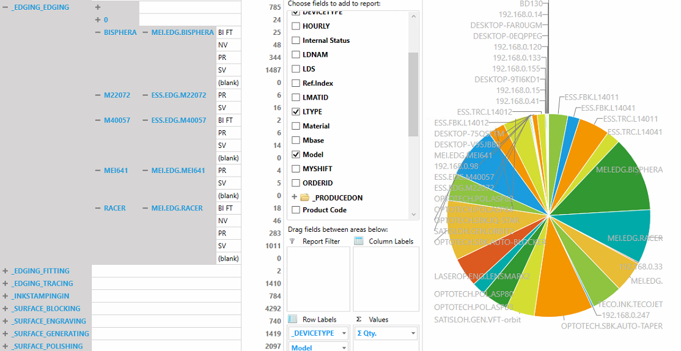
The machine monitoring gives a real time overview for your production. Target value (set in the “Capactity” fields in the “Machines” screen) determines the displayed color. The small value in the “Throughput” column represents the last 5 minutes. The small value in the “Total today” is the target value based on the lab opening time. Click the plus + sign to show any scheduled maintenance actions.
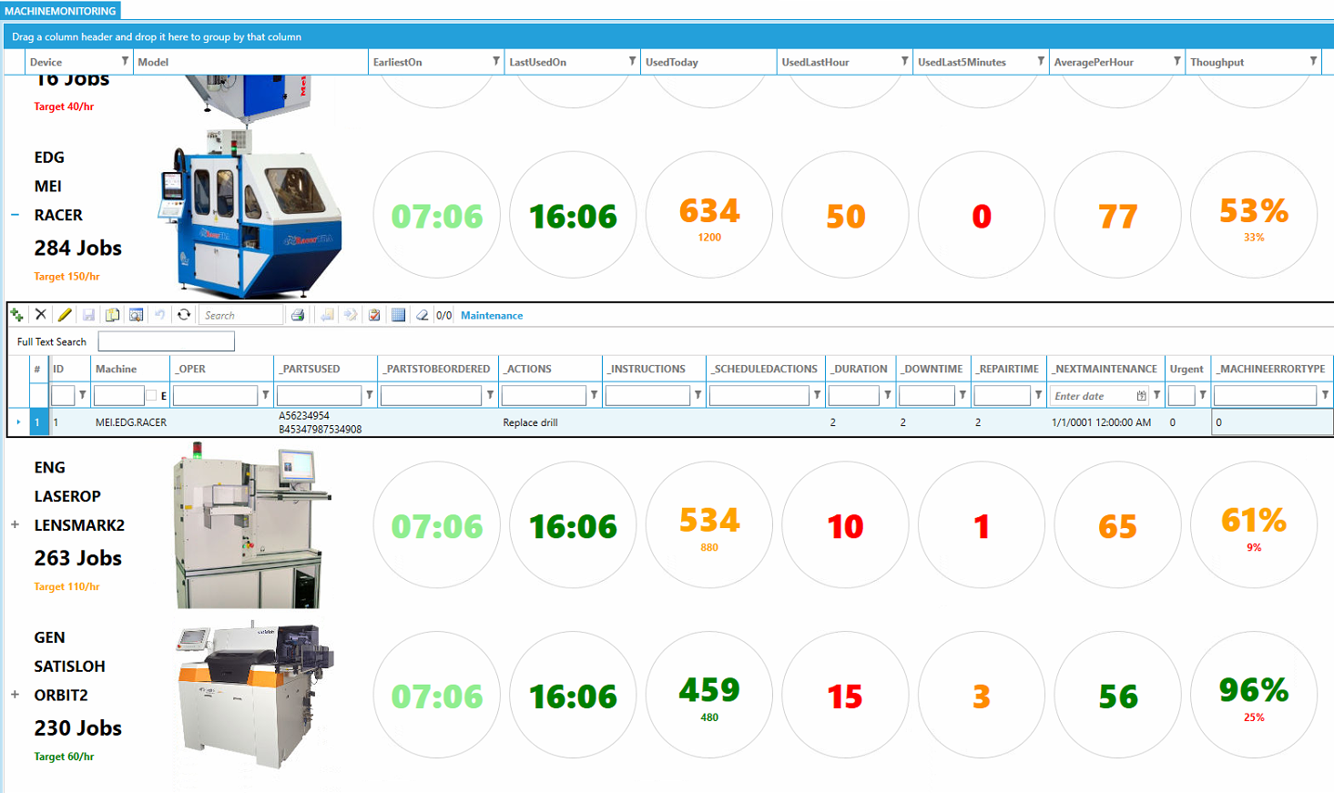

Online
Customers can log-in to the online ordering and check the order status while sending a Query? to customer service and also click the reorder button. This tracks re-do’s and multiple pair orders.
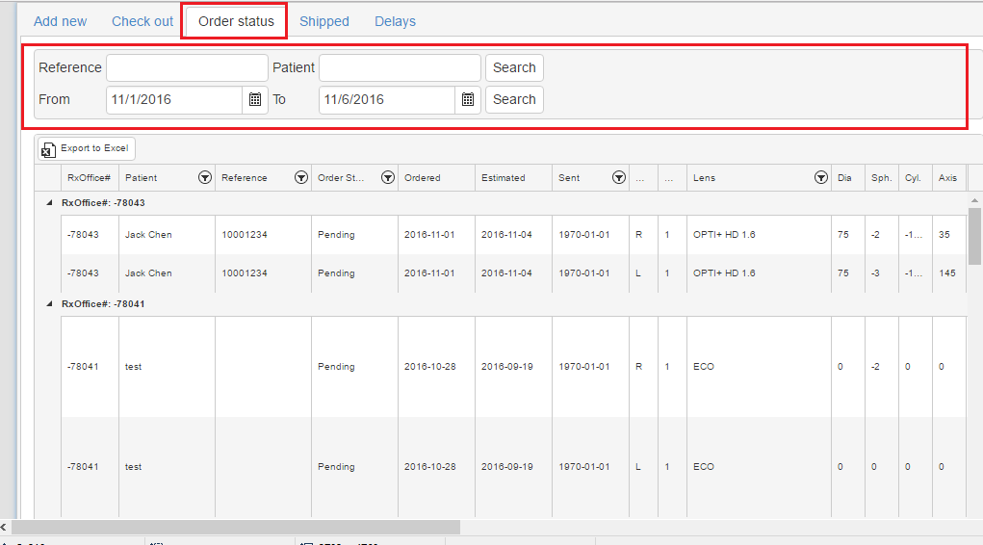

Contacts Module

Customers
There are different types of customer. Any type of customer can create an (online) order. They distinct by where the order is delivered and invoiced.
Type | Description | Deliver to | Invoice to
Direct | Regular customer | Customer | Customer
Distributor |  | Distributor | Distributor
Indirect | Customer of distributor | Distributor | Distributor
Chain HQ | Head office | Chain HQ | Chain HQ
Chain Branch |  | Chain branch | Chain HQ/Branch
Note: all pricing and discount is defined for the “Invoice To” customer.

Statement options
You can assign a different layout for the statement, based on customers requirement.
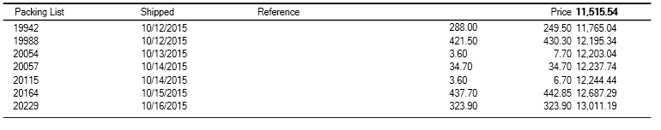
Summary: each line is one shipment
Line: each line is one order.
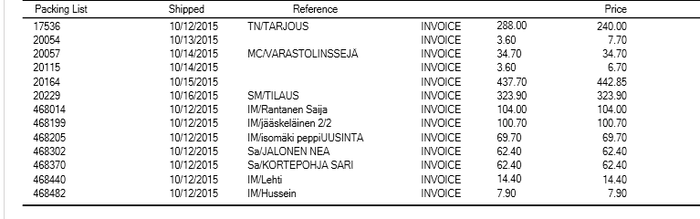
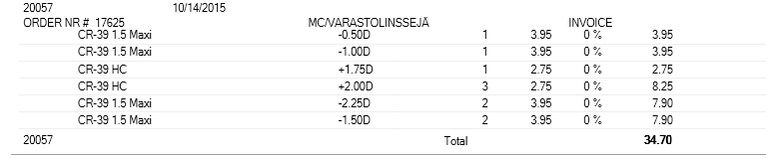
Detail: each line is one order. The details for the order are shown

Employee
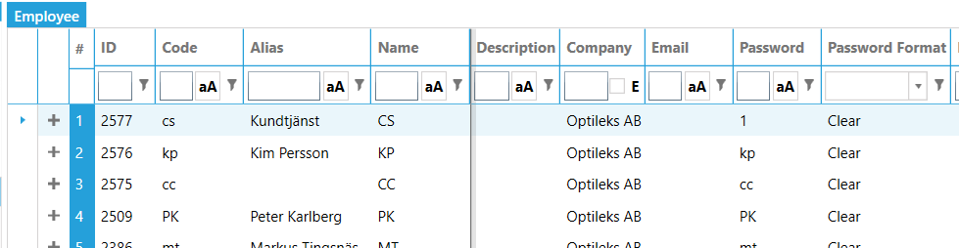
You can assign your employees different logins with individual permissions. Code and password are used as login credentials. To assign roles, see chapter Permissions

Sales Agent
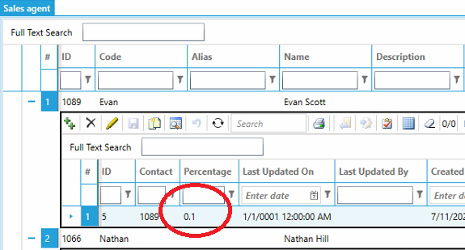
Define the sales agent in the “Sales agent” tab. Their commission is defined in the “percentage” column (0.1 means 10%)
A sales agent may represent several customers at the same time. You can assign the sales agent to the customer in the customer screen.
On the “Incentives Pivot” you can select a period and load the incentives earned by the sales agent. Like always you can drill down or add more information (like customer name, product name etc.) to the pivot.
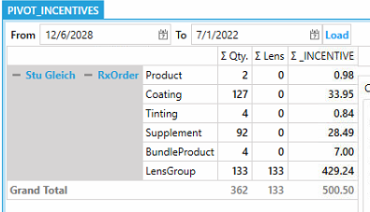

Mailroom
Any process related to sending of the goods to the customers are done in the mailroom module. The layout for the reports can be customized in the report templates.

Predefined Shipping price
Predefined shipping price calculates and charge shipment cost automatically while shipping the orders, if user doesn’t specify the shipping price.
- Config basic shipping data
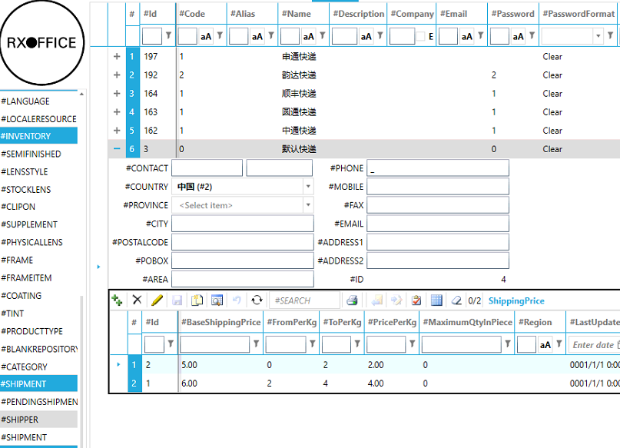
For example: The record #1 means the base price is 5.00 + (Net Weight) * 2 if weight is between 0Kg and 2 Kg.
- Create Shipment
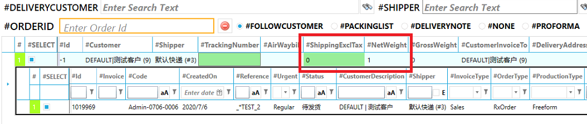
If user leaves “0” for shipping price, the program calculates the shipping price according to basic data.

Pending shipment
The pending shipment lists all items that are ready to be send to the customer. There are 3 ways to find the items
- select the customer in the Delivery text box. This will list all orders for this customer.
- select the Shipper. This will list all orders for customers assigned to this shipper.
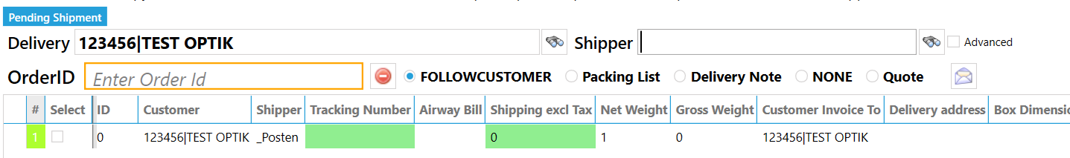
- enter the Order Id. This will add one order to the list. It will also select the customer, so you can use scanning the job ticket as a quick way to select a customer.
When you click the Print button, the system will print:
Follow customer (the default shipping document assigned to the customer), the Packing list, the Delivery note or a Quote. The None option will not print any documents, but will generate and invoice number and change the status.

Before printing, optionally enter the Tracking Number (will be assigned to all orders in the shipment), weight and dimensions (for transport costs calculation).

After printing, the system updates the order status and saves the documents as PDF. If the customer is marked for electronic invoicing, he will receive the PDF in his mailbox.

Instead of using a USB scanner to enter the Order Id and shipper (print a list of shippers from the Contacts module), you can also use RS232 scanner. This requires an entry in the “Machines”

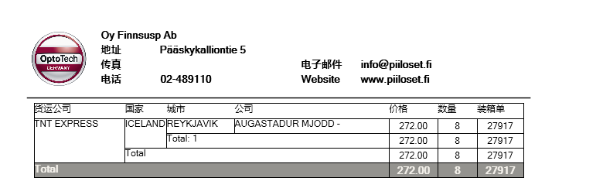
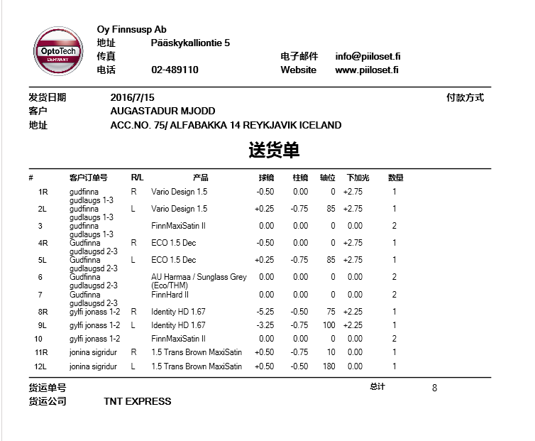
- acking list
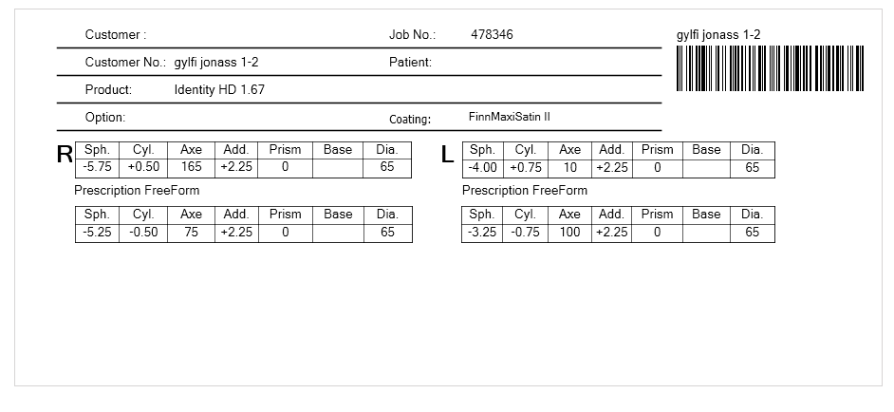
- Envelope
- Warranty card
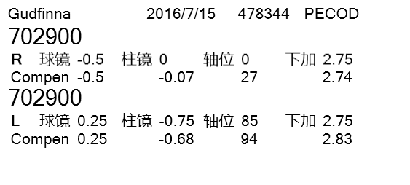

Serial barcode scanner
Instead of using a USB scanner, you can also use RS232 scanner. This requires an entry in the “Machines”
Device must be BARCODE
Address is the name of the computer that has the serial scanner connected
Interface RS232
Settings COM4;9600;8;1;0;0;0;0 (change 4 to your port number)
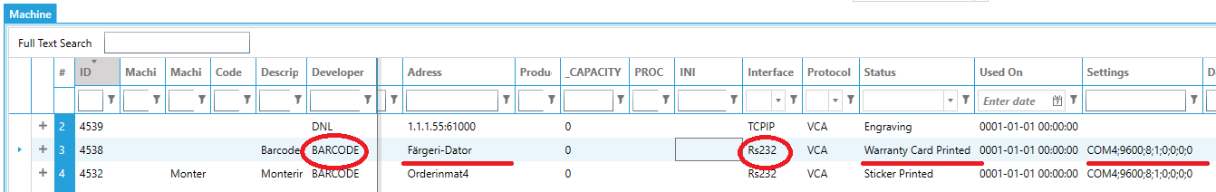

Status
“StickerPrinted” will print Job sticker
“WarrantyCardPrinted” will print warranty card

Price module (ERP version)
Before an item appears in the orders module, it must have a price entry. You can’t sell a product if there is no price definition; it may have zero price, but it must exist.
A price is defined for a specific product and pricelist combination. Before entering prices, you must create the price lists and the product. To create a new price entry quickly, you can select (multiple) products in the Inventory module, right-click and select the Create price option. This creates an entry in the prices table. At this point, the system can’t know your selling price and retail name, so those need to be entered manually afterwards.
If you prefer to do it manually, you can also add a price entry by click the Create button 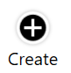and select the product to be priced from the drop-down list.
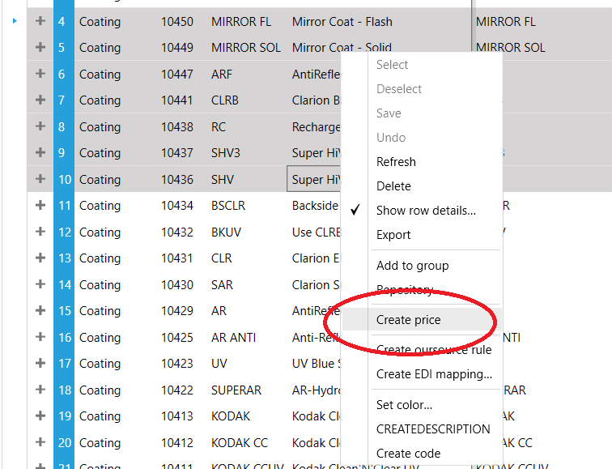

Lens
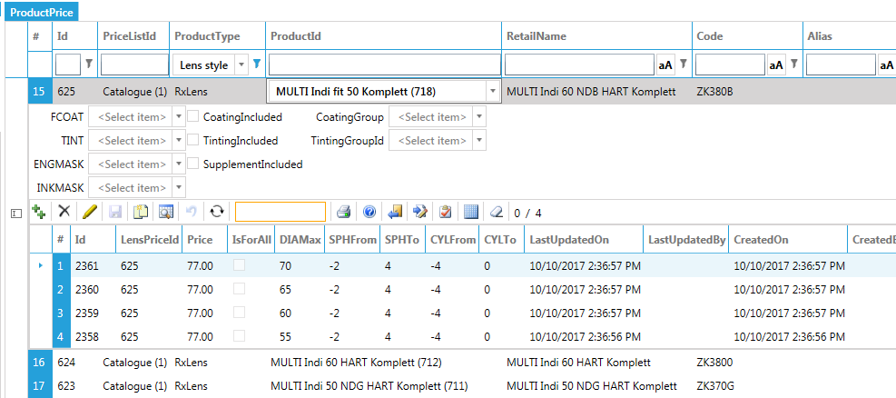
- Open “Price module” and click the “product price” on the navigation bar.
Columns:
- Product: select the product you want to price;
- Retail name: the name as printed on all customers documents (e.g. invoice and warranty card)
- Code: internal code for fast order entry
For lenses you can optionally define:
- default coating: system adds this coating to the job when selecting this lens
- includes coating: check if the price includes the coating
- available coatings: select the coatings which are available for this lens. Note: leave empty to allow all available coatings for the lens material.
- Engraving: by default the system uses the engraving as defined in the product. Here you can define a custom engraving for branding purpose

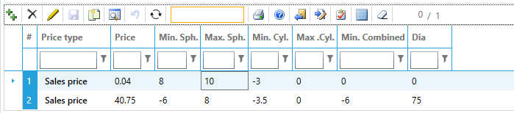
- Create the price for power range
- Min. Combined: to ensure the lens inside does not become to steep for production you can limit the Minimum combined power. On the minus side you have for example a minimum sphere –10 and a minimum cylinder –6. In total that would be a minimum combined of –16. But probably you want to limit it to, for example, combined –12. So sphere – 8 with cylinder –4 or sphere –9 with cylinder –3. Sphere –10 with cylinder –3 would not be allowed (because –13 is “steeper than –12). If you leave min combined to be 0, the program defaults the “min combined” equal to the “Min sphere”
- Save item.

Supplement Charges
Different additional charges can be added to an order automatically based on user defined conditions
For example, if the sphere power is outside the defined min-max range in the lens price, an additional charge will be automatically applied.
The price depends on the number of 2 diopter steps.
Example
if the sphere is defined up to 4 and the customer orders:
- 5 then the step is (5 - 4) /2 = 0.5; 0.5 is one "step"
- 6 then the step is (6 - 4) /2 = 1; 1 is one "step"
- 6.25 then the step is (6.25 - 4) /2 = 1.12; 1.12 is two "steps"
In the “From – To”, you must define the number of steps (not diopter!) the charge applies to. In the example below the charge will apply if the sphere is 0.25 to 6 diopter out of range. Note: do not enter 0 in the “From”; then the charge would always apply.
The quantity mode can be an accumulation (e.g. It increase the quantity for multiple occurrences on a per piece base) or constant (e.g the supplement is only applied once in a job) Typically glazing charges are constant and power related charges accumulate.
If required, you can specify multiple lines with same “Service Type”. The system will automatically choose the appropriate one based on the conditions.
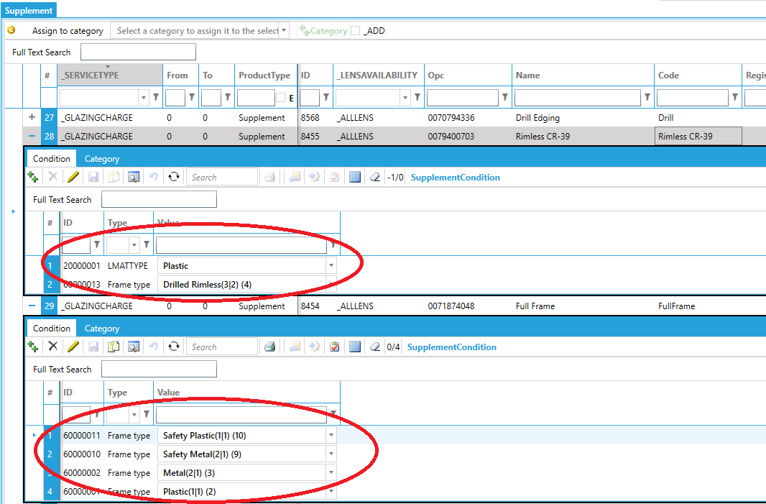

Product bundling (Packages).
The product bundle feature, allows combining several products or services into a single comprehensive package for an all-inclusive reduced price. Like any other products, you must first create the product in the Inventory module and then you can price them (by pricelist) in the pricing module.
Before you can create a package, you must group the products into categories. The categories will appear in the dropdown. You create a package for frame and lenses. Optionally the package can also include coating, tint and supplement; if these are not included in the package, the system will use the standard pricing for this product type.
When the order is saved, the program will check all items in the order if their combination matches any product bundle definition; if yes, the package product is automatically added to the order and all items in the package will have a price of 0.

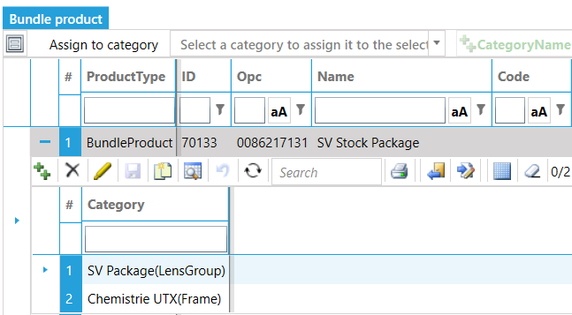

Copy pricelist
To copy items from one pricelist to another, select the items you want to copy and click the “Copy pricelist” from the context menu.
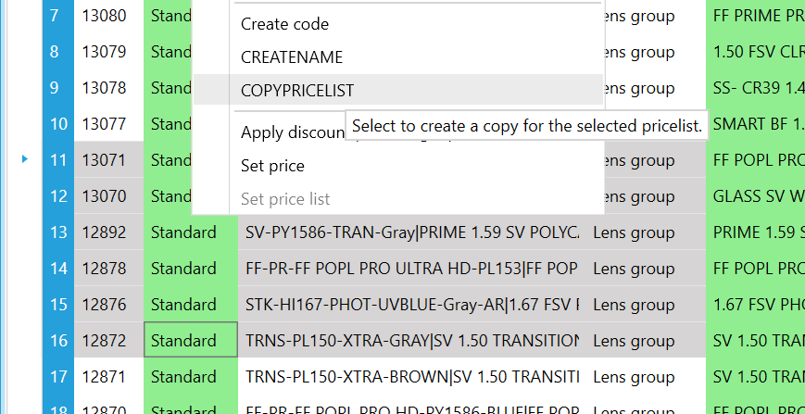
From the pop-window, select the destination price list and click Ok. The system will check if the product already exists in the destination pricelist; if yes the line item will be ignored. After the copy, the copied items appear as new records in the grid. You can double check before saving and “refresh” to undo or save to store new items in database.
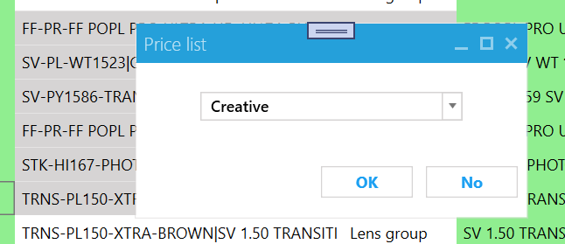

Discounts and rewards
The product pricing is controlled by pricelists and discounts. A product can be in multiple pricelists and a customer can use multiple pricelists through his assigned “price list header” (e.g. bill plans).
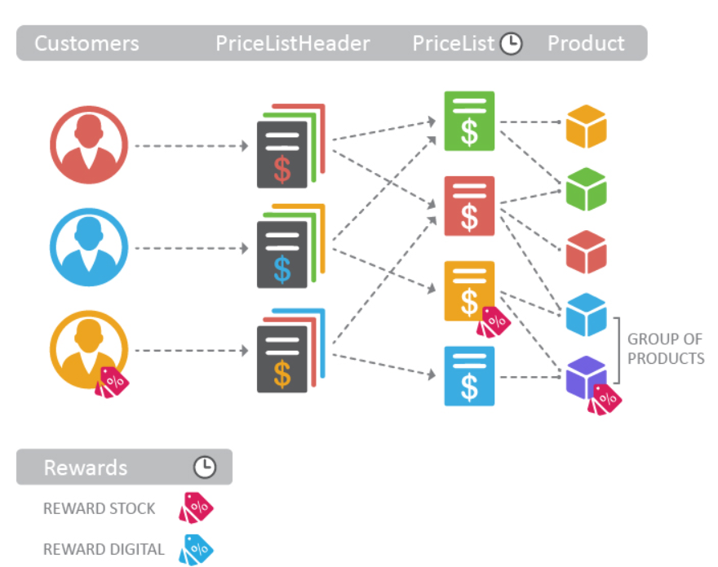
The system conceptually organizes rewards into two broad categories. The first category is instant rewards (e.g. discounts) which are earned and redeemed in the same transaction. The second category is deferred rewards. These are rewards that are earned in one or more customer transactions and redeemed in subsequent interactions (e.g. discount awarded based on monthly turnover).
- Item exclusivity: When this flag is TRUE, a deal has item matching rules which once applied (i.e. matched to a sale /return item) cannot be used on any subsequent sale return line item in the transaction. It is a "use it once" rule. Example: We have two RewardDerivation rules (with attendant eligibility rules). They each have their ItemLevelExclusivityFlag values set to TRUE. Only one of the two rules may be used in a transaction Buy SKU 3879 and get a SKU 3879A attachment for free (limit 1 per customer) Buy SKU 3879 or SKU 4736 and take 50% off anything in Dept 232. In this example the firing of the first rule for SKU 3879 is exclusive and prevents the firing of the second rule.
- Disposition code: indicates if the redemption of points is instant (based on rules fired at the point of sale) or deferred which requires a separate action on the part of the customer and/or retailer. Redemption of points may happen any time after they are earned. Typically, they are redeemed automatically using electronic coupons. Deferred redemptions mean that points may be redeemed at a later time based on a retailer defined event or trigger.
  - Instant: discount reward is redeemed within the scope of the transaction it is earned in
  - Accrued_To_Instant: use balance
  - Deferred_Accrued: increase the balance
  - Deferred_Accrued_Instant earn marketing target but give them the discount instantly. If the target quantity or amount is not reached in an agreed period, the customer gets an invoice on the difference later on
- Transaction level action: Determines how a Reward is applied to a transaction
  - % Off": base retail price is reduced by the discount percentage
  - New price: base retail price is replaced by the value
  - Amount off: base retail price is reduced by the amount which is a flat monetary value.
  - Earn reward currency: Points, miles, or another retailer designated reward currency units are added to a customer account.
- Redeem reward currency: transforms the earned reward currency for the current transaction and, at the customers option, previously accrued reward currency balance into a discount that can be taken at a transaction or line item level
- Priority tie breaker: assign a priority to the reward
- Limit amount: the reward applies if the total amount of trigger items in the subtotal (line item group or transaction total level) exceed the N value in a buy N get M reward. Enables a BOGO reward pattern at the transaction or line item group level.
- Minimum amount: The minimum value a transaction subtotal (i.e.a line item group or transaction-level total of line items) must have in order to have a reward applied. Example: Buy $150 or more worth of merchandise in a transaction get a 10% discount. The $150 is the minimum amount. If the customer buys $149.99 worth of merchandise NO DISCOUNT reward is earned.
- Maximum amount: The maximum subtotal value (for line item groups or transaction totals) that once exceeded ends the reward application. Example Buy $100 to $500 merchandise and receive a 5% discount. The maximum value on which a discount may be given is $500. If a customer purchases $525 worth of merchandise, the discount is capped at $25 (5% of $500). The discount does NOT apply to any amount over the $500.
- Derivation value: The reward value (a monetary amount or percent) applied to a base retail to arrive at the value of the reward.
- Valuation: determines how the reward is defined
  - Money = 0,
  - Quantity = 1,
  - Transactions = 2
- Effective date: The date and time a reward is active and may be earned and redeemed by customers.
- Expiration date: The date and time a reward is no longer active and may NOT be earned and redeemed by customers.
When determining which reward to apply, the system checks
- Is the order created in the effective date range;
- Does the product, pricelist and customer meet the reward criteria
If more than one rewards match the criteria, the system uses the reward “header” with the highest priority (3) and if inside that reward there are multiple matches it takes the criteria with highest priority.
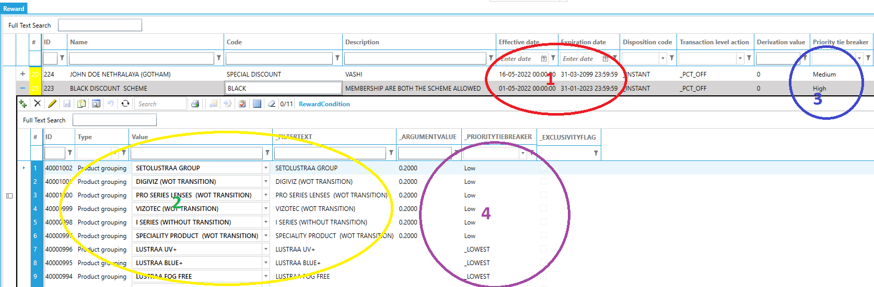

Buy X get Y

Buy X get Y promotions are a popular way to incentivize new customers to buy your products and to reward loyal customers. You can use them to increase your sales and profits and to sell slow moving inventory.
With Buy X get Y promotions, you can offer customers one free item from “Get Product group” if the order one item from “Buy product group”. You can either give a discount percentage, fixed discount or the “get product” at a fixed price.
To limit which customers will be eligible for the promotion, you can set the price list header or the membership program.
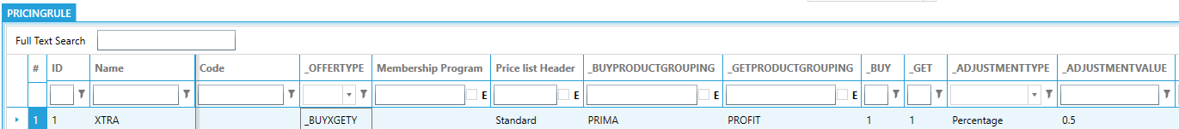

Rebate program
Rebates are an incentive program in which you offer your customers a monetary reward for reaching designated sales goals. After the target specified in the agreement is met, customers get a percentage of the price back for a better deal on their next order.
For example, the customer had a turnover off 5000 products in group “Bonus Grouping”. Then the reward will be 5000 x 10% = 500 (5000 is more than 4500 but less than 7500 so line with Id 2015 is valid). The first 21 days of the new month, he will automatically get 90% discount on products until the reward balance is zero. Optionally you can limit the products the rebate will be applied to in the “Rewards” column (Note: this reward MUST be defined with disposition code equal to “Accrued_To_Instant” or the reward is not processed)
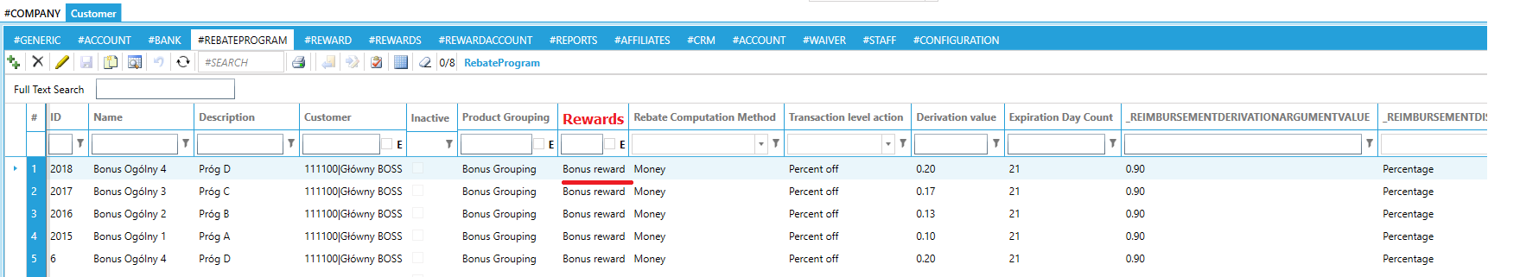
At the end of the month, right click the customer grid to calculate the rebate.
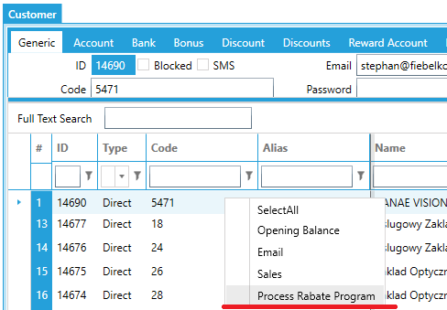
This will create an entry for each customer in the rebate account. When the customer places an order between the Effective – and expiration date and there is a positive balance, a discount as defined in the rebate program will be automatically applied.
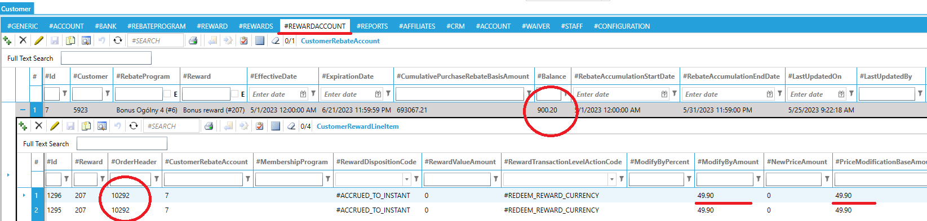
Open the row details to see the history on the rebate usage. The order lines are listed and on each line the original (=base) , modification and new price are displayed. In the example the price was 49.90. There was enough balance to discount the full amount, so the remaining is 0.

Import / Export

Generic
Bulk data modifications can be easily achieved with the LMS Import from an Excel File and Export to an Excel File. All items in the system can be exported and reimported using Excel interface.
Select the items to export and click the Export button. The system prompts for a file name and prompt to open when finished. You can open the file with Excel for easy editing
To import a file, the format MUST be in the same format as the exported file. Click the Import button and select the file to import. The new items will be green and changed items will be indicated with yellow. To commit the import, click the Save button

Frame data
To create a repository of frames, you can import files in the standard VCA/OMA format. The system will search for existing FUPC or FRAM. If it does not exist, it will create it; otherwise overwrite the existing with the data contained in the file.
- Open the "Frames" tab;
- Click the Import button;
- Select the files you want to import (multiple selection is allowed);
- Click the Open button
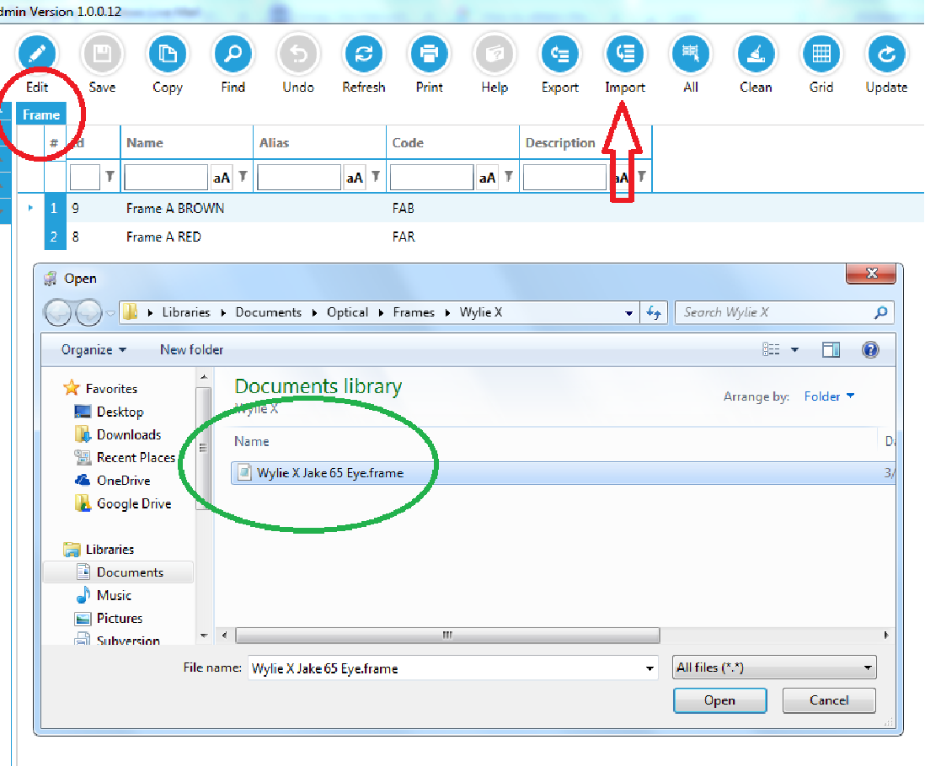

Lens Description Standard (LDS)
The importing is a two step process. First you must import the blanks to the local RxOffice repository. Then you must assign the imported lenses to one of your lens products.
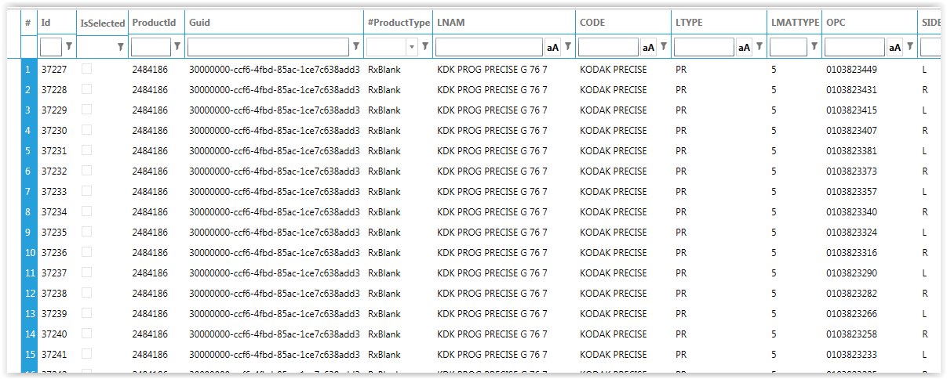
To import the blanks from the online repository, take any blank from one lens style, enter the OPC and press the “enter” key (or use a barcode scanner). The system will load all SKU’s that belong to the same lens style.
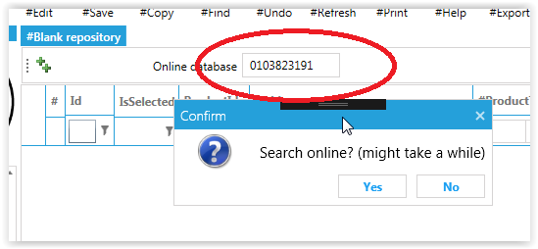
If the lens is not available in the online repository, you can import files that comply to the "Lens description standard". For example files, please visit http://youngeroptics.com/vca.aspx.

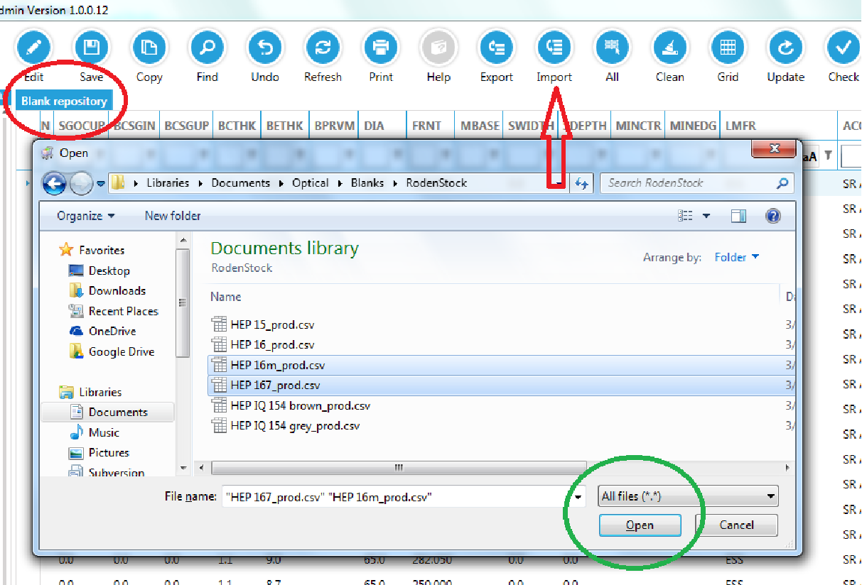
- Open the "Blank repository" tab;
- Click the "Import" button and browse for the "Lens description" file(s)
- Click "Open"; now the items will be in the list

The second step is to Export the repository to the internal blank.
- Open the "Blank repository" tab;
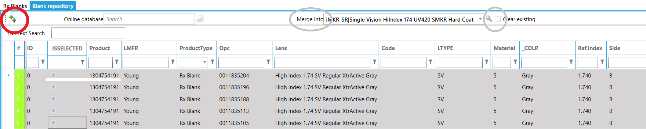
- Select the items you want to export (all blanks that belong to the same group have same Product number.
- Optionally you can select an existing group which the selected lenses will be copied into. You can choose to clear existing items in that group (so all existing blanks will cleared and the group contains the selected ones) or add them to the existing blanks (if there are 5 blanks in the group and you have 6 in the repository after click the ++ there will be 11 in the group)
- Click the "++" button

- Open the “Rx Blank" tab; you will see the items
Optionally you can also assign the lenses directly to a material.
- Open the Rx blank tab;
- enter the OPC in the "search box";
- click enter;
The system searches the blank repository for the OPC and imports it if it exists
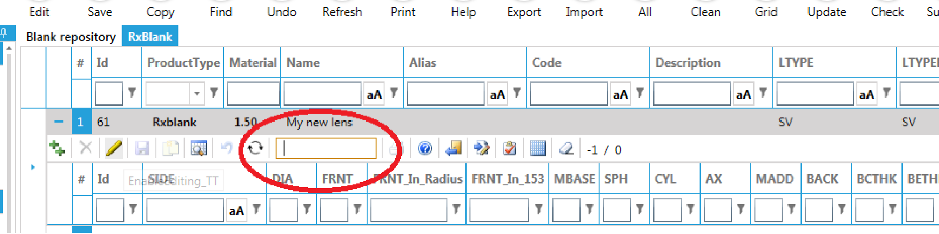

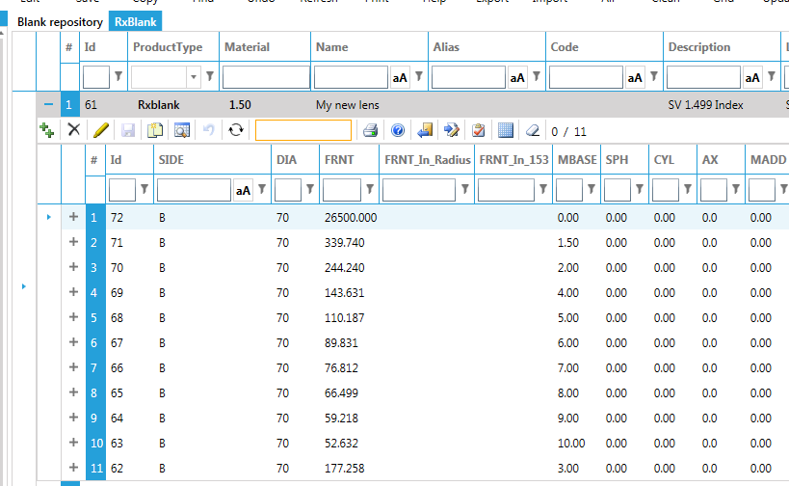

Import sag data
Some conventional lenses require the definition of the front surface for an accurate thickness calculation. The high base lenticular OMEGA lenses from Essilor for example. The are in an industry standard format
Base,Add,Radius,Angle,Sag
10.65,0,15,0,2.478934971
10.65,0,17.5,0,3.398177529
and can be assigned to the lenses in the “Semi-Finished” screen. Right click it (note: only one file can be assigned at once) and select the “Import sag data” and browse for the file.
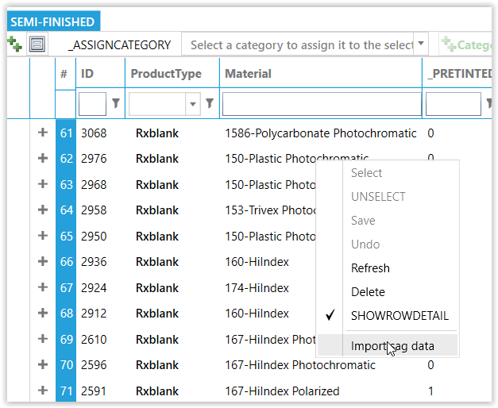

QC
The quality control module connects the auto lensmeter from Nidek, Huvitz, A&R and any VCA compatible equipment, with the LMS.
- Enter the job number or use barcode scanner to load the job. The screen will populate the prescription and design data.
- Do the measurement on the device. The QC module compares the measured data against the design data and uses a predefined quality standard to pass or fail the lens.
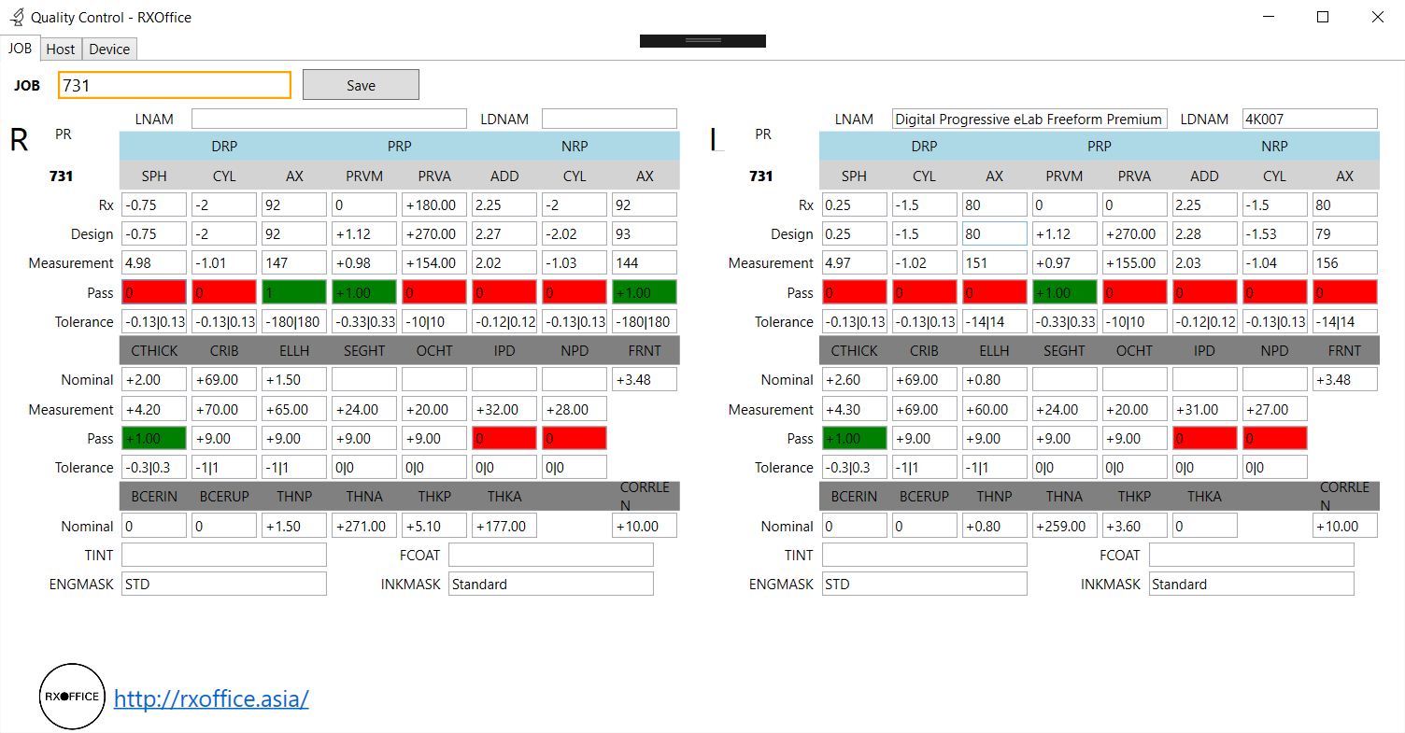
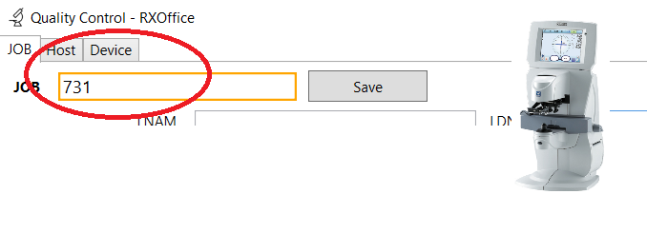
- When measurement is complete, click the Save button to upload the measurement data to the LMS.

Accounting

Statement

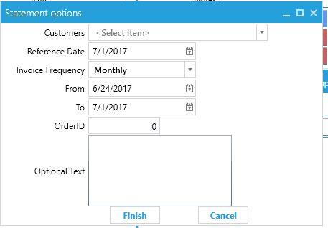
Invoice frequency: in the customer you can set the invoice (=statement) frequency. When you select the frequency from the filter screen, it will print the statement only for customer who set this particular frequency

From – To: defines the period for the shipped orders you want to include in the statement
OrderId: in case you want to print a statement for a single order only

Payments
From the payments screen, click the “+” button to create a new payment. Then click the “Allocate” button; a new window pops up. In the window select the customer, what the target payment type (sales, shipment) and click the “Load”

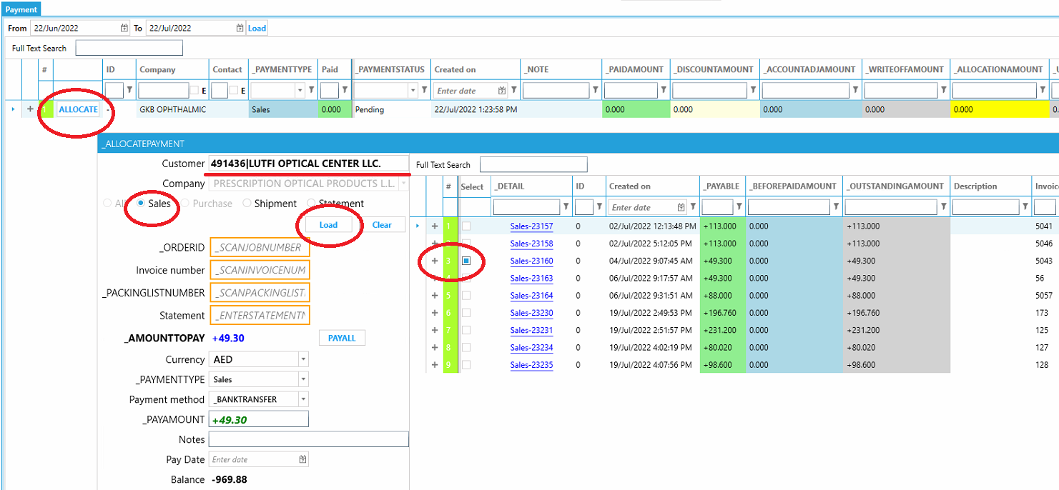
Save the payment. The status will be “Pending”. To authorize the payment, click the proceed button. This will do the authorization and allocation to the payment target. Now the payment will reflect in the Payments Pivot, Ledger and statement.
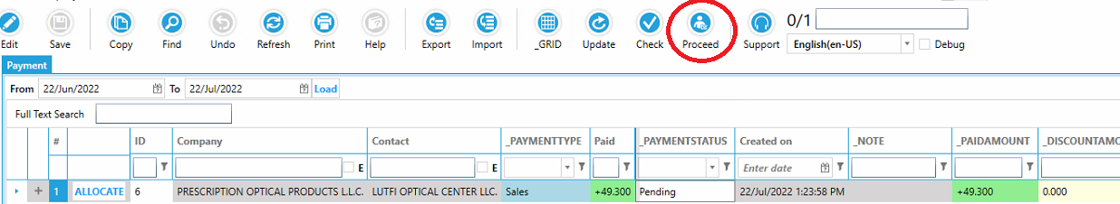

Thickness configuration options
The lens thickness is determined by numerous factors.
- the minimum edge and center thickness specified depending on material and frame
- the minimum thickness on the crib (MINTHKCD)
- minimum overall lens thickness (MINAVG, see section 23.1)
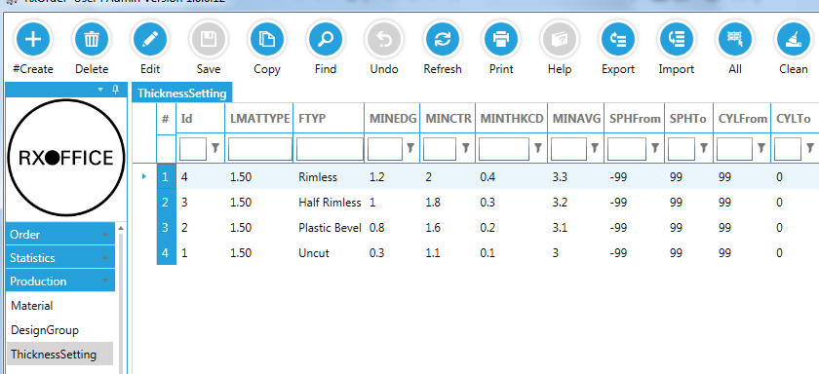
- the crib diameter

Low power lens thickness
For low power lenses, you can specify the “average thickness”. This is defined as “center + edge” thickness. The reason for this parameter is to prevent low power lenses to become to “slappy”. Imagine a +0.25 lens. If the minimum center is set to 1.2 and the minimum edge to 0.8 then the final lens would be be 1.6 in the center and 0.8 on the edge; the lens would bend like paper. This is where the “average” comes into the equation; it will increase center (and therefor edge) until center + edge = “the defined value”.
A recommended value is between 3.8 and 4.2 (depending on the material). Then the thickness would be
(3.8 – 2.4)/2 = 0.7
1.6 + 0.7 = 2.3
and the edge
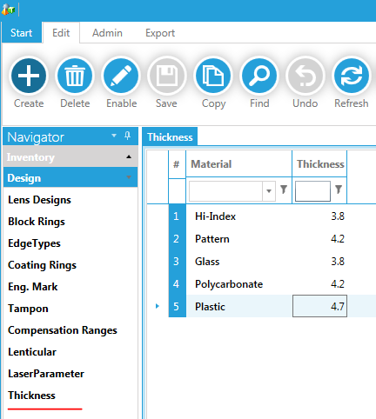
0.8 + 0.7 = 1.5

Safety lenses
To make lenses thicker for safety purposes, you can specify the minimum edge- and center thickness depending on frame-, edge and thickness type.

Configuration
Log in as administrator to modify the system configuration.

Status

Production
For a frame to come, you can assign the edging tray to order. When the lens is ready, you scan the lab job ticket. If the frame arrived, the system will show you the edging tray number where to find the frame. Once the frame arrives you select the “Edging” radio button. If the lens is ready, the system will tell you; if the lens is not ready yet, assign the frame a tray number so when the lens is ready the system can tell you in which tray you can find it.
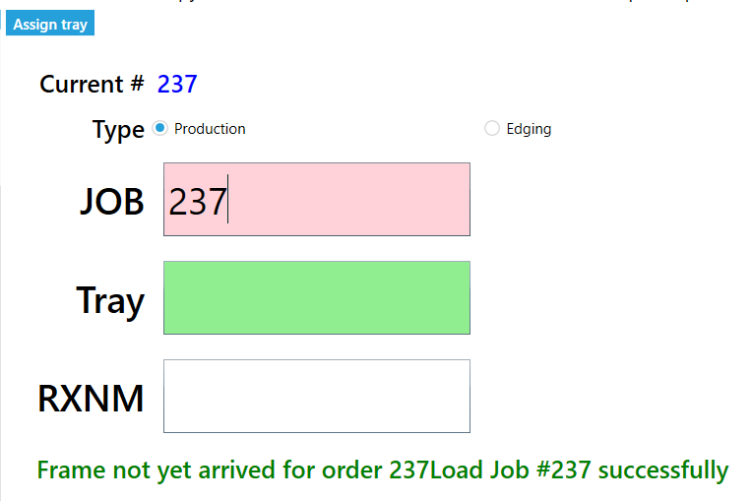

Permissions
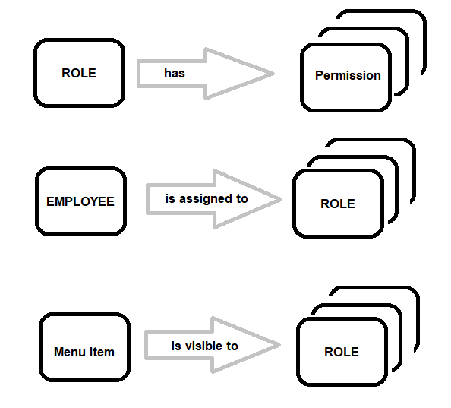
Within your organization, roles are created for various job functions. The permissions to perform certain operations are assigned to specific roles. Members or staff (or other system users) are assigned particular roles, and through those role assignments acquire the permissions needed to perform particular system functions. Since users are not assigned permissions directly, but only acquire them through their role (or roles), management of individual user rights becomes a matter of simply assigning appropriate roles to the user's account; this simplifies common operations, such as adding a user, or changing a user's department.
In the example below, employee Stephan is assigned to the “Customer Service” and “Manufacturing staff”. Each of these roles, have their own permissions. For example the role is allowed to query and order. Imagine Stephan wants to delete an order, the system will not allow him because he is not assigned any “Order delete” permission. One of the menu items he can see is the “Jobticket” this is defined in the “menu item” screen.
Note: if you check the “isAdmin” all permission settings are bypassed. Employees marked with IsAdmin do not have any restrictions.

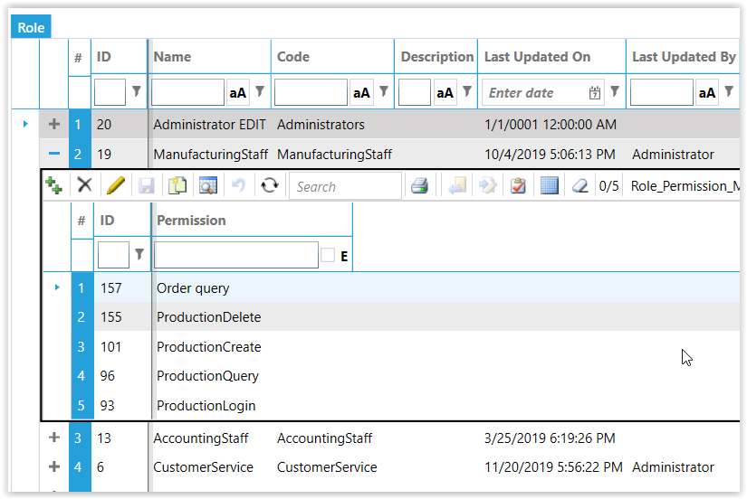
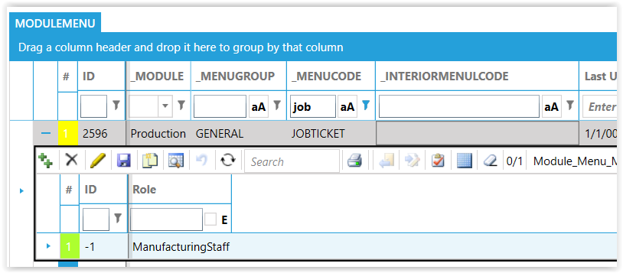
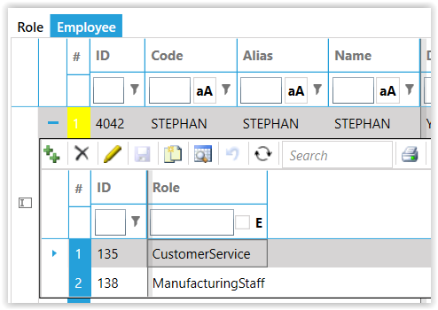

Redo
Before you can do a redo, you must define the possible reasons. The return action is the default action when you choose this reason for return on a job (obviously can be changed afterwards). In the details section you can optionally predefine the parameters for the return. If you leave the customer empty, the reason is for all customers, but optionally you can make specific rules on a per customer basis. You can specify multiple lines based on how long ago the original job was created. For example you could credit 50% (e.g. Refund type percentage and Refund parameter 0.5) if the order is between 0 and 30 and 10% if the order is between 31 and 365 days old.
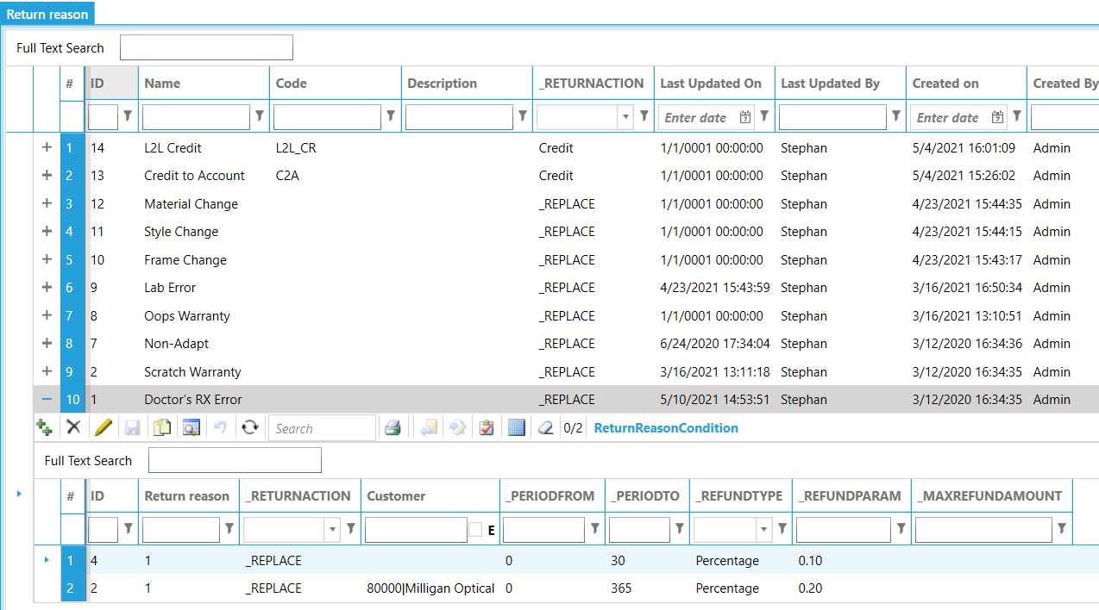
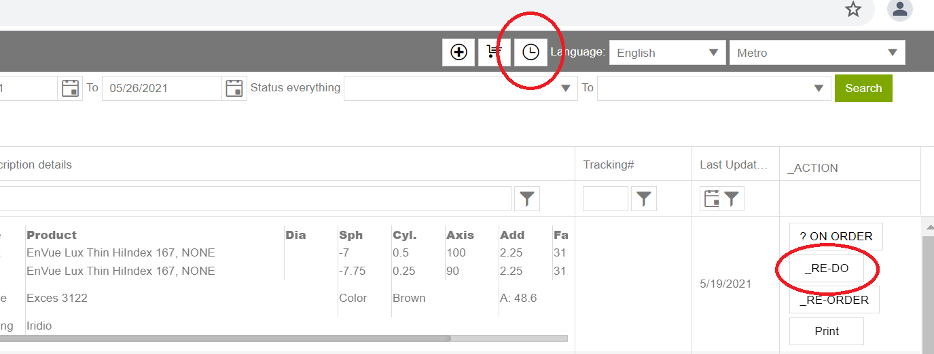
On the ROE, find the job in the status page and click the Re-do button.
Choose a reason for the redo from the drop down and optionally enter some comments. Click confirm and
a) the system will make a copy of the original job
b) you will be re-directed to the main order page and can process this job like any regular job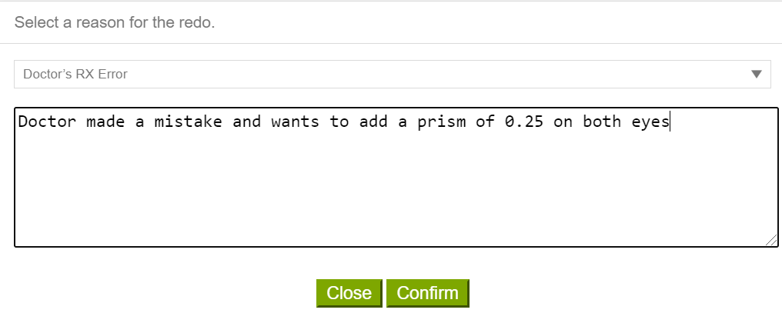
In the LMS, load the original job and click copy (note: order must be shipped. You can’t do a redo on a job that is still inside that factory; that case would be registered as defect).
- set the invoice type to Return
- select the return reason from the dropdown
- if the return reason parameters are predefined, the fields will be automatically populated. You can change as required
- after entering 1 line, you can select the others and click Unify request; then same parameters will be applied to all selected lines
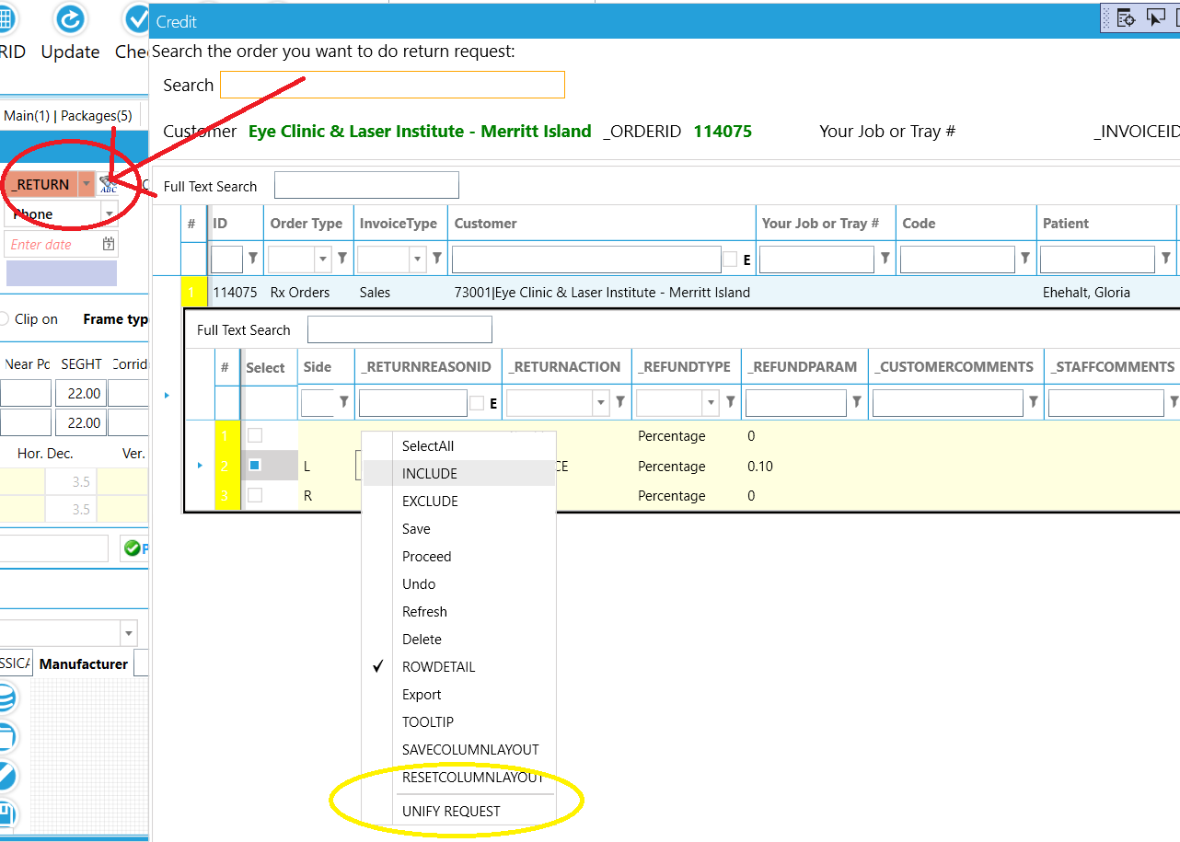

Appendix

Blending
In the Orders advanced tab, you can enter the blending parameters (freeform only). An optic zone is defined around the frame cross, and then, away from this zone, the thickness is reduced with a gradual change of curvature in order to obtain a thinner lens. Below two blending examples taken from the NOVAR documentation. The first one is the regular blending and the second the blending to frame.
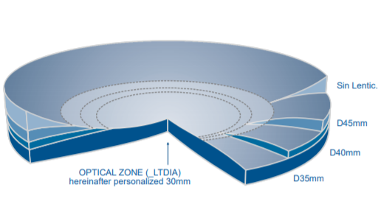
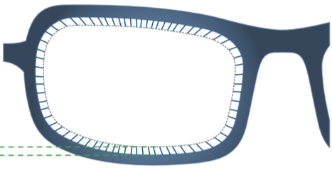

Product mapping
If you receive orders from your customers or you want to outsource to a third-party lab, chances are likely the names and codes used at the other end are different from yours. To overcome this problem, you can create a mapping between your and “their” products. During the import/export, the system will “translate” your names (e.g. My) to theirs (e.g. Ext) and vice versa on importing. This makes it easy to send or receive data with any other system.

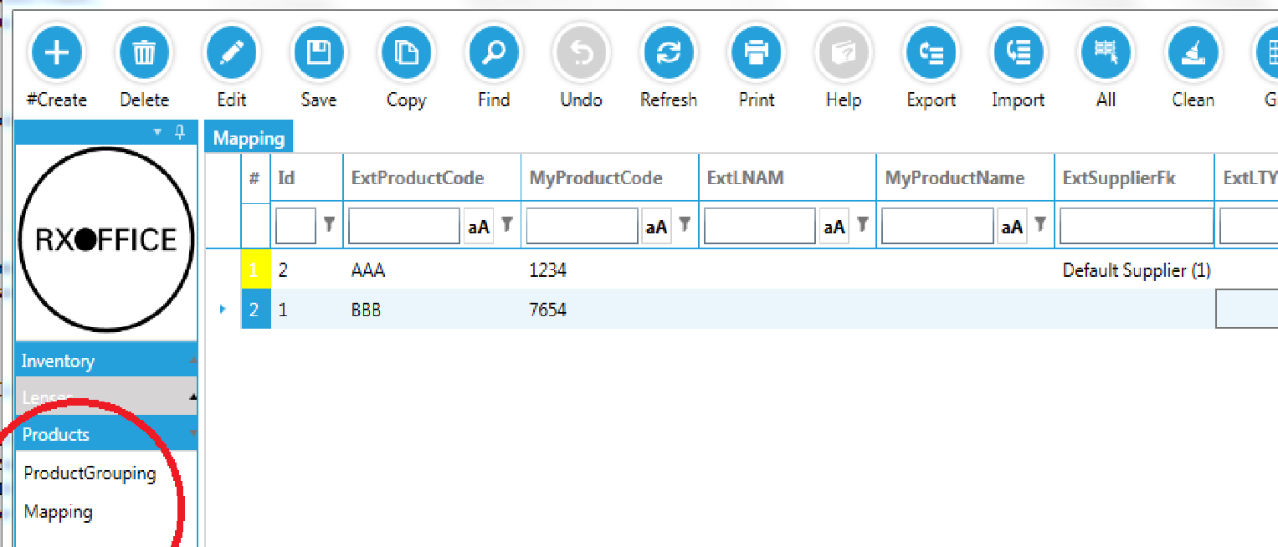

Outsourcing
When creating an order, the system will automatically create the files to outsource for you. Which lenses you want to outsource is data mined in Outsource Rules screen. To add rules quickly, you can right-click the product and select “Create outsource rule”. When the order is saved, the system checks if the product has an entry in the Outsource rule. If yes, it checks if the (optional) condition is met and if yes, it assigns the supplier to the job.
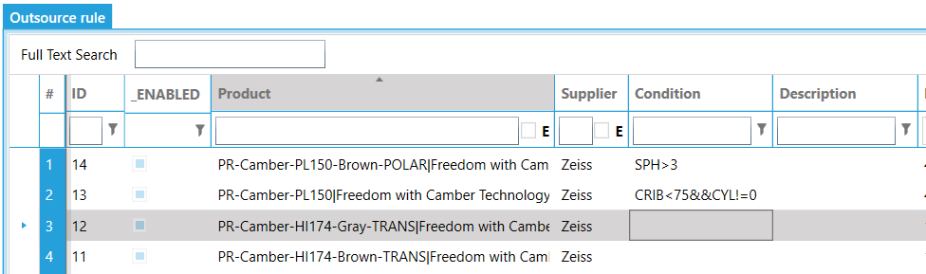

The following is the steps how to outsource.

- Set “outsource” to “Supplier”. Optionally you can set how you want it processed. If the order itself is remote edging, but you want to do the edging yourselves, you can send it as “Uncut” or “Uncut Precal” to the supplier. Enter the order as usual and click “Save”
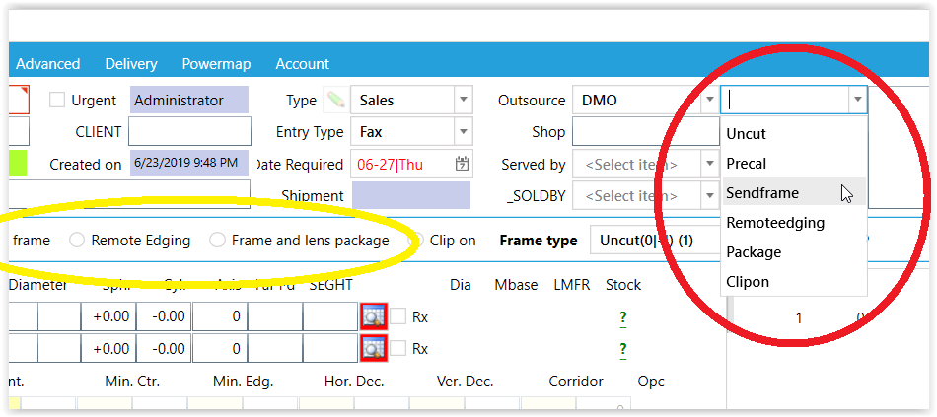
- Go to “outsource” screen and then refresh
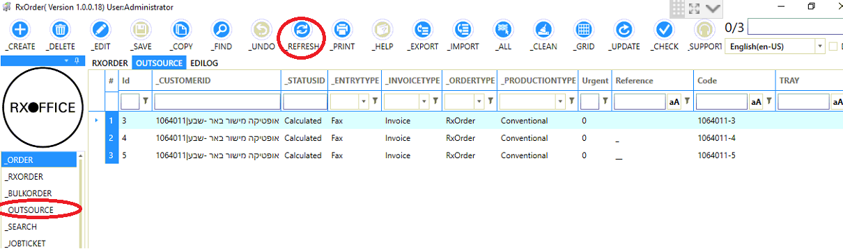
- Select the orders you want to export and then click “Export”
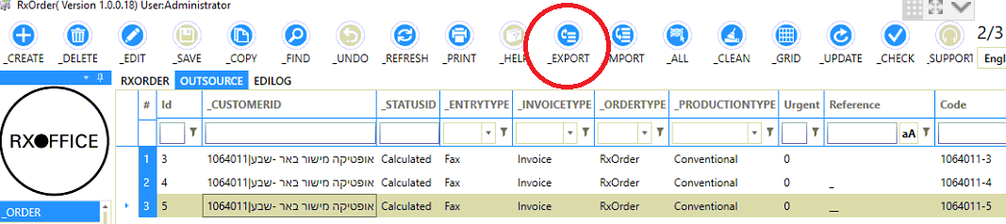
- When it is done, no matter it succeeds or fails. The program pops up necessary information of the result.
- If you want to check it deeply, you can go to “EditLog” screen. Which shows the full context of EDI process.
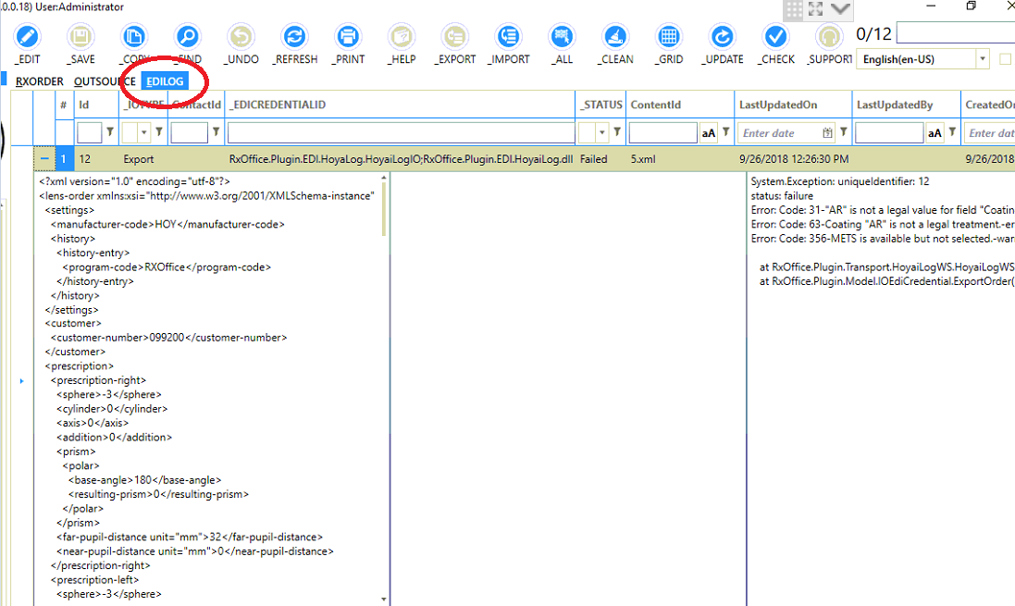

TIP: The format to be used for each supplier must be specified in the Suppliers screen in the EDI export column. Besides build in industry standards like VCA or B2B, you can write build your own exporters (see section 22.7).
When the job is created, the system will determine the supplier to use depending on the defined criteria. After the job is saved, you can optionally change the outsource in the order itself.
You can see all items which are ready to be send to a third-party lab in the RxOrders->Outsource screen. Select all items you want to order now at the supplier and click the Export button. This will upload the order according to the suppliers’ specifications. Note: you can select orders from different suppliers at once; the system will group them automatically by supplier.

Blank selection
The blank selection depends on multiple conditions
- preferred base curve
- size (blank must be big enough to cut out)
- thickness (blank must be thick enough to provide required edge- and center thickness)
- stock quantity (optional)
The base curve is determined by:
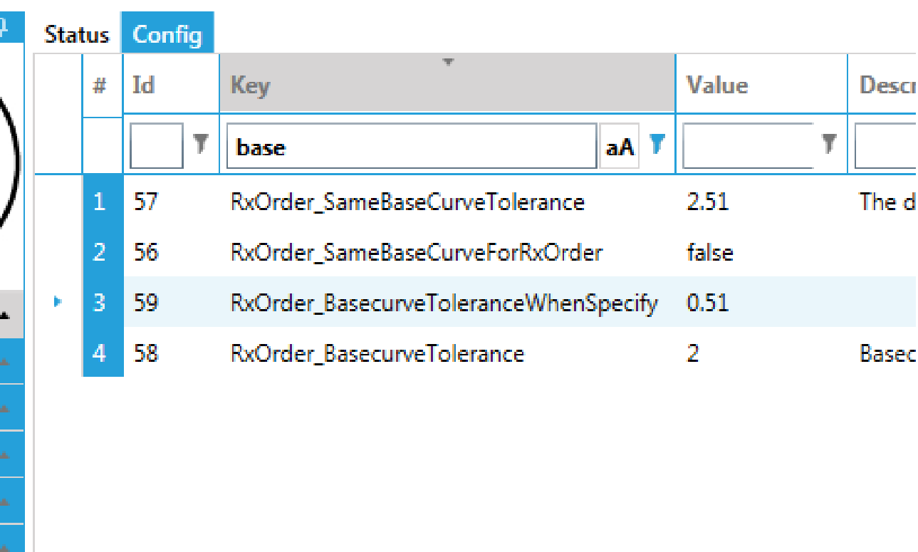

- the customer specified a base curve (i.e. entered specific for this job; any logic described below will be omitted). The system will search a base curve closest to this value. The allowed margin can be defined in the global configuration (in the image, the difference between customer request and available may be 0.51 diopter).
- the system uses a build in formula to determine the optimum front curve based on the prescription. The basic theory is a) the inside curve must be concave b) the inside curve should not be too steep;
- you can define a base curve chart for each product. In the chart you define a power range and the front curve to be used;
- you can write a custom plugin (see section 22.7) to determine the front curve based on your own logic.
For b,c and d the rule is:
- how much the front curve may difference from the optimum, is a configuration value (it will start searching lowest difference first).
- If left and right don't differ more than the configuration value, the system will equalize the bases (flatter for minus and more curved for plus powers)
The diameter is determined by the shape, fitting parameters, the (maximum) decentration and the safety margin. Shape and fitting parameter are given fact, but decentration and safety margin to be used can be configured in the system. By default, the system will use minimum decentration below a configurable (usually +1 diopter) combined power and optimum decentration above this value. Only when the lens diameter would require a bigger lens, the system will start to decenter until the shape will cut out. Ultimately, if still not cut out, the system will decrease the safety margin.
The system will first search the blanks assigned to the product. If not found (and you defined alternates) it will search the alternates (see section 22.4) according the logic described above.

Alternate lenses
Normally a “final lens” product”, uses a lens from one specific material. The system allows the user to select only blanks (so physical stock items) from this material. But for some lenses you can configure the program to choose a lens from a different material; in RXOffice this is called an alternate material. This is useful if you run out of single vision 1.5, you can give the customer as “alternate” a 1.56; the customer would not notice since the program remains the product name and price for the 1.5 for invoicing.
The program first automatically chooses the “regular” and then (if diameter too small or base curve difference out of tolerance) falls back to the “alternate”.
You can add alternate lenses in the Inventory. The "Alternate" is the substitute
To customize your own rules for alternative lens material for inventory, production or marketing, RxOffice offers a flexible feature for lensgroup alternative. It allows to customize user-defined conditional criteria to meet different scenario (see section).
Go to inventory module->Alternative screen.
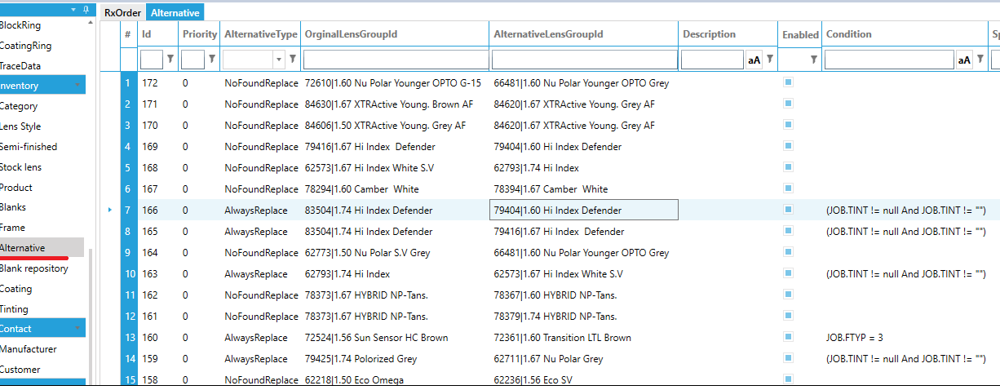
Columns Description:
Column | Description
Priority | Rxoffice take highest priority rule for multiple rules meet conditions.
AlternativeType | NoFoundReplace: the rule will be available only when none of blanks of original lensgroup is valid for current order.  AlwaysReplace: the rule will be always available, besides original lens group will be not available for current order any more.
OriginalLensGroupId | Original lensgroup
AlternativeLensgroup | Alternative lensgroup
Enabled | Set this rule is ready for working
Condition | Use if condition is met (leave empty to always apply). See section Error! Reference source not found. for examples.

To be noted: If there are multiple alternative rules meet and none of their alternative type is “AlwaysReplace”, Rxoffice will find the blank from high priority to low priority (-1, 0,1,2,3….). The priority of original blank group is -1. If any of their alternative types is“AlwaysReplace”, Rxoffice will only find blank in alternative blank groups.

Define conditional rules
For example:
- if only order has tinting, this rule will be applied, set:
(JOB.TINT! = null and JOB.TINT! = "")
- if only order's edging is rimless, set:
JOB.FTYP = 3
- if only SPH is greater than 6, set
JOB.SPH > 6

Power corrections
If the machines consistently produce wrong powers, you can configure adjustments that should
be applied to the calculation. For example, if the final inspection power is always 0.2 too high, you can apply a sphere adjustment of -0.2. These values will not show on the warranty card or any other documents send to the customer. They are internal to let the machine actually produce a wrong power (but due to the production error the result is the correct power; 0.2 – 0.2 = 0) Note: this is a “last resource”; always better to have the machines calibrated correctly to produce powers without any corrections. Common issue is the addition is to weak due to the polishing process. You can increase the addition with 0.15 (by applying an ADJADD of 0.15) and the inspection value will be spot on, but in fact you polished away 0.15 diopters which does not do any good to the design performance.
You can define a power range for the adjustments to be applied with the “From - to sphere, cylinder axis, addition and prism. If you need to define more granularly, you can select a lens material (LMATTYPE) or even more specific a material, lensgroup and design. The more parameters you define the more control you have. The system has no limit in how many constraints you define, but it does increase the complexity in maintaining your compensations table, so it is advisable to keep it as minimalistic as possible.
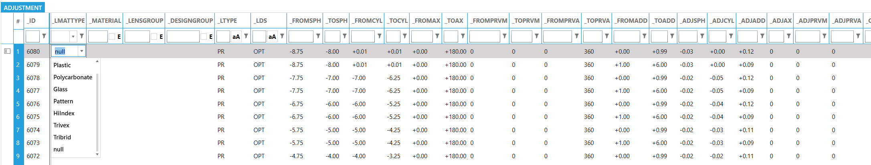
ADJSPH | Delta (correction to) Sphere Power
ADJCYL | Delta (correction to) Cylinder
ADJADD | Delta (correction to) Add Power
ADJAX | Delta (correction to) Cylinder Axis
ADJPRVA | Delta (correction to) Prism Axis
ADJPRVM | Delta (correction to) Prism

Email accounts
To send email confirmations and Invoices attachments, you must set up the e-mail account for each of your companies. After saving, you can “Check” if the configuration is valid. A test will be send to the host. If no error pops up, all is working. If an error pops up, please contact your e-mail provider
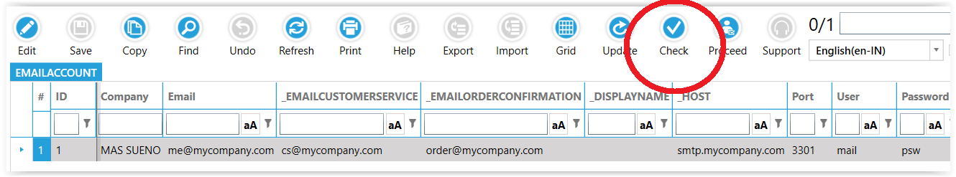

EDI import/Exporting
EDI integration is the electronic communication of business messages, such as orders and purchase, between your own system and your supplier’s systems, removing the need for manual re-keying of information.

EDI Credentials
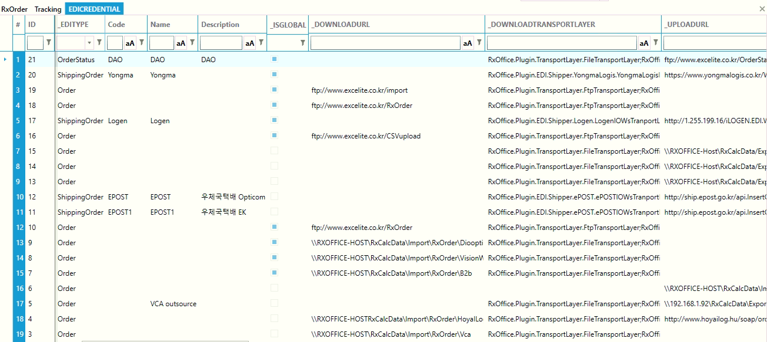In the EDI credential, you specify the upload- and download folder for the specific EDI format. If you need to specify user name and password (e.g. if the folder is an FTP location), enter it here.
The system supports unlimited imports. By default, OMA/VCA, B2B, Hoya, Essilor, Huabo are available, but any other format can be added through the plugin-architecture.
- Download URL: the folder, http or ftp address where the system searches for the records to be imported.
- Download transport layer: how the system should access the files in the download url.
- Upload URL: the folder, http or ftp address where the system searches for the records to be exported.
- Upload transport layer: how the system should access the files in the upload url.
- EdiType: what kind of EDI to external, eg. Order, Status, Shippment.

EDI Export/Import according each contact
- In the real world, the electronic orders of different customers may come from different platform, data format or even mixing. In RxOffice, the lab can configure EDI credential according to each customer.
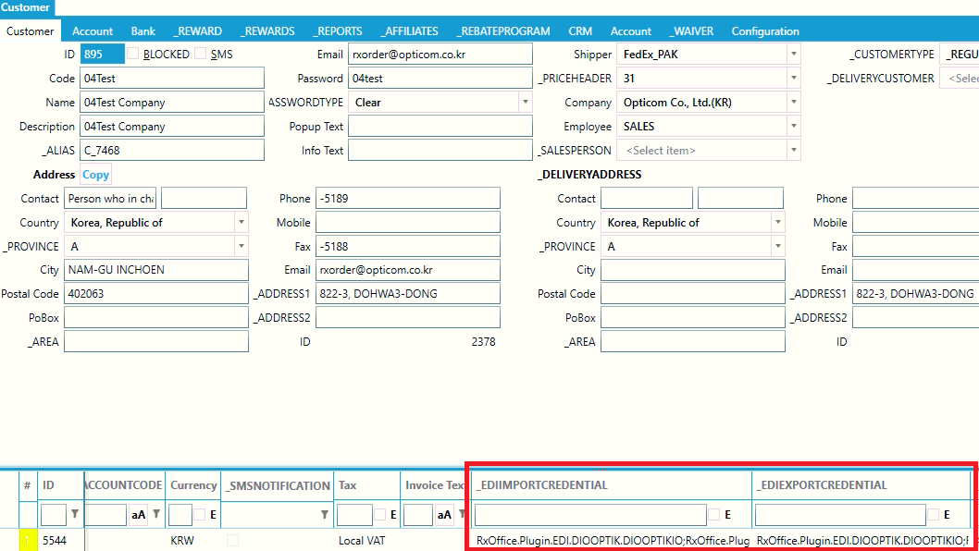
In customer screen, EdiImportCredential and EdiExportCredential are the means of EDI import/export for current customer.
- For status uploading, the lab can set “Condition” to have current EDI is only used with stratifying the conditoin
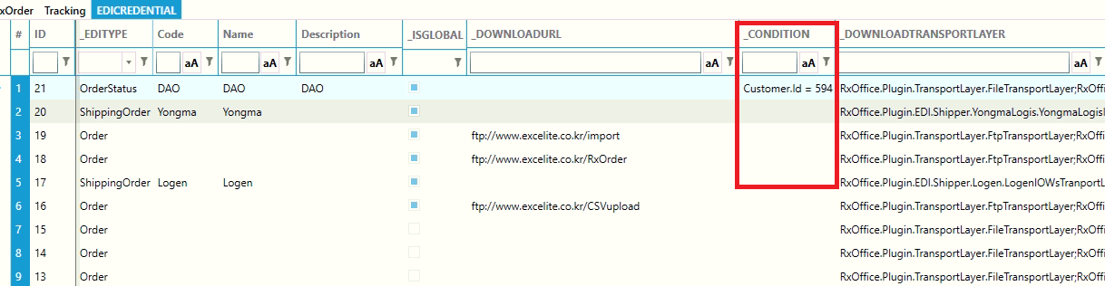
Eg. Conditoin : “Customer.Id = 594 or Customer.Id = 111” means only order’s customer Id equal 594 or 111, The programs export these orders to this status uploading EDI

Edi Mapping
There is no uniform standard naming convention in the lens industry which can make system integration a tedious and error prone task.
The matching of your product with name ABC to the same product (but with name XYZ) at the suppliers end, is called product mapping. The system has a feature “EDI Mapping” which allows, supplier specific, bi-directional matching of ABC to XYZ. Once settings are done, all EDI operation will follow the settings automatically. Navigate to “EDIMapping” screen:
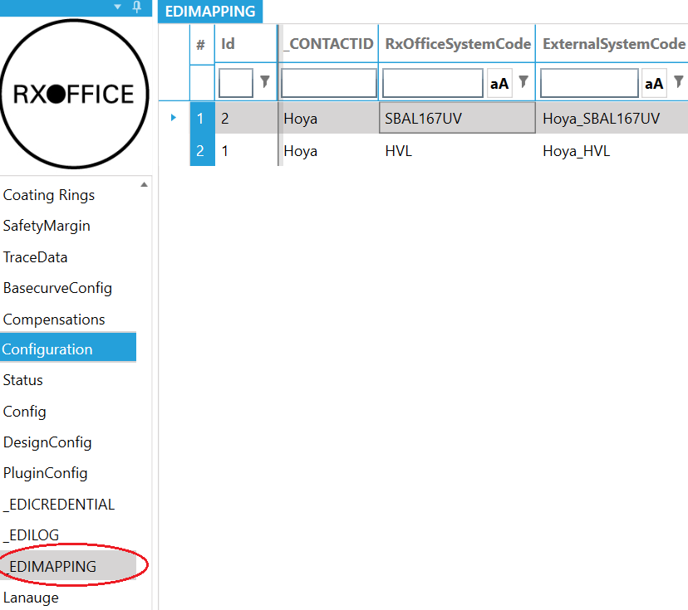
Columns explanation:
*ContactId: The external system, it can be a supplier, shipper, customer
RxOfficeSystemCode: The code of retail item or code of product in Rxoffice system
ExternalSystemCode: The corresponding code in the external system
“*” columns mean no constrain on this column if it is absent
To create the mapping entries quickly, open Inventory and right-click the products and select the . The system can not know the name at the suppliers end, so these must be entered manually but it saves you the time of creating the mapping entries manually.

Plugin
In the systems root folder, locate RxOffice.Plugin.xml. You can edit it with notepad. Which dll's to be used for a specific task (can be chained), is specified in this file.
How to write a plugin for RxOffice
Plugins are software components used to extend the functionality of the system. They enable third-party developers to create abilities which extend an application.
The system has several types of plugins. For example, export methods (such as OMA), base curve selection providers, price computation methods, and many others. Contact technical support to see if someone has already created a plugin that suits your needs. If not, this article will guide you through the process of creating your own plugin.
First thing you need to do is to create a new "Class Library" project in the solution. It's a good practice to place all plugins into \Plugins directory in the root of your solution.
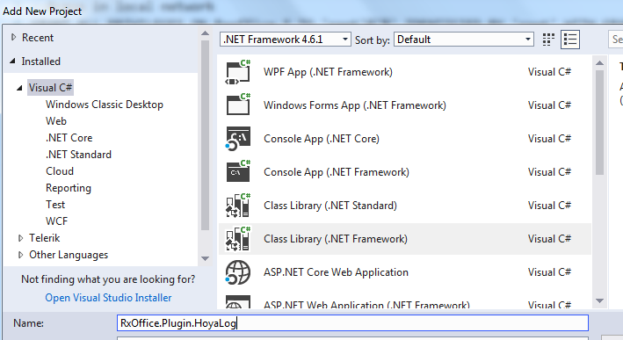
Add a reference to RXOffice.Plugin.dll
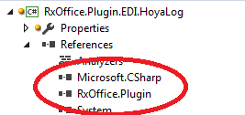
Implement the Interface. For more technical details, please contact our support team.

Job data adjustment
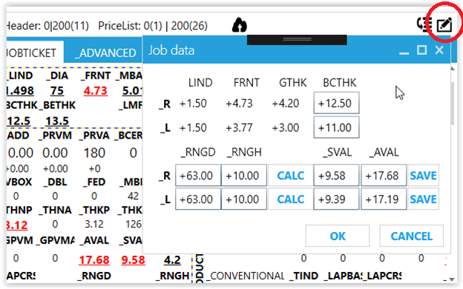
The calculation is done automatically on saving or when you click the “calculate” button. In some case you may want to override the automatic block ring selection or the final thickness. Click the “Edit job data” icon and enter the new data. To calculate the new SVAL for a different block ring, click the “Calc” button. You can also change the SVAL directly. Click the Save button to commit the change to the job.

Shape Adjustment
RxOffice offers a power full feature for shape adjustment. Here is the overview of shape adjustment user screen.
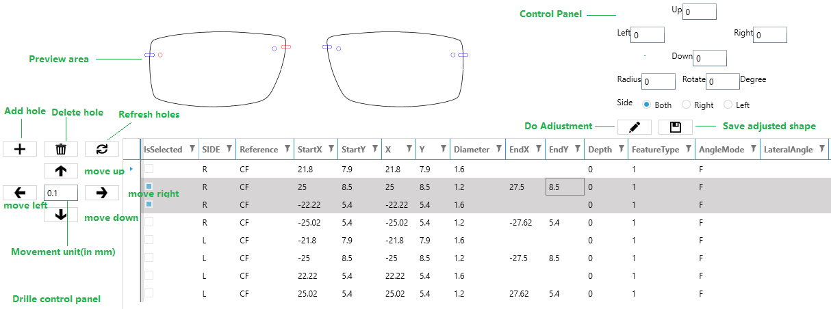
Preview
"Preview section" illustrates the resultant immediately after adjustment.
Shape Control Panel
Shape Control Panel offers below features:
shape size adjustment in up, down, left, right direction
- Radius scaling
- Shape rotation
Example #1 let us say we want to make height of right shape 3mm longer on bottom section. We enter 3 in "Down" textbox and select "Right" for side. Then click "adjust" button.
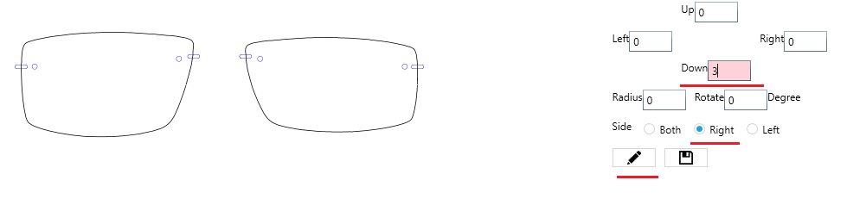
Example #2, It is very often shape size is smaller than physical frame,
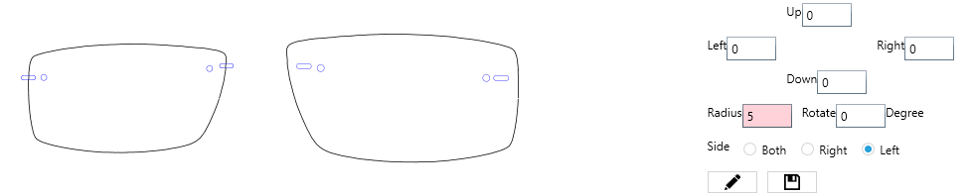

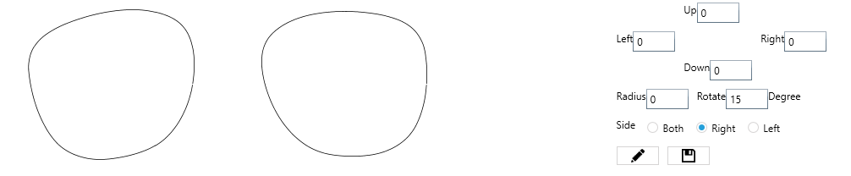
Example #3, sometimes the shape is rimless, the shape data is collected by blocker's camera. So, the shape is not upright, we have to rotate it. Let us we rotate shape right 15 degrees for right lens.
Drill control panel
"Drilled control panel" provides full operations for drill hole. It contains:
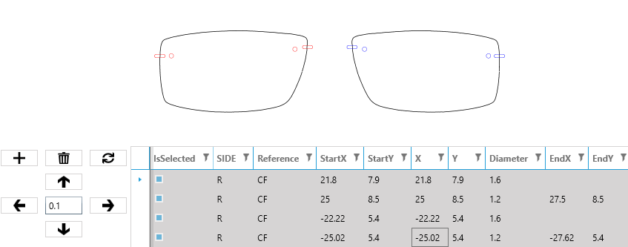
- Holes selection and preview, when holes are selected in List, its color becomes red

- Add/Delete/Refresh holes
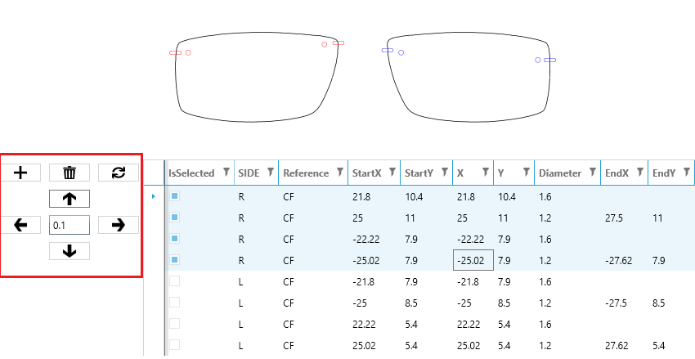
- Holes movement, user can move the selected holes in up/down/left/right direction with flexible unit.

Once you done the adjustment, you have to click "save" for applying shape to working context

Lens basics
A spherical lens can be likened to a slice of a football. The lens's power is contingent on its radius; a greater radius results in a more flattened lens, which translates to a reduced power.
Diopters (D)= (n−1​) / Radius of Curvature (m)
In this formula:
- Diopters (D) represents the optical power of the lens.
- The refractive index of the lens material (LIND) is denoted as "n."
- The Radius of Curvature should be in meters.
The curvature of the front surface of a lens can be characterized in two distinct manners: nominal (MBASE) and true curves (FRNT). The nominal curve is determined using a fixed index of 1.53 (typically indicated on the packaging). Conversely, the true curve is computed based on the actual refractive index of the lens, which is essential for precise calculations.
As a matter of convention, frame curvature (FCRV) is typically expressed in a 1.53 refractive index. For instance, if an Oakley frame is labeled with an 8 base curve, achieving a suitable match between the curvature of the lens and the frame requires a close approximation of the radius. A significant disparity can result in difficulties fitting the lens into the frame, or if forced, it may lead to an aesthetically unpleasing result. For instance, an 8 diopter lens in a 1.53 index corresponds to a radius of curvature of (1.53 - 1) / 8 = 66mm. To attain a radius equivalent to this in a 1.67 index lens, a front curve of approximately 10.11 diopters is needed, calculated as (1.67 - 1) / 0.066.
The power of a thin lens is typically calculated by subtracting the back curve from the front curve. For instance, when a lens has a front curve of 6 base and an internal power of -2, it yields a 4 diopter lens. However, when the front curve, as defined within the system, differs from the actual base curve, the resulting power discrepancy follows a direct 1:1 relationship. For instance, if the true lens power is 5.75 but the computer system indicates it as 6, the reading on the lens-meter will register at 5.75 - 2 = 3.75 diopters. In this case, the lens would be rejected due to a power deviation of 0.25 diopters.

Troubleshooting

Lens thickness
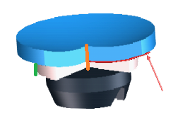
If the final lens thickness does not match the thickness on the job ticket, re-do the lens and do not de-block the lens. Measure the SVAL and compare with job ticket. If SVAL is not correct, the issue comes from the machine. If SVAL is correct, make sure the block ring height AND diameter is equal to the job ticket. Then de-block the lens and ensure the blank front curve matches the front curve on the job ticket. In the image, the red line marks the front curve, the green the block height and the orange the SVAL.

Off-power
If the lens does not measure correctly, check the actual front curve matches the front curve on the job ticket. A general rule is: if the sphere is wrong but the cylinder is correct, then the front curve is wrong. If both sphere and cylinder are of, you need to re-calibrate your surfacing equipment. If the addition is weak, but the sphere and cylinder are correct you can try reducing the polishing time.

Freeform calculations
Please contact the LDS vendor support. They will require the LDS, LMS and SDF files for the problem job. You can find them in
\\XXXX\Rxcalcdata\LDS\YYYYY\Backup\ZZZZZ.LDS
\\XXXX\Rxcalcdata\LMS\YYYYY\Backup\ZZZZZ.LMS
\\XXXX\Rxcalcdata\SDF\ZZZZZ.SDF
Where XXXX is the name of your server and YYYY the code for the LDS system (OPT = OptoTech, IOT = IOT etc.) and ZZZZ the job number.
The input, output and SDF folders are defined in the design configuration. Note; if the SurfaceFileFolder is empty in the Design configuration, the program falls back to the Path_SurfaceFile as defined in the configuration.
The LDS file is processed by the calculator and usually the calculator moves the file to a backup location. To find the backup file, you need to check the calculators configuration. An other option is to stop the calculator and re-calculate the job from the LMS; that will create a LDS file in the input folder and you can copy it to the location you want (after re-start the calculator it will be processed by the calculator and the LMS and SDF files are created)
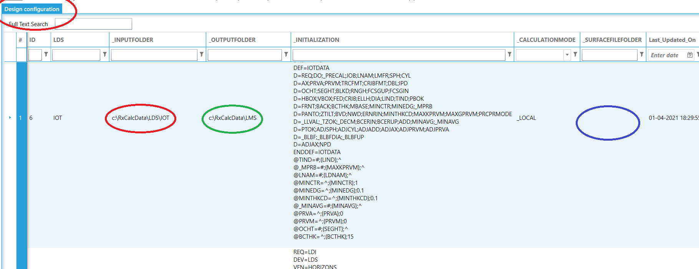
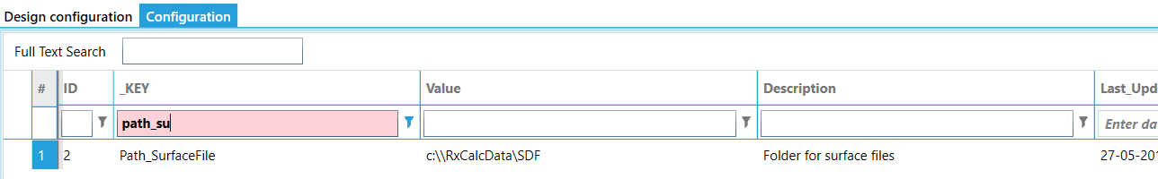

Lens assignment and pricing
Check the lens ID in the tooltip hovering the item.
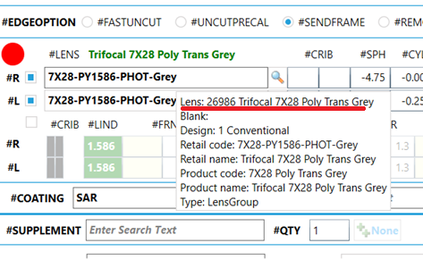
The assigned price(s) you can find in the price module and enter the product Id
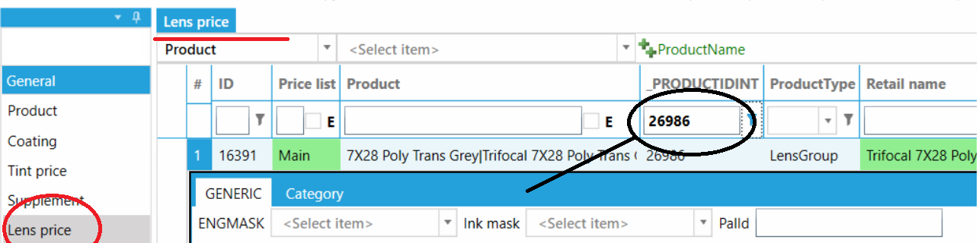
The assigned lenses, you can find in Inventory, Rx-or stock lens. If it is a freeform lens, you will find it in lens style. Additionally, you may have defined alternative lenses; these will be shown in the available blanks list on the UI
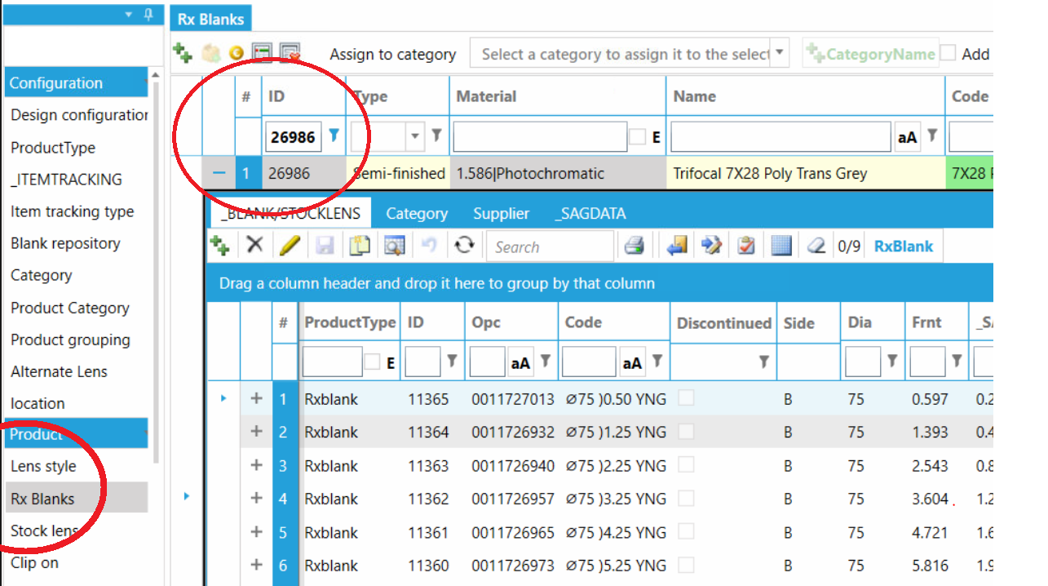

Machine interface

Steps to follow on the machine to check basic network connection with the server
# | Description | Action
1 | Ping server | Start->Run->Cmd  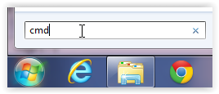  Ping xxx.xxx.xxx.xxx  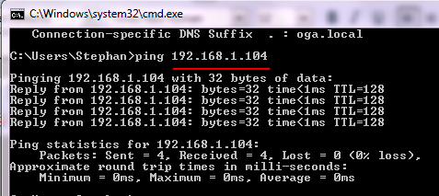  where xxx.xxx.xxx.xxx is the the server ip address
2 | Open share | 1. In RXOrders, click the Configuration  2. Look for DESIGN_FILE_PATH  3. On the machine  Start ->Run->\\Server-PC\surfacefiles  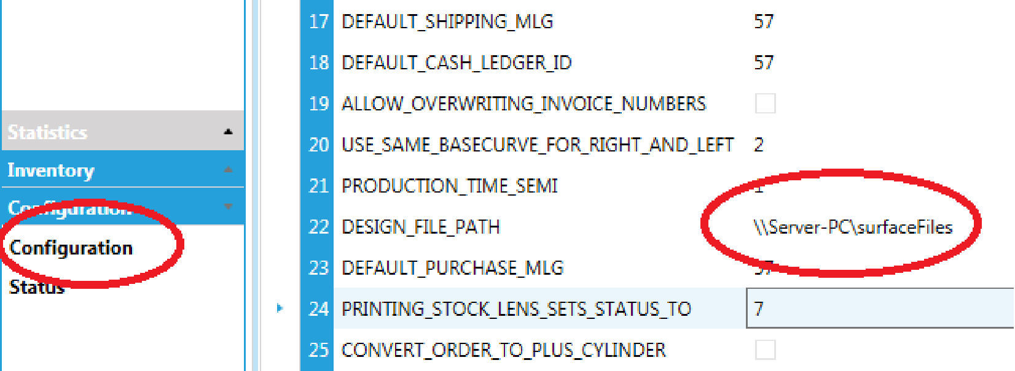

If the steps above are not successful, please contact the local administrator and correct before you continue.
On the server
# | Description | Action

On the machine
# | Description | Action
1 | Start databridge | Port number from the previous step. Also make sure the Disconnect on idle is marked  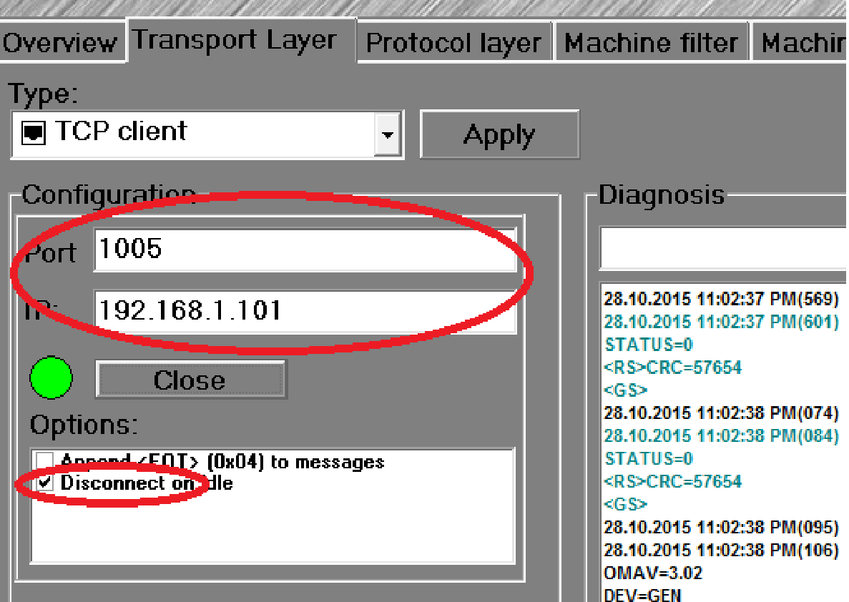  Port number from the previous step. Also make sure the Disconnect on idle is marked

Now you should be able to request a job on the machine. Best way to see the communication is to enter the JOB number in the databridge in the Protocol layer tab. If it does not work from there it will also not work from the machine GUI

Troubleshooting
  - RxOffice error message on start
If you receive a message like below, check
- your pc can ping the mysql server on the network
- the mysql service is running
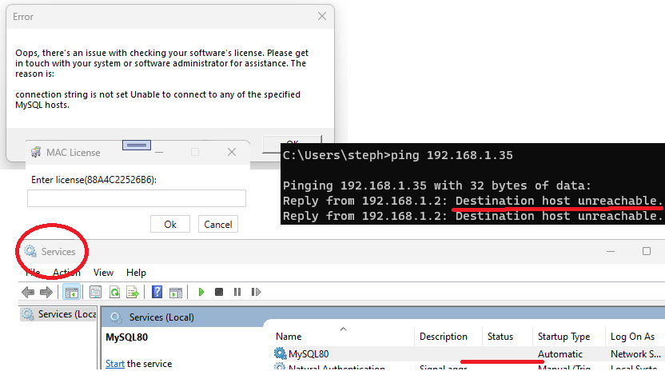
  - Optotech LDS doesn’t calculate
Open the path where the calculator is installed and open the “Currentlog.txt” with notepad. It should provide you some clues why the calculation doesn’t work. Potential causes are you have an active RDP connection to the PC, the dongle is physically not present or broken or expired.
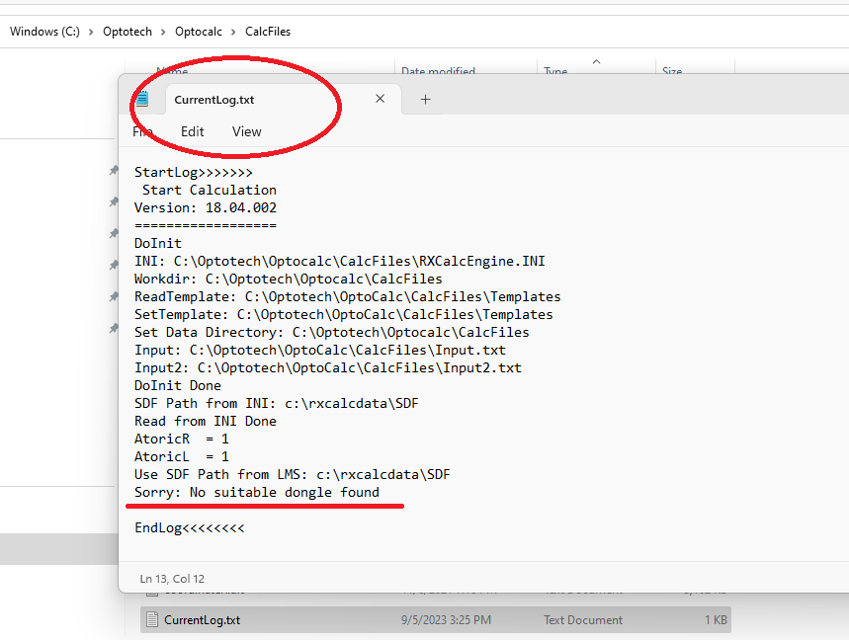

Backup
To avoid data los you should make backups of all active databases regularly. If you have a backup, you will be able to restore the whole database or some of its objects easily.
In the application folder, you find a file “backup.bat” (replace ABCD1234 with your real password)
cd C:\Program Files\MySQL\MySQL Server 5.7\bin
rem mysqldump -uroot -pABCD1234 rxoffice --hex-blob > c:/temp/rxoffice.sql
rem mysqldump -uroot -h 127.0.0.1 -pABCD1234 rxoffice --hex-blob > c:/temp/rxoffice.sql
Running the file creates a backup file “rxoffice.sql” in the c:\temp folder. It is recommended to change the path to a USB drive. You can plug in a different drive on Monday, Tuesday etc. to have a backup history for several days. The green line will prompt for a password; the blue line has the password (ABCD1234) and will not. More information about backup parameters you can find here https://dev.mysql.com/doc/mysql-backup-excerpt/5.7/en/mysqldump-sql-format.html
You can also create a backup schedule using the Windows task scheduler. Below a brief explanation; please Google it if you need more guidance
Open Control Panel -> Task Scheduler and select Create Basic Task
Set the task schedule
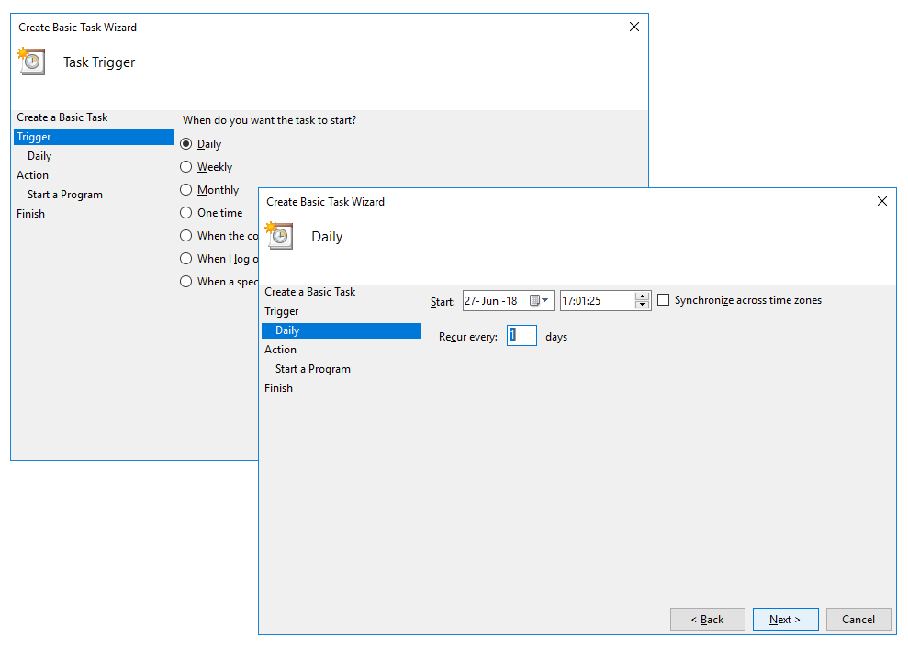
Select the “backup.bat” file in the LMS application folder
